**Fire Stopping Installation - An Overview**

In modern architecture, safety is paramount, especially when it comes to fire protection. Passive fire stopping plays a critical role in maintaining the integrity of buildings and ensuring the safety of their occupants. This method involves installing various fire stopping systems that prevent the spread of flames and smoke through concealed spaces in walls, floors, and ceilings. By effectively compartmentalizing a building, passive fire stopping minimizes the risk of fire spreading, allowing occupants more time to evacuate and fire services to respond. Therefore, investing in effective fire stopping installation is essential for any construction or renovation project. When choosing to enhance fire safety, it is vital to collaborate with reputable fire stopping companies that specialize in these critical installations. These companies have the expertise and knowledge to implement effective fire compartmentation services that align with local building codes and regulations. They provide a range of solutions tailored to various structures, including commercial and residential buildings. If you are looking for additional info on [fire stopping installation](https://www.nationalfireltd.co.uk/fire-stopping/), explore the mentioned above site.

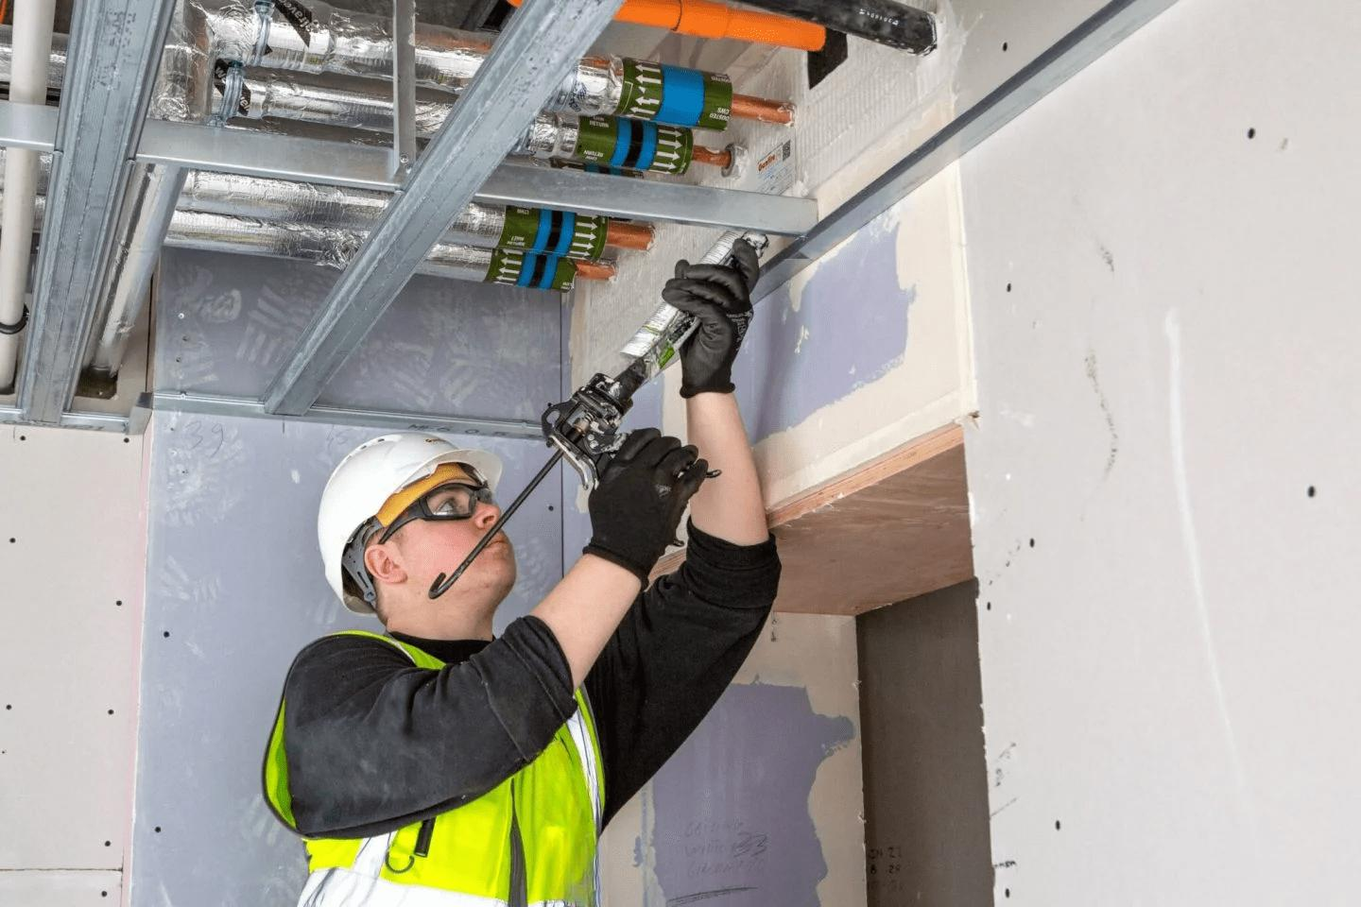

A professional approach to firestop protection ensures that the materials used are of high quality, providing reliable performance and compliance with safety standards. Thus, engaging with experienced professionals helps in achieving comprehensive fire safety measures. Fire compartmentation solutions for buildings are designed to limit the spread of fire within a structure, and fire compartmentation contractors play a significant role in this process. These specialists assess the layout and construction of a building to identify vulnerable areas where fire could potentially spread. By employing cavity fire barrier solutions and fire-resistant cavity barriers, they can effectively create compartments that hinder the movement of flames and smoke. This strategic approach enhances overall building safety, ensuring that even if a fire occurs, its impact is minimized, safeguarding lives and property. For commercial buildings, effective cavity wall fire safety systems are particularly crucial. These systems incorporate cavity fire barriers for commercial buildings to provide robust protection against fire hazards. By using non-combustible materials and adhering to best practices in fire stopping, these barriers create a reliable line of defense.

Proper installation and maintenance of these systems are vital to ensure their functionality. Regular inspections by qualified professionals can help identify any issues or weaknesses, ensuring that fire compartmentation measures remain effective over time. Moreover, the role of compartmentation fire safety systems extends beyond just preventing fire spread; they also support building resilience. In the event of a fire, these systems can significantly reduce damage, allowing occupants to evacuate safely while protecting the structural integrity of the building. This resilience is vital in minimizing disruptions to business operations and reducing the financial impact of fire incidents. By investing in effective fire stopping strategies and working with qualified contractors, building owners can significantly enhance their property’s safety profile. In conclusion, the importance of passive fire stopping cannot be overstated. As fires continue to pose a significant risk in various settings, adopting comprehensive fire compartmentation solutions becomes essential. The collaboration with experienced fire stopping companies ensures the effective installation of systems that not only comply with safety regulations but also provide peace of mind to occupants. By prioritizing fire stopping installation and regularly maintaining these systems, property owners can contribute to a safer built environment and protect their investments against potential fire hazards. Through the implementation of these measures, we can work towards a future where buildings are not only aesthetically pleasing but also fortified against the dangers of fire.