**User Guide On Designer Fans**

In recent years, ceiling fans have evolved beyond their traditional function of air circulation. Today, modern designer fans combine both form and function to enhance the aesthetic appeal of homes. These fans are no longer seen as simple appliances but as integral elements of interior design. From sleek, minimalist designs to artistic and bold styles, designer ceiling fans bring a fresh and stylish touch to any room. Whether it's for the living room, bedroom, or patio, these fans now serve as focal points in modern home decor, blending practicality with cutting-edge design trends. The rise of contemporary ceiling fans has made them a popular choice for homeowners looking to elevate their living spaces. With their sleek lines and elegant finishes, modern designer ceiling fans fit seamlessly into various design schemes, whether it's industrial, minimalist, or eclectic. These fans are available in a wide range of styles and sizes, offering options for every taste and space. Are you hunting for [designer fans](https://henleyfan.com/)? Visit the earlier outlined site.

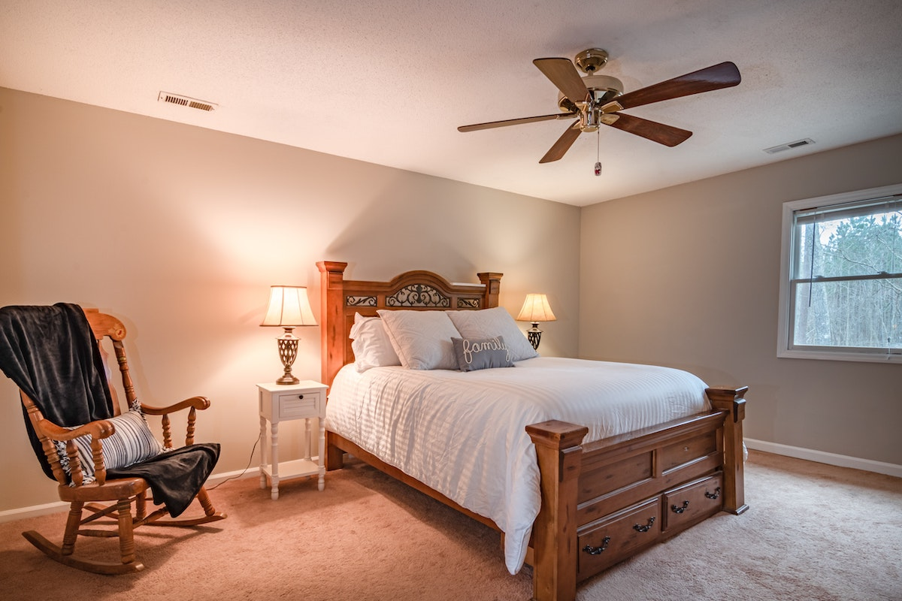

In particular, designer fans for living rooms have become a favorite, as they not only cool the room but also add a touch of sophistication, transforming the space into a stylish haven. One of the key features of these designer ceiling fans is their advanced technology. Many models now come equipped with a remote control ceiling fan function, allowing for ease of use and convenience. This feature lets homeowners adjust the speed and direction of the fan with just the push of a button. Some models also offer energy-efficient options, reducing electricity consumption while providing optimal air circulation. With the ability to find a designer ceiling fan online, consumers have more access than ever to a wide variety of choices, making it easy to find the perfect fan to suit their needs. While many designer fans come with integrated lighting, there are also designer ceiling fans without lights available for those who prefer a cleaner, more minimalist look. These fans focus solely on air circulation and design, making them ideal for spaces where lighting is already sufficient or unnecessary. Whether you're looking for a statement piece or something that blends into the background, modern designer fans without lights provide a stylish and functional solution.

The diversity in design ensures that there's a fan to complement any decor, from modern to traditional. In addition to their stylish designs, these remote control ceiling fans are also incredibly practical. They offer homeowners the ability to control the airflow in their homes without needing to adjust the fan manually. This convenience makes them particularly appealing for large living rooms or open-concept spaces where reaching the fan may be difficult. By integrating this level of technology, designer fans ceiling options have become an essential component of modern living, enhancing both comfort and convenience. In conclusion, the blend of style and functionality found in designer ceiling fans makes them a must-have for any modern home. Whether you’re looking for a sleek remote control ceiling fan or a bold statement piece, the variety of modern designer ceiling fans available today offers endless possibilities. With their ability to complement any interior design style while providing essential cooling, these designer fans are redefining the role of ceiling fans in home decor. By choosing a designer ceiling fan online, you can effortlessly elevate your space, combining comfort, style, and technology.