**The Value Of Wild Flower Seed**

Creating a wildflower garden can be a rewarding experience, offering beauty and ecological benefits. Strategic planning is essential to ensure your wildflower meadow thrives and flourishes. From selecting the right seeds to preparing the site, this guide will help you turn a simple area into a breathtaking meadow masterpiece. The first step in planning your wildflower garden is selecting the appropriate wildflower seeds. It’s crucial to choose seeds that are suited to your region's climate and soil conditions. Native wildflower seeds are the best option as they are adapted to local ecosystems, providing the best chance for successful growth. Look for wild flower only mixtures that feature a selection of native species. This approach ensures that the plants will thrive in your environment and attract local pollinators. Additionally, consider complete seed mixtures, which often contain a variety of species to ensure continuous blooms throughout the growing season. Before you plant, prepare the site thoroughly. Choose a location that receives ample sunlight, as wildflowers typically need at least six hours of direct sun each day. Make a search on the below mentioned website, if you are searching for additional information regarding [wild flower seed](https://wildseed.co.uk/mixtures/wild-flower-only-mixtures/).

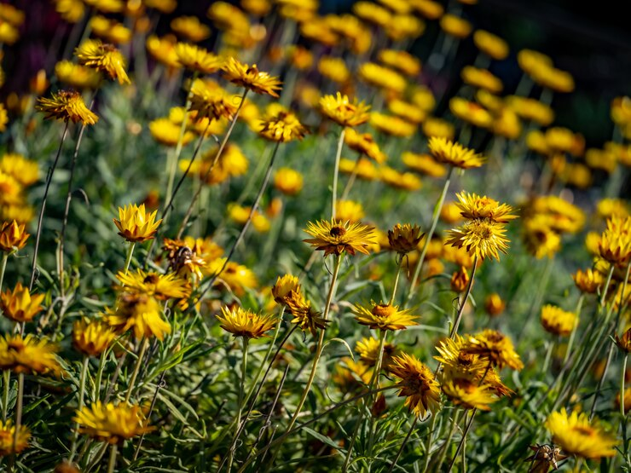

Clear the area of weeds, grass, and debris, as these can compete with your wildflowers for resources. If the soil is compacted, use a rake or tiller to loosen it up. Wildflowers generally prefer poorer soil, so there’s no need to add fertilizers. This natural approach encourages a diverse ecosystem that benefits local wildlife. Once you’ve prepared the site, it's time to sow your seeds. Mixing the wildflower meadow seeds with sand can help distribute them more evenly over the planting area, preventing overcrowding. Scatter the seed mixture evenly and rake the soil lightly to ensure the seeds make contact with the soil without being buried too deeply. Most wildflower seeds require light to germinate, so covering them with just a thin layer of soil is sufficient. After sowing, watering is critical for germination. Gently water the area to keep the soil moist but not soggy. This is particularly important during the initial weeks after planting, as seeds need consistent moisture to sprout. The germination period can vary from a few days to several weeks, depending on the species. As the seedlings emerge, gradually reduce watering frequency, as wildflowers are typically drought-resistant once established. As your wildflower garden grows, patience is essential. It may take time for the plants to establish and reach full bloom.

To promote biodiversity and a vibrant display, avoid using herbicides and pesticides, which can harm beneficial insects and disrupt the ecosystem. Allowing some wildflowers to go to seed will encourage new growth and ensure the longevity of your meadow. Regular maintenance is crucial for the health of your wildflower garden. Periodically check for weeds, which can compete with your wildflowers for nutrients and water. Removing weeds by hand or using a hoe can help keep your garden thriving. Additionally, consider cutting back the flowers in late autumn, which will prepare the area for the next growing season. This practice can help manage growth and promote healthier plants. In conclusion, creating a wildflower meadow masterpiece requires careful planning and attention to detail. By selecting the right best wild flower seeds, preparing the site adequately, and maintaining the garden properly, you can cultivate a stunning display that not only enhances your landscape but also supports local wildlife. Whether you choose flower mixture seeds for a diverse bloom or stick to a simpler selection, your efforts will result in a beautiful and sustainable habitat that thrives through the seasons. Embrace the journey of growing your wildflower garden, and enjoy the vibrant colors and the ecological benefits it brings to your space.