**Information On Stretch Tent Marquee Hire**

Planning a surprise party requires careful coordination and stealth to ensure the guest of honor has an unforgettable experience. One of the first steps is to determine the theme and size of the celebration, as these factors will guide your choices for bouncy castle rent and other activities. Bouncy castles are a fantastic option for outdoor parties, especially for children, providing hours of entertainment. When searching for rental options, be sure to book well in advance to secure your preferred size and design. Many rental companies offer delivery and setup services, which can alleviate some of the logistical challenges involved. In addition to securing a bouncy castle, you’ll need to think about party equipment hire. This can include tables, chairs, linens, and decorations that fit your party theme. Using party hire online platforms can simplify the process significantly, allowing you to browse through various rental items from the comfort of your home. Pay close attention to the details, such as color schemes and styles, to create a cohesive look for the event. Make sure to choose a reliable vendor by checking reviews and asking for recommendations from friends or family. Go to the below mentioned website, if you are searching for additional information regarding [tent rentals surrey](https://www.rent-event.co.uk/whats-for-hire/stretch-tents-marquee-event-tents/).

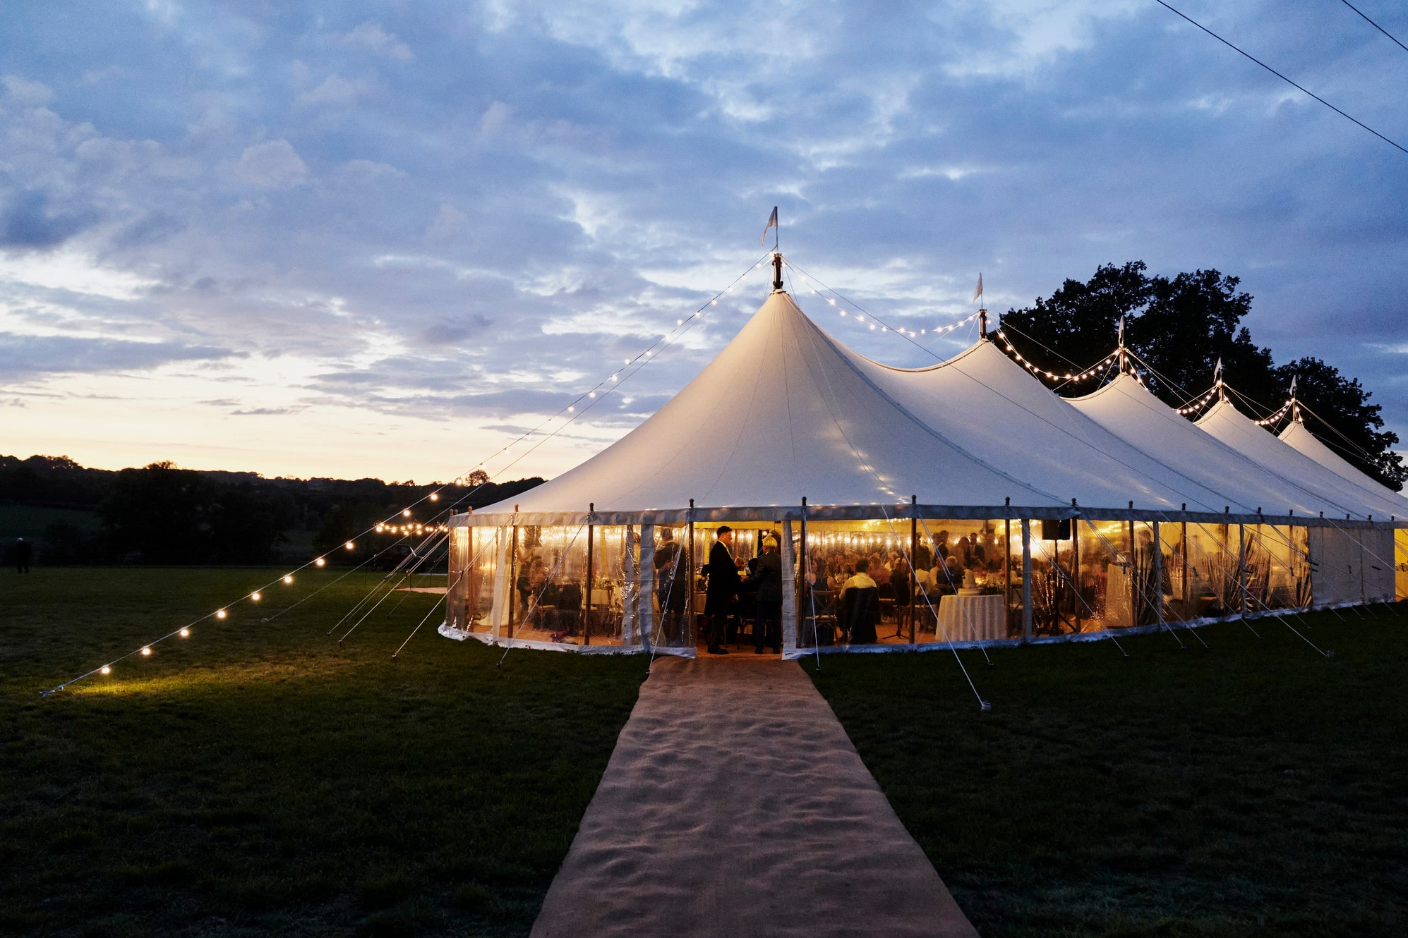

Tent rentals are another critical aspect of organizing a surprise party, especially if you plan to host it outdoors. A tent can provide shade during a sunny day or protection in case of unexpected rain, ensuring your event continues smoothly regardless of the weather. When considering tent rentals, think about the number of guests you’ll have and the layout of your backyard. You want enough space for guests to mingle, eat, and enjoy activities comfortably. Rental companies often have various tent styles and sizes, so take the time to find one that fits your needs. Incorporating fun elements, such as a photo booth, can elevate the excitement of your surprise party. With photo booth hire, you can add an interactive element that encourages guests to capture fun moments throughout the celebration. Many companies offer customizable backdrops and props, making it easy to tailor the booth to your theme. Make sure to check the options available, as some packages include instant prints that guests can take home as keepsakes. This addition not only entertains but also creates lasting memories for everyone involved. Another important factor to consider is food and beverages. Decide whether you want to prepare the food yourself or hire a catering service. Depending on your budget, you could opt for finger foods, snacks, or a more formal meal.

Ensure there is a variety of options to cater to different dietary restrictions, including vegetarian or gluten-free choices. Having refreshments readily available keeps guests satisfied and engaged, allowing the party to flow smoothly. Consider creating a designated area for food and drinks to make it easy for guests to serve themselves. Lastly, communication is key when coordinating a surprise party. Make sure to enlist the help of trusted friends or family members to assist with planning and managing tasks on the day of the event. Share responsibilities for decorations, food preparation, and logistics to ensure everything goes smoothly. It’s also essential to keep the details under wraps to maintain the element of surprise. Use private messaging apps or group chats to keep everyone in the loop without alerting the guest of honor. In summary, organizing a surprise party involves several critical elements, including bouncy castle rent, party equipment hire, and tent rentals. By planning ahead and using party hire online services, you can coordinate everything from food to entertainment seamlessly. Don’t forget to incorporate interactive elements like photo booth hire to enhance the celebration. With careful planning and a little creativity, you can pull off a surprise party that the guest of honor will remember for years to come.