**Information On Lockdown Alarm For Schools**

School safety is a top priority, and the implementation of a lockdown alarm is one of the most effective ways to ensure the protection of students and staff. These systems are designed to alert everyone in the building of a potential threat, allowing them to act swiftly. A lockdown alarm for schools helps prevent confusion during emergencies, as it provides clear instructions and warnings. When a potential threat arises, schools can rely on the lockdown alarm system to quickly and efficiently secure the premises, ensuring that all areas are locked down and safe. The benefits of having a school lockdown system are numerous. It allows for a faster response time, which is crucial when every second counts. Traditional systems, such as fire alarms, are not suitable for threats like intruders, but a dedicated emergency lockdown alarm specifically addresses these situations. Go to the below mentioned site, if you are looking for additional information about [lockdown alarm for schools](https://camelott.co.uk/lockdown-alarm-schools/).

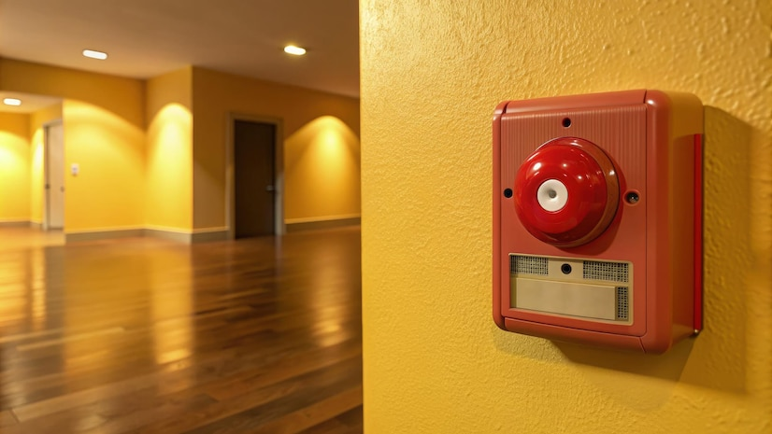

The system not only alerts those inside the school but can also notify local law enforcement, ensuring that help is on the way as soon as possible. Furthermore, these systems can help guide students and staff to safe locations within the building, reducing the potential for panic. With the recent introduction of Martyn's Law alarm systems, schools, theatres, and public venues are required to enhance their safety measures. This law emphasizes the importance of being prepared for any kind of threat, including terrorism. A theatre lockdown alarm system, for instance, can ensure that performers, staff, and audience members are kept safe in the event of a security breach. Similarly, a stadium lockdown alarm system can prevent mass panic and guide thousands of spectators to safety in the case of an emergency. Public venues of all types are recognizing the importance of venue lockdown alarm systems.

Whether it's a stadium, theatre, or school, having a reliable alarm system in place ensures that everyone knows what to do during an emergency. These alarms can also be integrated with other security systems, such as CCTV and access control, to provide a comprehensive safety solution. A well-designed lockdown alert system not only helps secure the premises but also aids in post-incident investigations by providing detailed records of how the event unfolded. Schools, in particular, benefit immensely from these systems. A school lockdown alarm ensures that students and staff are not only alerted to potential dangers but are also guided through the necessary steps to stay safe. The ability to lockdown classrooms, hallways, and other areas of the school can prevent intruders from causing harm. Furthermore, the system can be tailored to each school’s specific layout, ensuring that every part of the building is protected. In conclusion, investing in a reliable lockdown alarm system is essential for schools and other public venues to ensure safety during emergencies. These systems not only provide immediate alerts but also help coordinate the necessary response to protect everyone on the premises. Whether it’s a school lockdown alarm, a theatre lockdown alarm system, or a venue lockdown alarm system, having the right safety measures in place can make all the difference when it comes to protecting lives.