**Information On French Antique Furniture**

Antique dealers often curate unique pieces that tell stories of the past, attracting collectors and enthusiasts alike. Antique shops serve as treasure troves filled with vintage items, each with its own history. Among the popular categories are antique garden furniture, which adds a charming touch to outdoor spaces. These pieces are not just functional; they also enhance the aesthetic appeal of gardens, blending beautifully with nature. Decorative garden antiques, such as vintage pots or wrought iron benches, can create focal points that evoke nostalgia while providing practical seating or display areas. One interesting item that collectors may seek is a cheese making vat. This large vessel, often made of copper, has historical significance, especially in regions known for dairy production. A copper cheese vat not only serves as a functional item but also as a decorative piece, showcasing craftsmanship and culinary heritage. These vats can become striking conversation starters in kitchens or dining areas. Are you hunting about [french antique furniture](https://www.louisehalldecorative.com/furniture)? View the previously outlined website.

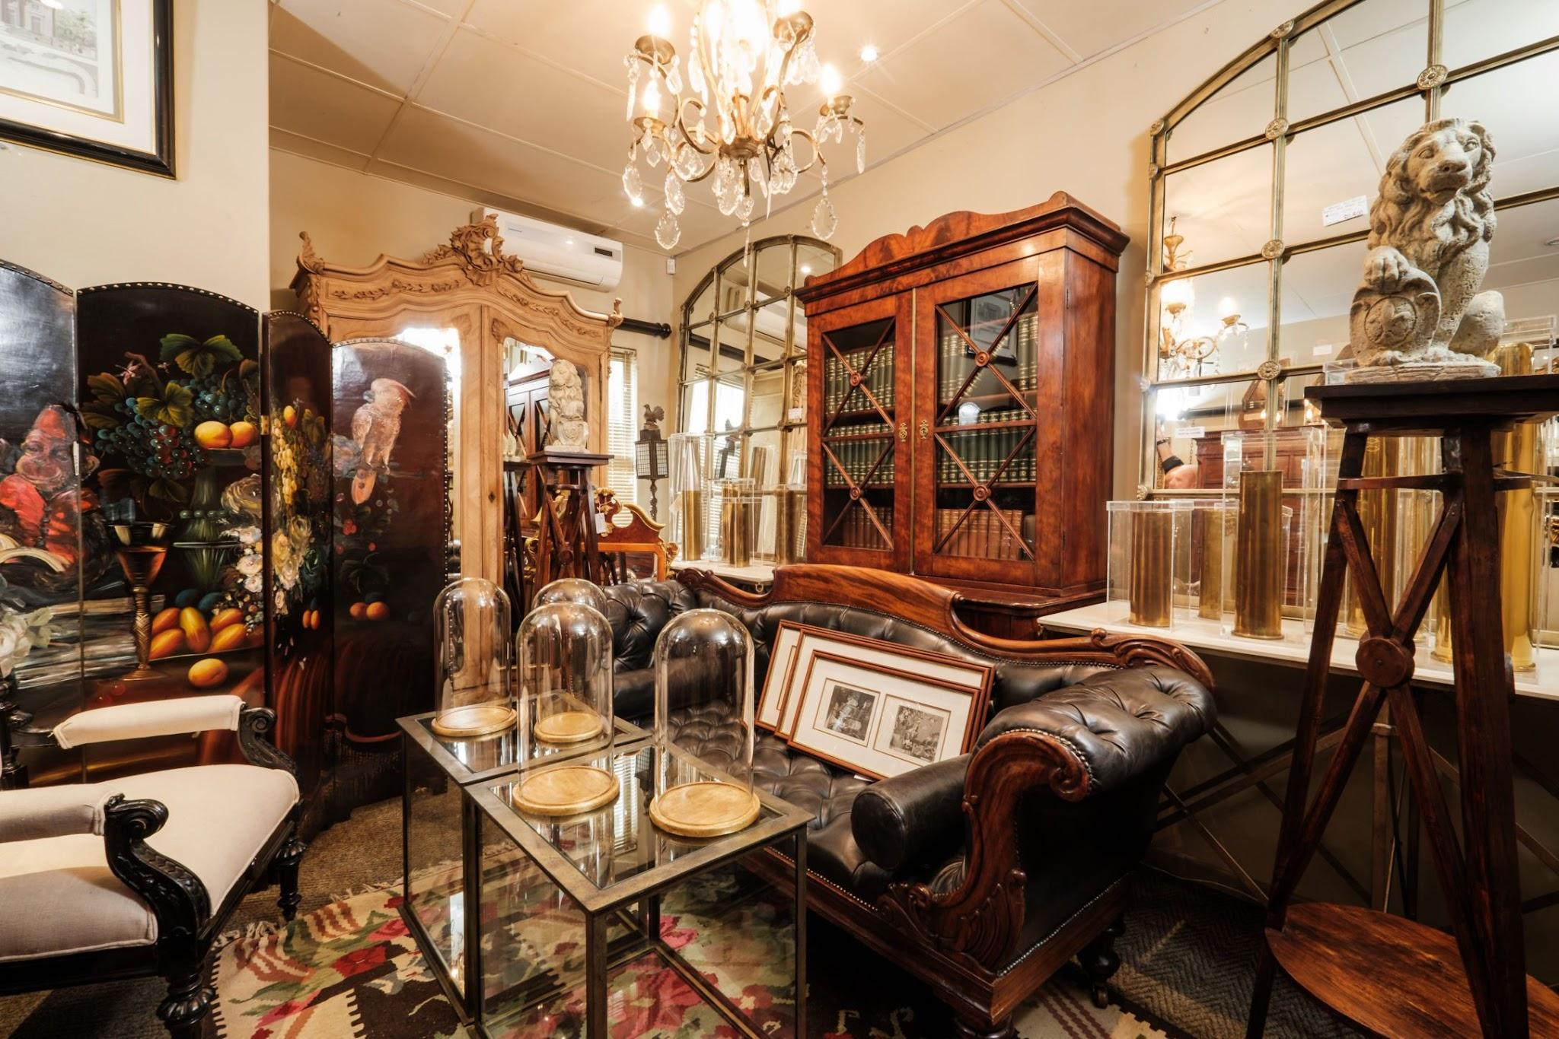

Their unique designs often attract attention, and they can be used creatively in home décor or as a centerpiece for themed events. Chairs are another essential item found in antique shops. Antique chairs vary widely in style, from ornate Victorian pieces to minimalist Mid-Century Modern designs. Each type reflects the era it comes from, showcasing the craftsmanship and materials used during that time. Collectors often seek specific styles to complete their collections or to enhance their home décor. Antique chairs can be repurposed or restored to fit modern aesthetics while retaining their historical charm. Adding a few antique chairs to a space can create a warm, inviting atmosphere that invites guests to sit and linger. Decorative garden antiques offer a unique way to personalize outdoor areas. Items like vintage birdbaths, sundials, or decorative sculptures can enhance the landscape while serving as functional art. These pieces often serve dual purposes, providing both beauty and utility. Antique dealers frequently stock a variety of garden antiques that can complement existing landscapes or inspire new designs.

Incorporating these items into garden settings can elevate the overall ambiance and create a serene retreat for relaxation and enjoyment. For those looking to create an inviting outdoor space, mixing antique garden furniture with decorative pieces is key. By combining a copper cheese vat as a planter with vintage garden chairs, one can achieve a unique and cohesive look. Such combinations not only celebrate the past but also create an engaging environment that blends different historical elements. This approach allows individuals to express their personal style while appreciating the craftsmanship and stories behind each antique piece. In summary, the world of antiques offers a rich array of items, from antique garden furniture to cheese making vats and vintage chairs. Antique dealers provide access to these treasures, which can enhance both indoor and outdoor spaces. By incorporating decorative garden antiques and selecting unique furniture, individuals can create environments that reflect their taste and appreciation for history. Whether it’s a copper cheese vat or an intricately designed chair, each piece adds character and charm, making any space more inviting and engaging.