**Individual Guide On Steel Ear Stretching Kit**

The ancient art of ear stretching has a rich history that spans cultures and centuries. This practice, which involves gradually enlarging the size of the earlobe, is often associated with various cultural traditions. From the indigenous tribes to the contemporary fashion scene, ear stretchers have become symbols of identity, spirituality, and personal expression. Today, the trend of stretch earrings is not only prevalent among subcultures but has also found its way into mainstream fashion. As more individuals explore this transformative journey, it is essential to understand the cultural significance and modern appeal of ear stretching. Historically, ear stretching has served numerous purposes across different societies. In many tribes, it was a rite of passage and a demonstration of beauty and strength. For others, it represented social status or tribal affiliation. In ancient cultures, such as the Mayans and Aztecs, individuals wore large stretch earrings to signify their connection to the spiritual world. Today, the significance of stretched earlobes varies, with many adopting the practice as a form of self-expression. Make a search on the following site, if you are searching for more details on [steel ear stretching kit](https://www.stretchitbodyjewellery.co.uk/collections/kits).

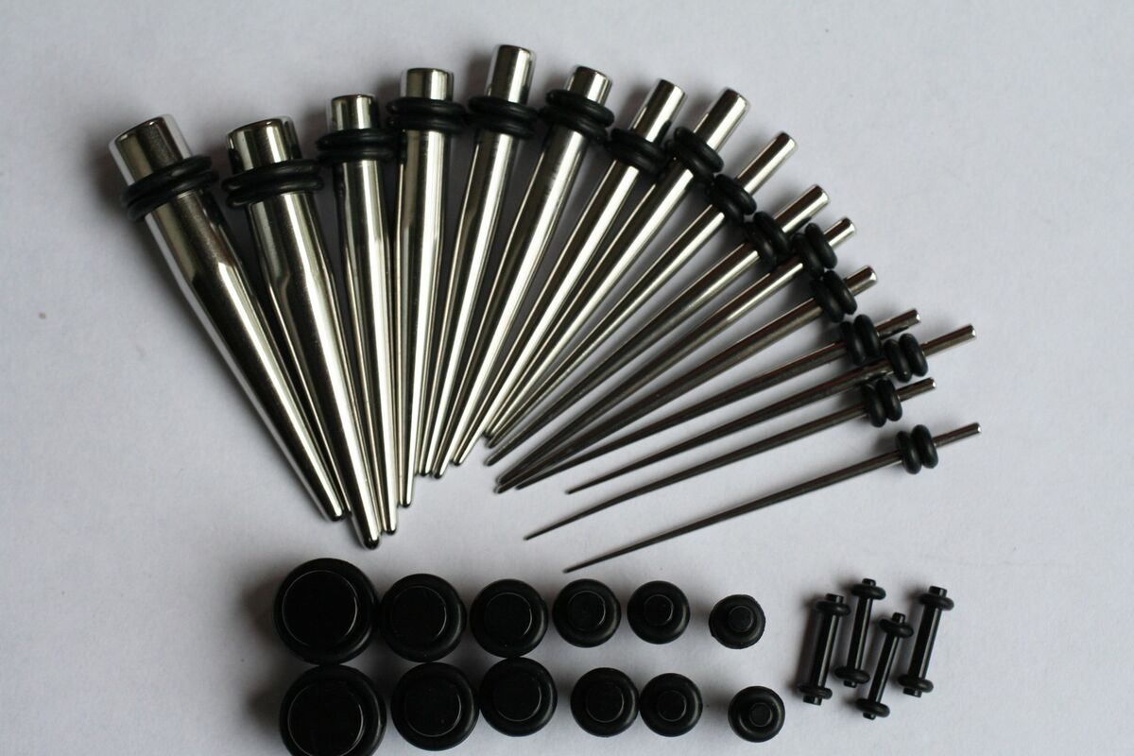

This contemporary take on an age-old tradition has contributed to the resurgence of interest in ear stretching and the various products available, including the ear stretching kit. Modern ear stretching often begins with an ear stretching kit beginners that includes tools designed for gradual enlargement. These kits typically feature a range of materials, including acrylic, glass, and surgical steel. The surgical steel ear stretching kit is particularly popular due to its hypoallergenic properties and durability. Users typically start with small gauges and progressively move to larger sizes using stretching kits. It is essential to follow a proper stretching guide to ensure the process is safe and effective. This approach minimizes the risk of tearing or damaging the earlobe, allowing for a successful journey into larger ear sizes. As individuals advance through the stages of ear stretching, they may find themselves exploring various ear stretching sizes. It is common to encounter terms like “double zero” or “triple zero,” indicating specific measurements in the gauge system. The best ear stretching kit often includes various sizes to accommodate personal growth and style preferences.

Additionally, users may opt for decorative plugs or tunnels that reflect their personality. These accessories enhance the aesthetic appeal of stretched earlobes, transforming them into unique fashion statements. For those interested in taking the plunge, investing in a quality earlobe stretching kit is crucial. Many beginners often seek an ear stretching starter kit that includes everything needed for safe stretching. These kits can provide a comprehensive experience, featuring tools, care instructions, and aftercare products. Regular cleaning and maintenance are vital in preventing infections or complications during the stretching process. Utilizing products like ear stretchers can also help ensure a smooth transition from one size to the next, allowing individuals to enjoy the journey without discomfort. As ear stretching becomes increasingly mainstream, it is essential to recognize its cultural roots while embracing its modern interpretations. The combination of tradition and contemporary fashion has allowed the art of ear stretching to flourish in diverse communities. With the right knowledge and tools, such as the large ear stretching kit, anyone can embark on this personal journey. Whether for cultural significance or as a fashion statement, ear stretching continues to capture the imagination of individuals worldwide. By understanding the importance of proper techniques and respecting the traditions behind it, enthusiasts can celebrate the beauty of this ancient practice in their own unique way.