**Hire Videographers - An Overview**

Brand video production plays a critical role in modern marketing, transforming ideas into engaging visual content that can reach a wide audience. A successful video campaign starts with a solid concept that resonates with the brand's core message. Partnering with a video production agency or creative video agency is essential to bring that concept to life with professional quality. These agencies specialize in creating videos that capture attention, drive engagement, and reflect the essence of the brand. Whether it's for a product launch or a company story, quality video production can help turn your ideas into a viral success. One key aspect of successful brand video production is choosing the right videographer or video production company. Whether you need corporate video production companies or a smaller video production agency, it's important to work with professionals who understand your goals and audience. A well-executed video reflects not only the brand but also the values and tone of the business. The best video production teams are skilled in storytelling, combining visuals, audio, and messaging to create a memorable impact. Are you hunting about [hire videographer london](https://www.thefilmfarmers.co.uk/videographers)? Go to the previously described website.

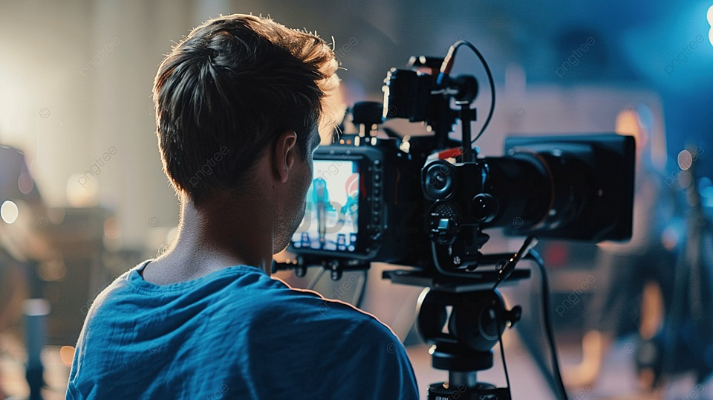

A successful video campaign can help solidify a brand's image and create lasting customer connections. In addition to storytelling, event videography is a vital part of creating compelling branded content. Capturing live events through professional event videography allows brands to document important moments, from conferences to product launches, in a way that can be repurposed for marketing. These videos provide authentic, real-time content that can be used across multiple platforms. A skilled videographer ensures that the energy and significance of the event are captured, making it easier for brands to share the experience with a wider audience and keep the conversation going long after the event ends. The rise of branded content video production has also been a game changer for companies looking to stand out in competitive markets. Instead of direct advertising, creative video agency professionals focus on creating content that is engaging and valuable to the audience. These videos subtly incorporate the brand while focusing on storytelling or entertainment, making them more likely to be shared and go viral.

When you hire videographer services or work with a digital video agency, it’s important to choose those with experience in branded content video production to ensure your message is woven seamlessly into the narrative. Finally, measuring the success of your brand video production goes beyond just views or likes. A successful campaign should generate engagement, encourage shares, and drive conversions. By working with an experienced video production agency or corporate video production companies, you can ensure your video not only captures attention but also serves a clear marketing purpose. The right video production strategy will help create content that resonates with your audience, turning them into brand advocates. With professional planning and execution, your video campaign can go from concept to viral, helping your business reach new heights. In conclusion, brand video production is a powerful tool for any business looking to build its presence online. Working with the right digital video agency or video production company ensures that your concept is brought to life in a way that engages and inspires. From event videography to branded content video production, choosing professionals who understand your vision is crucial. As businesses continue to compete in the digital space, investing in high-quality video production can make all the difference in achieving viral success and long-term brand growth.