**Detailed Report On Bell Tents for Hire**

When planning a family camping trip, selecting the ideal tent size is crucial for ensuring comfort and minimizing conflicts. A well-chosen tent not only provides enough space for everyone but also contributes to a positive camping experience. Understanding the different factors that influence tent size can help you make the best decision for your family. This guide will explore the importance of tent sizing, highlighting options such as Love Canvas Tents and their features to enhance your camping experience. The first consideration when choosing a tent size is the number of people who will be sleeping inside. For family camping, it’s essential to account for each person's sleeping needs. A common guideline is to select a tent that allows for at least two additional people beyond your group size. For instance, if you are camping with four family members, consider a tent rated for six people. This extra space helps prevent overcrowding, allowing for comfortable movement, gear storage, and a more relaxed atmosphere. Next day delivery bell tents are an excellent option for families who may need a larger space and want quick access to their camping essentials. In addition to capacity, think about the type of sleeping arrangements your family prefers. If you are hunting for additional details on [bell tents for hire](https://love-canvas.co.uk/bell-tent-hire/), just go to the previously mentioned website.

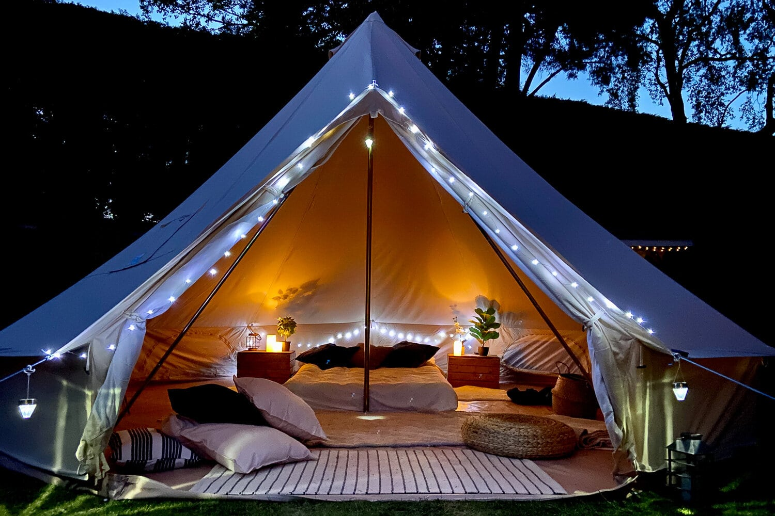

If you plan to use air mattresses, sleeping bags, or cots, make sure to account for the dimensions of these items when selecting a tent. Bell tents are known for their spacious interiors, providing ample headroom and room to move around. Love Canvas offers a variety of sizes and styles, making it easier to find a tent that meets your family's specific needs. Families who prioritize comfort will appreciate the extra space that bell tents provide, helping to create a cozy atmosphere that encourages relaxation. Weather conditions can also influence your choice of tent size. A larger tent can provide more shelter from wind and rain, making it a safer option during inclement weather. Tents equipped with canvas awnings can offer additional outdoor space for cooking or gathering while keeping the main tent area dry. When considering the weather, remember that an adequately sized tent will help your family stay comfortable, regardless of external conditions. Opting for bell tents for hire may be a wise choice for families who want to experience the advantages of a spacious tent without the commitment of purchasing one. Storage space is another essential factor in ensuring a comfortable camping experience. When camping with family, gear can quickly accumulate, leading to clutter and chaos.

Choosing a tent that offers enough room for personal belongings can minimize stress and create a more enjoyable environment. Consider incorporating storage solutions, such as hanging organizers or gear lofts, to keep the interior organized. Utilizing portable power packs can help keep devices charged, reducing the need for bulky chargers and cords that can create additional clutter. Ultimately, the goal of family camping is to bond and create lasting memories. Selecting the right tent size can significantly impact your trip’s overall enjoyment. Investing in a quality tent like those offered by Love Canvas ensures your family has a comfortable, stress-free experience. With proper planning and consideration of the factors discussed, you can create a camping experience that fosters connection and enjoyment. Family camping comfort largely depends on choosing the ideal tent size. By taking into account the number of campers, sleeping arrangements, weather considerations, and storage needs, you can select a tent that maximizes enjoyment and minimizes arguments. Options like next day delivery bell tents and canvas shelters provide quick access to quality camping solutions. By prioritizing comfort and convenience, your family can enjoy a successful camping trip filled with unforgettable moments. Embrace the great outdoors together and make lasting memories in your carefully chosen tent.