**Complete Report On AI Keynote Speakers**

AI Visionaries on stage can truly shape the success of a tech conference. Selecting the right keynote speaker artificial intelligence can bring the expertise and insights necessary to captivate the audience. However, a key component in ensuring smooth transitions and a coherent flow between ai keynote speakers is having an experienced conference moderator. The role of the moderator is vital in managing time, facilitating discussion, and guiding interactions between speakers and the audience. This ensures the audience grasps key insights, making the event not only informative but also engaging for everyone involved. An effective facilitator and moderator works behind the scenes to ensure the content flows naturally and connects the dots between diverse topics. With ai conference speakers discussing cutting-edge technology and business speakers sharing strategies, a skilled moderator can bridge these areas by asking the right questions and keeping the audience engaged. If you are looking to learn more about [ai keynote speakers](https://www.rivamedia.co.uk/artificial-intelligence-speakers/), look into the previously mentioned website.

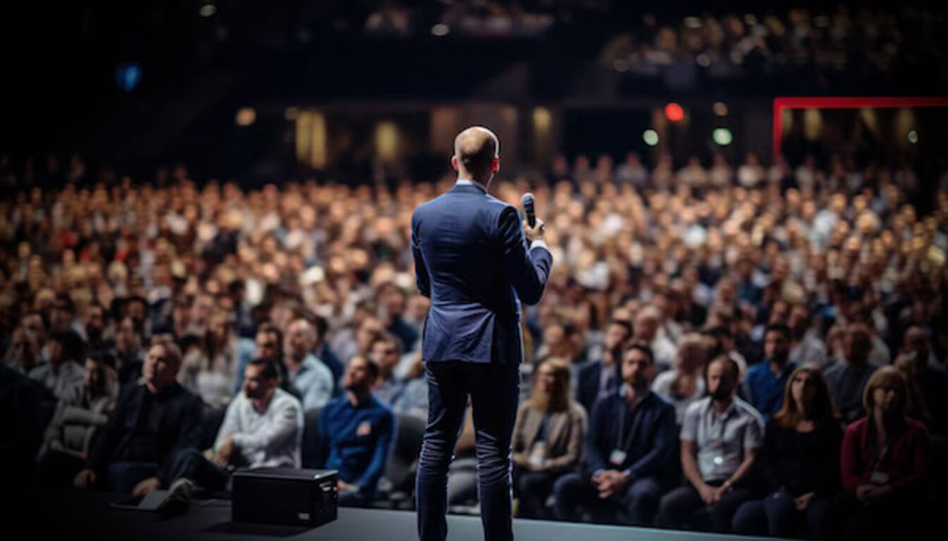

Moderators are instrumental in enhancing the delivery of the content, ensuring the audience remains captivated and focused on the key points presented. This way, the knowledge shared by inspirational business speakers is clear and impactful for everyone in attendance. Selecting a keynote speaker artificial intelligence is a decision that impacts the entire tone of the conference. These ai keynote speakers are often thought leaders, sharing insights into AI’s future potential. However, pairing them with business motivational speakers can provide a well-rounded view of how AI is influencing not just technology but the business world as well. The synergy between business keynote speakers and AI experts can be fully realized when a conference moderator seamlessly transitions between topics. This balance keeps the energy high, ensuring no information gets lost in translation and attendees gain practical, actionable insights. Incorporating sustainability keynote speakers into a tech conference introduces an important dimension, as technology increasingly intersects with environmental concerns.

When keynote speakers on sustainability share their thoughts, they provide valuable perspectives on how businesses can integrate sustainable practices into their operations. The role of a facilitator and moderator becomes even more crucial here, ensuring the diverse range of ideas from AI and sustainability fields connect in meaningful ways. By carefully managing the flow of these conversations, a moderator can help the audience see the connection between technology, business, and sustainability. Finally, the inclusion of top sustainability speakers alongside business speakers at a tech conference ensures that there is a balance between innovation and responsible growth. These speakers can offer visionary strategies for the future, but it is the moderator who ensures that these ideas are accessible and actionable for the audience. Without a skilled conference moderator, important takeaways might be lost. The ability to facilitate a discussion that touches on AI, business, and sustainability is no easy task, but it’s one that an experienced facilitator and moderator can handle, ultimately shaping the conference's success.