**Information On Vintage Dutch Furniture**

Selecting antique furniture for a modern home requires careful consideration to blend vintage charm with contemporary style. When choosing vintage furniture, focus on pieces that resonate with your taste and complement your existing decor. Antique dining chairs can be a perfect addition to a modern dining room, offering both elegance and comfort. It’s essential to understand the history and craftsmanship behind each piece to appreciate its value. Seek out antique furniture dealers who are knowledgeable and can provide insights into the origins and significance of the items they sell. When integrating antique furniture into a modern setting, balance is key. Too many antique pieces can overwhelm a space, while too few may not achieve the desired aesthetic. Start with a statement piece, like a vintage sofa or a set of dining chairs, and build around it. The goal is to create harmony between the old and the new. If you are looking to learn more about [vintage dutch furniture](https://www.louisehalldecorative.com/furniture), look at the mentioned above website.

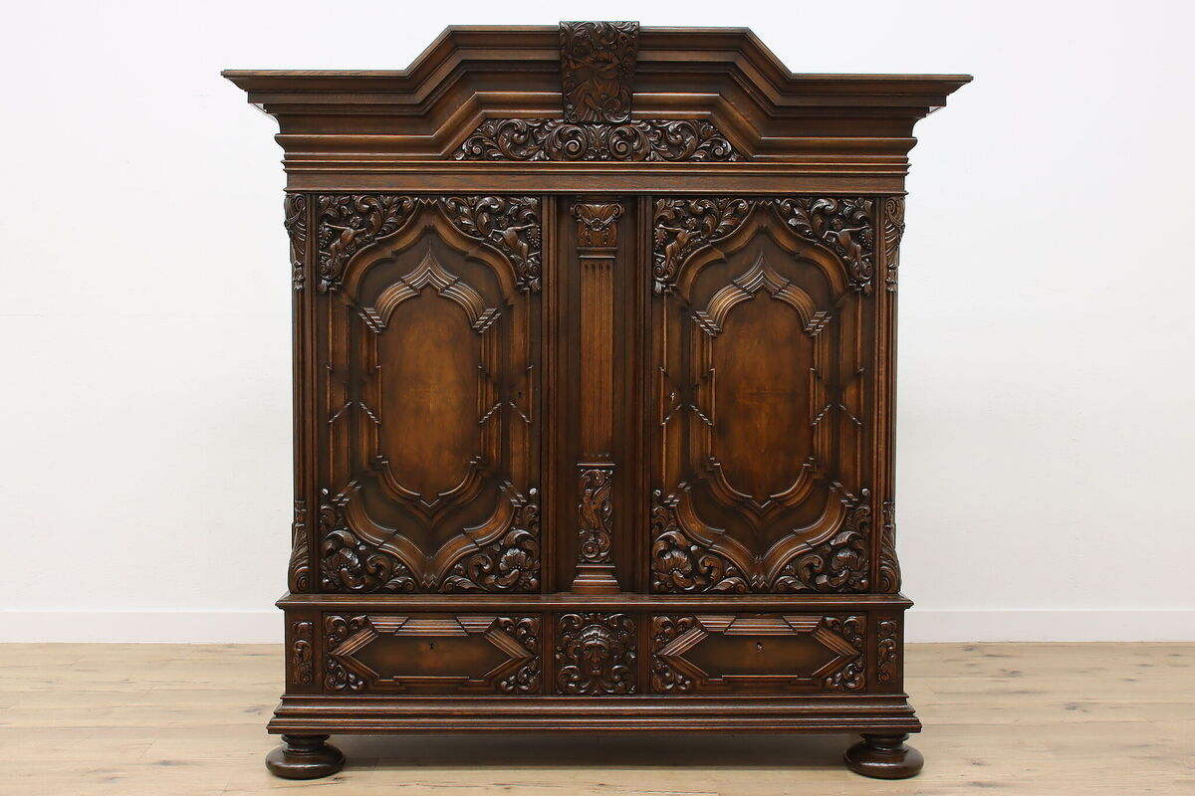

Mixing materials and textures, such as pairing a wooden antique table with sleek, modern chairs, can create a dynamic and inviting space that reflects your unique style. The condition of vintage furniture is another crucial factor to consider. While some wear and tear can add character, significant damage may require costly repairs. Inspect each piece carefully for any signs of deterioration, such as cracks, loose joints, or fading. If you're purchasing from antique furniture dealers, ask about the piece’s history and any restoration work that has been done. This information can help you make an informed decision and ensure that the antique furniture you select will stand the test of time in your home. Incorporating antique furniture into a modern home also involves understanding its functionality. While these pieces are often admired for their beauty, they must also serve a practical purpose. For example, dining chairs should be comfortable and sturdy, especially if they are used daily. Consider the space available in your home and choose vintage furniture that fits proportionately.

A large antique wardrobe might be stunning, but it could overwhelm a small room. Ensuring that each piece is both functional and visually appealing is essential for creating a cohesive and livable space. Finding reputable antique furniture dealers is essential to acquiring quality pieces. These dealers often have a deep understanding of vintage furniture and can guide you in making selections that suit your home and style preferences. They can also help you avoid common pitfalls, such as purchasing reproductions or overpriced items. Building a relationship with a trusted dealer can provide access to a wider selection of antique furniture and the opportunity to learn more about the history and craftsmanship of each piece, enhancing your appreciation and enjoyment of your collection. Finally, consider the emotional and historical significance of antique furniture. Each piece tells a story and adds a layer of history to your home. Whether it’s a set of dining chairs passed down through generations or a vintage chest of drawers with intricate carvings, these items connect us to the past. By carefully selecting and incorporating vintage furniture into your modern home, you create a space that is not only beautiful but also rich with meaning and history, offering timeless treasures that will be cherished for years to come.