**Information On Venue Hire**

When planning an event, one of the most important steps is selecting the right venues. Whether it's a wedding, corporate event, or social gathering, the choice of the event venue can make or break the experience. A well-chosen location will set the tone for the entire event. To ensure you make the best decision, there are some essential questions you should ask. Doing so will help clarify the details and avoid any surprises down the road. Before signing any contracts, take the time to ask questions about accessibility, amenities, and capacity. When considering a venue hire, it's crucial to understand the available amenities. Some wedding venues offer a range of services such as catering, lighting, and décor, while others may simply provide the space. It's important to ask what is included in the cost of venue hire and whether there are any additional fees. If you are seeking for additional info on [venues in watford to hire](https://www.metropolitanbushey.co.uk/), explore the mentioned above website.

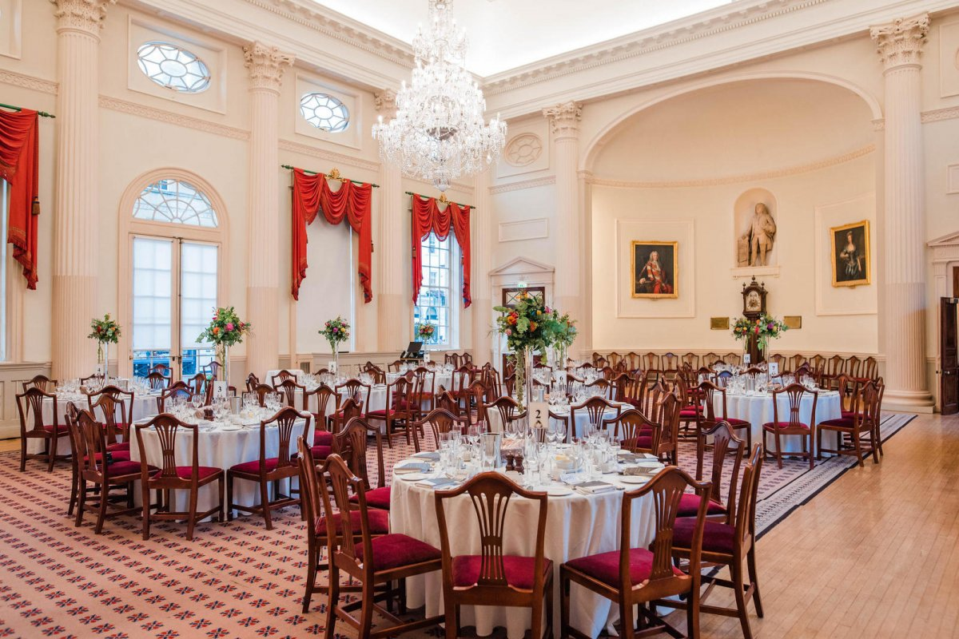

You’ll want to find out if the venue provides on-site staff to assist with setup and breakdown, and whether you are allowed to bring in external vendors. Understanding these details ahead of time will help you better manage your budget and avoid unexpected costs. Capacity is another critical factor when choosing an event venue. Always ask about the maximum number of guests the venue can accommodate. It’s not just about fitting everyone into the space but also ensuring that your guests will be comfortable. Whether you're hosting a wedding or considering sports ground hire, the capacity of the venue for sports or any other type of event must be considered. Fire safety regulations may also limit the number of people that can be accommodated. Ensure you know how many people the venue can legally and comfortably hold. Accessibility is another aspect you can’t afford to overlook when selecting a venue. Ask whether the venue is easily reachable for your guests, especially if you are considering more remote venues like country houses or specialized wedding venues. For sporting events, sports ground hire should have ample parking and be easy to locate.

If you are renting a pub for an intimate gathering, think about public transportation options and whether the pub offers private rooms for events. Accessibility will directly impact how smoothly your event runs and how satisfied your guests will be. Lastly, think about the venue’s flexibility in terms of scheduling and setup. Some venues may have strict hours for setup and teardown, which can complicate your plans. Ask if there is flexibility in accessing the space before your event for setting up and afterward for cleaning up. In addition, if you’re booking a venue for sports, make sure you clarify whether there are any time restrictions on the use of the space. Flexibility can be a game-changer when coordinating different vendors and elements for the event, so make sure to understand the venue's policies. By asking the right questions about the venue hire process, you can ensure a smooth and successful event. From event venues to sports ground hire, knowing what to expect helps you avoid surprises and make informed decisions. Ensure you cover the basics like capacity, amenities, and accessibility, and always clarify the venue's policies on scheduling and fees. Being thorough in your planning will save time, money, and stress, allowing you to focus on creating a memorable experience for your guests.