**Information On Outdoor Stage Hire**

When planning an outdoor event, unpredictable weather can be a significant challenge. It’s essential to prepare for all conditions to ensure your event runs smoothly. Event production services play a crucial role in helping you navigate these uncertainties. By working with an experienced event production company, you can safeguard your event against rain, wind, or heat. From securing the right stage hire to having contingency plans, experts in the field know how to adapt quickly to any situation. Proper preparation ensures that your event remains enjoyable, even in less-than-ideal weather conditions. A reliable event production company can provide the necessary resources to ensure your stage and equipment are protected. Outdoor events require sturdy setups that can withstand wind and rain, which makes outdoor stage hire a must. Go to the following site, if you are seeking for more details concerning [outdoor stage hire](https://www.justsmile.co.uk/outdoor-stage-hire/).

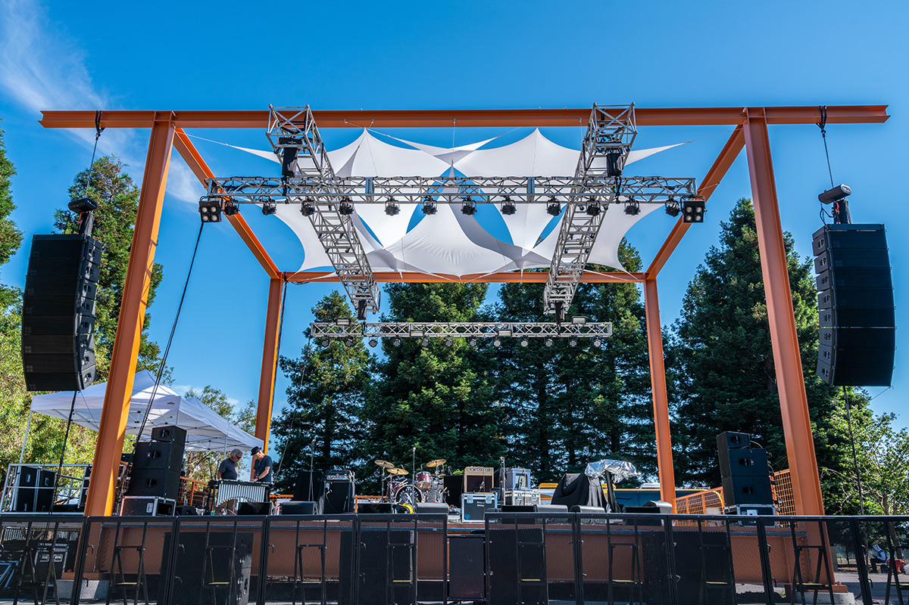

It’s vital to choose stages built for all weather, with secure roofing and flooring to keep both performers and equipment safe. Event production companies will typically also recommend waterproof coverings for the av equipment hire, ensuring that sound and lighting equipment remain operational despite any moisture or rain. Planning ahead minimizes the risk of technical difficulties or delays. Lighting is another critical element of outdoor events, and you should always prioritize lighting hire options suited for outdoor conditions. Party lights hire is an excellent way to create ambiance, but more importantly, weatherproof lighting hire ensures that your event remains well-lit, even during unexpected weather changes. For weddings or more elegant events, wedding lighting can add a touch of class, but it's vital to ensure the lights are waterproof and safely installed. Proper lighting not only enhances the atmosphere but also ensures visibility and safety for all guests.

Audio-visual needs should never be overlooked, and av hire is an integral part of any successful event. A good av production team will have backup plans for power outages or equipment malfunctions caused by weather. Ensuring that your av equipment hire includes weatherproofing measures, such as covers or housing for speakers and microphones, will keep the show running even in adverse conditions. Professionals specializing in av production know how to protect their equipment and keep the event's sound and visual quality intact, regardless of the weather. In conclusion, planning for weather contingencies is crucial for any outdoor event. Event production services offered by experienced event production companies will help you prepare for all scenarios. From sturdy outdoor stage hire to reliable lighting hire and careful av hire, professionals can protect your event from disaster. By choosing the right stage hire, av equipment hire, and making smart decisions about wedding lighting and party lights hire, you can ensure your event is a success, rain or shine. Careful planning and professional support will weatherproof your event, leaving your guests with an unforgettable experience.