**Information On Lifeboat Services**

In the world of maritime safety, lifeboats play an essential role in ensuring the survival of crew members and passengers during emergencies. A well-designed emergency life boat can make the difference between life and death in a crisis. Whether on a cruise ship or an offshore rig, having reliable lifeboats is critical for overall safety. Each lifeboat manufacturer must adhere to strict safety standards, ensuring that these vessels are durable, easy to deploy, and capable of withstanding harsh sea conditions. Regular lifeboat load testing is necessary to maintain operational readiness and ensure that all equipment functions properly under stress. For offshore facilities like oil rigs, having specialized lifeboats is even more crucial. Many companies opt for an oil rig lifeboat for sale when outfitting their platforms with safety equipment. These lifeboats are designed to handle extreme conditions and provide rapid evacuation options for crew members in dangerous situations. Lifeboat manufacturers offer a range of models to meet different safety requirements, and each must undergo rigorous testing to ensure its effectiveness. Go to the following site, if you are seeking for more details concerning [lifeboats](https://www.survivalsystemsinternational.com/uk/).

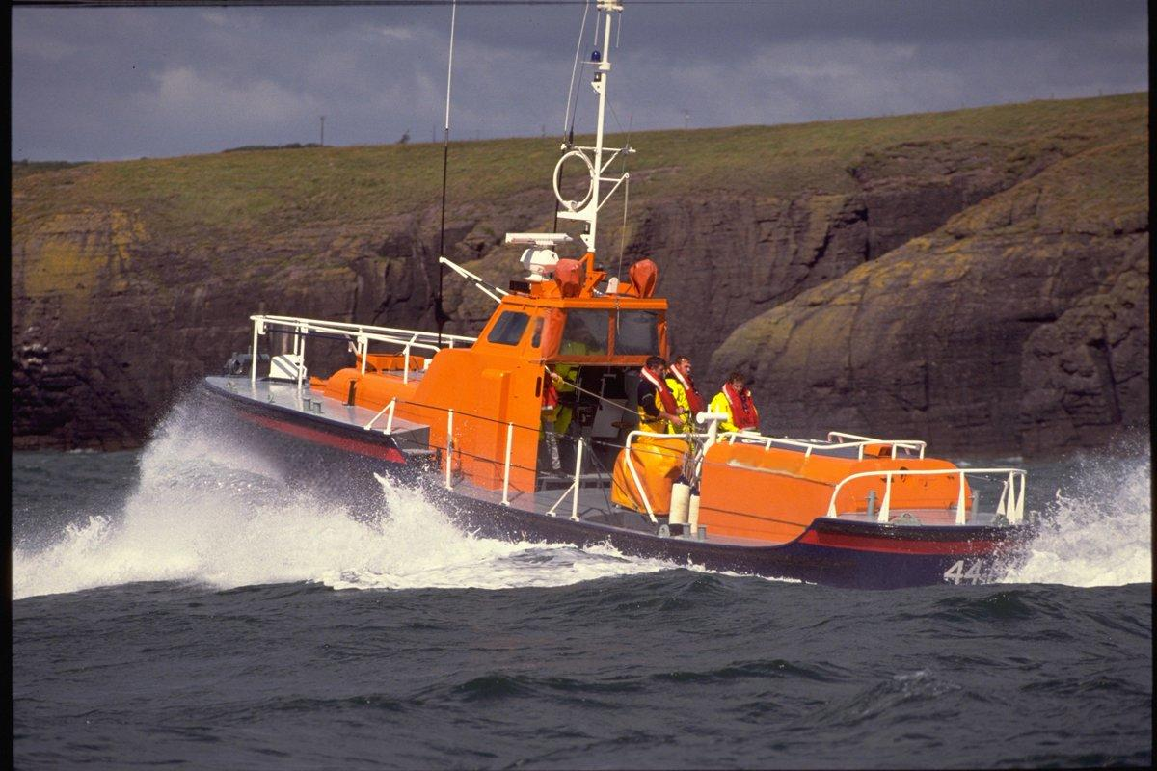

Additionally, finding a lifeboat for sale that meets the specific needs of an offshore facility can significantly enhance the safety measures already in place. Beyond traditional lifeboats, there are other safety options like the offshore life raft and the inflatable survival raft, which are both essential for smaller vessels or emergencies where launching a full-sized lifeboat may not be feasible. These rafts are compact, easy to deploy, and provide adequate safety in short-term emergency situations. An emergency life raft for sale is an excellent investment for those looking to upgrade their maritime safety equipment. Regular inspection and maintenance are crucial, ensuring that these rafts are in good condition and ready for immediate use when needed. For those in the market for lifeboats or rafts, a variety of life boats for sale are available to suit different vessel types and safety requirements. Purchasing from a reputable lifeboat company ensures that the equipment meets international safety standards and can be relied upon during emergencies. Whether buying new or used, it’s essential to verify that the lifeboat manufacturer adheres to stringent testing protocols.

This can provide peace of mind, knowing that the equipment will perform as expected when the need arises. Proper training on lifeboat operation and deployment is equally important in maximizing the effectiveness of the equipment. In addition to purchasing, lifeboat load testing is a critical part of maintaining the safety and functionality of your maritime safety equipment. These tests simulate the weight and stress that lifeboats would encounter during an actual emergency, ensuring that they are capable of handling the full capacity of passengers and crew. Regular load testing, conducted by professionals, helps identify any potential issues with the lifeboat’s structural integrity or operational mechanisms, allowing for timely repairs or replacements. This level of preparedness is vital in safeguarding lives during maritime emergencies. In conclusion, ensuring that your vessel is equipped with reliable lifeboats and rafts is a vital aspect of maritime safety. From sourcing a high-quality lifeboat for sale to conducting regular lifeboat load testing, each step contributes to the overall safety of the crew and passengers. Whether you’re purchasing an oil rig lifeboat for sale or an emergency life raft for sale, investing in high-quality safety equipment is essential. Collaborating with a trusted lifeboat company ensures that all equipment meets safety standards and provides the necessary protection in emergency situations.