**Information On Groundworks Services**

Building strong foundations is crucial for the stability and longevity of any construction project. In domestic groundworks, the role of groundworkers is pivotal, as they ensure that the groundwork is laid correctly, setting the stage for a solid and safe structure. The meticulous planning and execution involved in civil engineering groundworks are fundamental to creating homes that will stand the test of time. These professionals work with precision, understanding the terrain, and applying their expertise to develop a base that supports the entire building, making sure that the structure above can withstand various pressures. In addition to ensuring the stability of homes, domestic groundworks also contribute significantly to the future functionality of the property. Civil engineering is not only about creating a strong foundation but also about integrating necessary services like drainage systems and highways access. If you're looking for more information on [manchester groundworks](https://yatesgroundworks.com/services/groundworks/), look into the previously mentioned site.

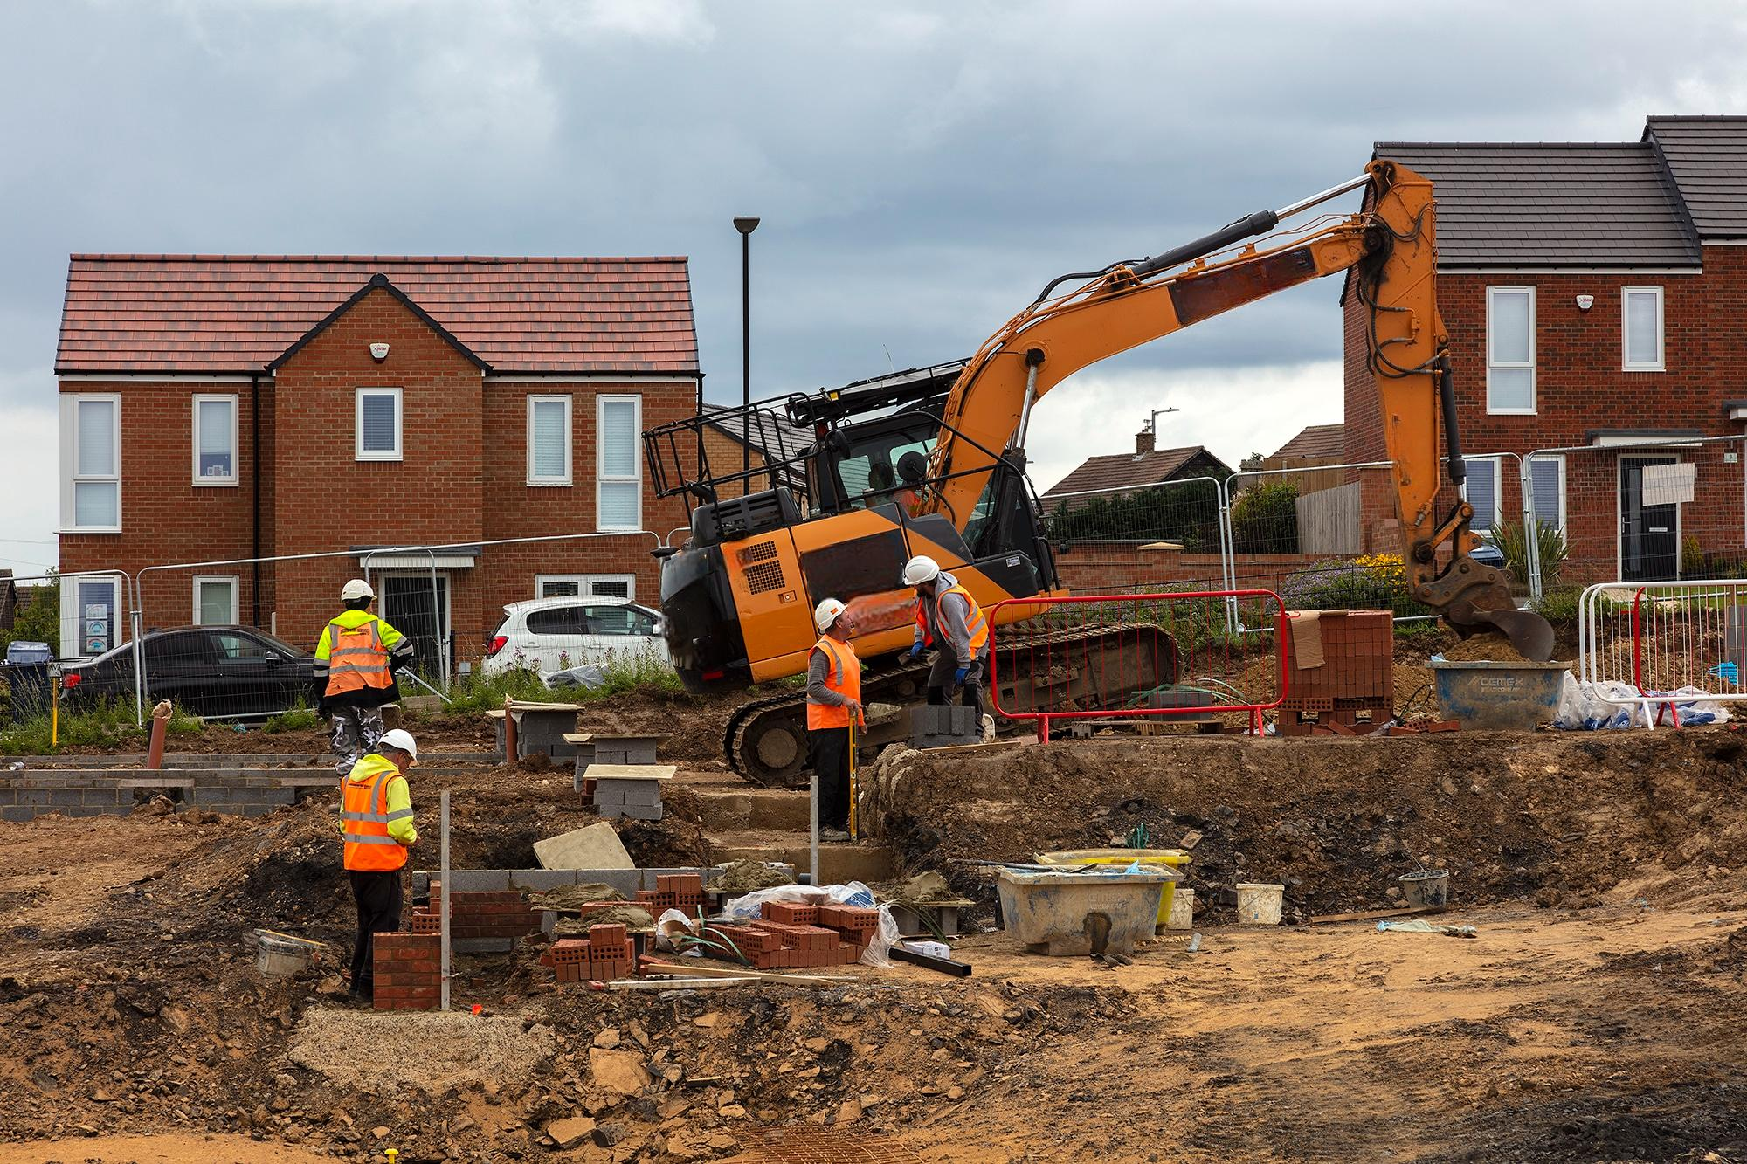

A drainage specialist plays a crucial role in designing and installing systems that prevent water damage, ensuring the home remains dry and safe. Proper drainage is essential, as it protects the integrity of the foundation and prevents issues like flooding, which can compromise the structure. The work of groundworkers extends beyond just the initial construction phase. Their expertise is also essential in planning for the future expansion of homes. Civil engineering groundworks are designed with foresight, allowing for potential modifications or extensions to the property. This forward-thinking approach ensures that any future developments on the property can be seamlessly integrated with the existing structure. Groundworkers are skilled in preparing the site for such possibilities, ensuring that the groundwork is not only strong but also adaptable to future needs. Highways and access roads are another critical aspect of domestic groundworks. Properly designed and constructed highways ensure that homes are easily accessible, which is vital for both residents and emergency services. Civil engineering in this context involves careful planning and collaboration with other professionals to create access routes that are safe and durable.

The inclusion of well-planned highways enhances the overall value and functionality of the property, making it more attractive to potential buyers and ensuring that it meets all necessary safety standards. The role of a drainage specialist cannot be overstated, as they are responsible for preventing water-related issues that can arise after construction. Proper drainage systems are essential for maintaining the health of the foundation and preventing costly repairs down the line. By integrating effective drainage solutions into the domestic groundworks, these specialists ensure that the home remains protected from water damage, which can significantly affect the structural integrity. Their work is a testament to the importance of thorough planning and execution in the early stages of construction. In conclusion, domestic groundworks are the backbone of any construction project, providing the necessary support for the entire structure. Groundworkers and civil engineering professionals work together to create foundations that are not only strong but also adaptable to future needs. The integration of drainage systems and highways access further enhances the functionality and safety of the property. As we look towards the future, the importance of civil engineering groundworks in shaping the homes of tomorrow cannot be overlooked. Their work ensures that homes are built to last, with the flexibility to adapt to the changing needs of the future.