**Information On CBD Skin Care**

The integration of full spectrum CBD into skincare routines is becoming increasingly popular for its potential benefits. CBD skin care brands are leveraging the natural properties of full spectrum CBD oil to offer products designed to enhance skin radiance. Unlike isolated CBD, full spectrum CBD contains a range of cannabinoids, terpenes, and other beneficial compounds, which may work synergistically to promote skin health. For those interested in exploring cbd skin cream products, choosing items from reputable cbd wellness stores can ensure quality and effectiveness. These products often highlight their use of full spectrum CBD for comprehensive skin benefits. CBD oil and drops are commonly used for various wellness purposes, including skin care. The versatility of CBD oil drops allows users to incorporate them into their daily routines in multiple ways, from adding them to moisturizers to using them directly. Are you hunting for [cbd skin care uk](https://www.doctorvoss.co.uk/collections/cbd-skincare)? View the before talked about site.

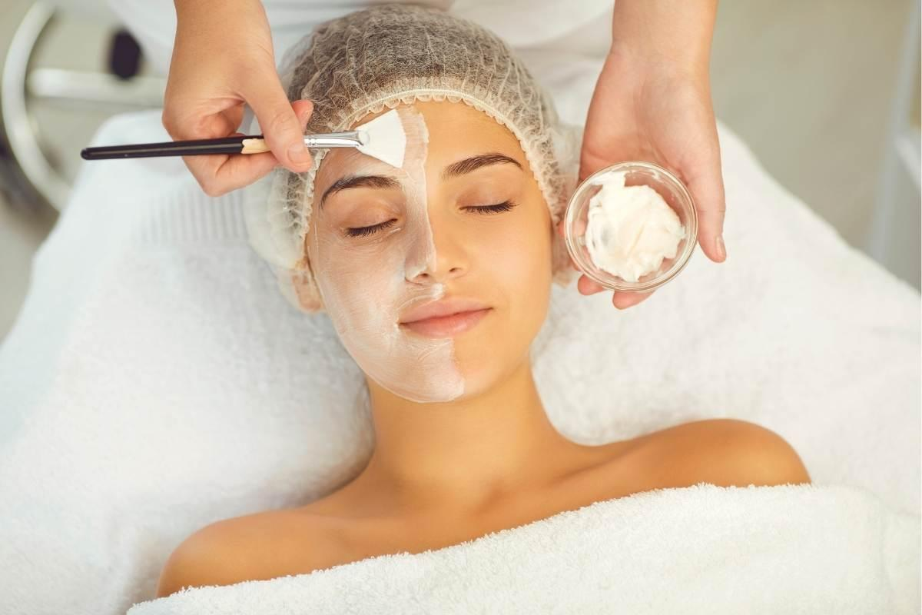

CBD oil drops for sleep and cbd oil for sleep are also popular, as they are believed to help with relaxation and improving sleep quality. However, for those specifically targeting skin health, products containing full spectrum CBD may offer additional benefits. The use of CBD skin care brands ensures that users can access targeted solutions for radiant skin. When purchasing full spectrum CBD products, it's essential to consider quality and source. Opting to buy CBD oil online from trusted vendors can provide access to high-quality wellness CBD products. Ensure that the products are tested for purity and potency, and check for third-party lab results when available. CBD wellness products from reputable sources often come with detailed information about their ingredients and the concentration of full spectrum CBD oil, helping consumers make informed choices. Understanding how to navigate the selection of CBD wellness stores can lead to better skincare results.

Incorporating cbd oil and drops into your skincare regimen can also complement the benefits of full spectrum CBD for sleep. Products designed to improve sleep may contain specific formulations that promote relaxation and help with insomnia. These cbd oil drops for sleep can be used in conjunction with CBD skin care brands to address both sleep and skin health concerns. By focusing on both internal wellness and external skin care, users can achieve a holistic approach to improving their overall well-being and appearance. Overall, the use of full spectrum CBD in skincare and wellness is an evolving field. CBD skin care brands are increasingly incorporating CBD skin cream products into their offerings, highlighting the benefits of full spectrum CBD oil. For those interested in cbd wellness products, ensuring that the products are from reputable sources is crucial. CBD oil and drops can be part of a comprehensive approach to wellness, addressing both skin health and sleep quality. As the market for wellness CBD continues to grow, staying informed about product quality and effectiveness will be key to unlocking the full potential of these innovative treatments.