**Individual Guide On Gift Hampers**

Personalized Christmas hampers are a thoughtful way to spread joy during the holiday season. Curating christmas hampers requires attention to detail, ensuring each item resonates with the recipient's tastes. One popular approach is to include gourmet items, such as cheese hampers and food hamper gifts, which offer a delicious experience. Including a variety of cheeses, crackers, and perhaps a bottle of wine, these hampers are perfect for food enthusiasts. Selecting items that complement each other enhances the overall experience, making the hamper a memorable gift. Creative christmas hamper ideas can transform a simple gift into something truly special. For instance, crafting a cheese and wine hamper gift allows you to combine fine cheeses with a carefully chosen bottle of wine, creating an indulgent treat. Personal touches, such as adding the recipient’s favorite snacks or a handwritten note, can make the hamper even more meaningful. Go to the following site, if you're searching for more information on [hamper gifts](https://www.hampergifts.co.uk/).

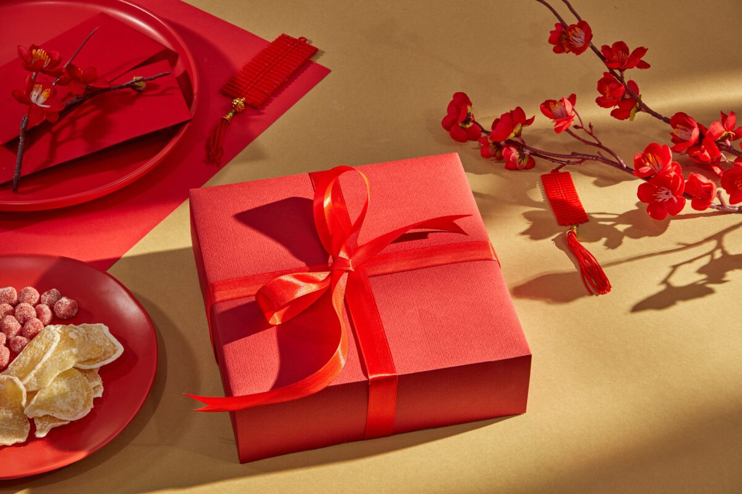

The key is to mix luxury with thoughtfulness, ensuring the hamper reflects the recipient’s preferences and adds a touch of festive cheer to their holiday celebrations. Beyond Christmas, hampers also make excellent gifts for other occasions. For example, birthday hampers for her can be customized with items that cater to the recipient’s tastes. Including gourmet foods, skincare products, or scented candles can create a luxurious experience. Similarly, cheese food hampers can be tailored to include the recipient’s favorite cheeses, paired with artisanal crackers and a bottle of wine. The versatility of hampers allows them to be personalized for any celebration, making them a popular gift choice throughout the year. When selecting items for a hamper, it's essential to consider the recipient's preferences. A well-curated cheese hamper gift might include a selection of hard and soft cheeses, paired with accompaniments like olives or chutneys. For those who enjoy a more indulgent experience, cheese and wine hampers offer a sophisticated touch.

The combination of rich cheeses and fine wine can create a luxurious experience that appeals to the senses, making the hamper a perfect gift for any occasion. Ensuring the items complement each other is key to crafting the perfect hamper. Finally, the presentation of the hamper plays a crucial role in its impact. Carefully arranging the items in a visually appealing manner can elevate the overall experience. Food hampers should be packed with care, ensuring that delicate items like cheeses or chocolates are protected. Adding decorative elements, such as ribbons or holiday-themed ornaments, can enhance the festive feel of christmas hampers. The effort put into the presentation reflects the thoughtfulness behind the gift, making it a memorable and cherished present that leaves a lasting impression on the recipient. Personalized hampers offer a unique way to express appreciation and love during the holiday season and beyond. Whether you're crafting christmas hampers, birthday hampers for her, or cheese food hampers, the key is to select items that resonate with the recipient and arrange them thoughtfully. By doing so, you create not just a gift, but an experience that delights the senses and brings joy to the heart.