**Individual Guide On Ear Piercing**

Body modifications have become increasingly popular, with ear gauges being a common trend. Whether you're new to this journey or already familiar, it's important to understand the basics of earring gauges. These accessories allow individuals to stretch their earlobes gradually, creating a unique and personalized look. Gauge earrings come in various sizes, which is crucial for those who want to safely stretch their ears. Starting with small sizes is recommended, and over time, you can increase the gauge size. This ensures the process is both safe and comfortable, making your journey through gauges more enjoyable. When exploring gauges piercing, it's essential to choose the right type of jewellery. Plugs earrings are a popular option, as they sit snugly in the stretched lobe and come in various materials, such as stainless steel, wood, or acrylic. It's important to research and find the most comfortable type for your ears. Additionally, cleaning and maintaining the jewellery is critical to prevent infections. Are you hunting about [body jewellery shop](https://www.stretchitbodyjewellery.co.uk/collections/body-jewellery)? Look at the before talked about site.

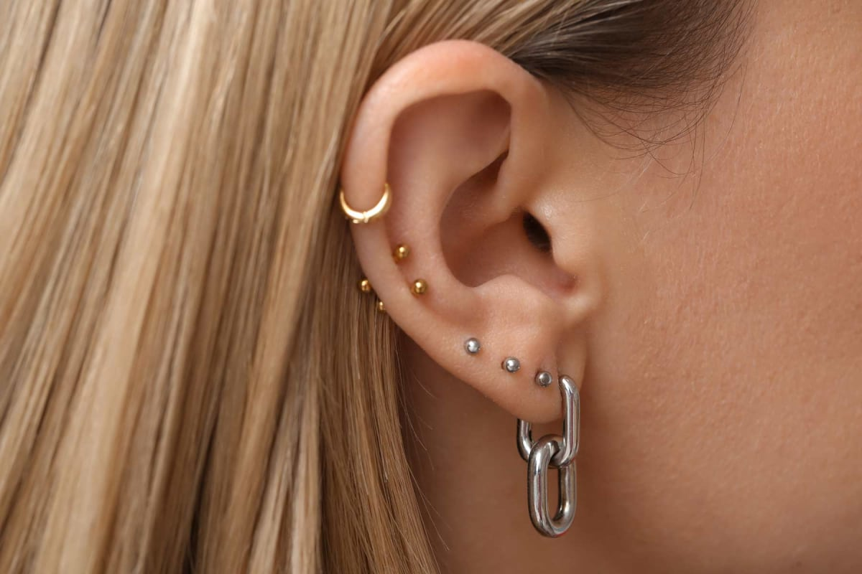

Many people find that gauge plugs provide a stylish and bold look, allowing for self-expression and individuality through body modification. Understanding the process of gauge ear piercing is crucial for beginners. One of the first steps is to consult an ear stretching guide. This will provide detailed instructions on how to stretch your ears safely and effectively. The guide can also help with determining the appropriate starting size and how to incrementally move up in gauge size. Stretching your ears too quickly can lead to complications such as tearing or infections, so patience is key in this process. Taking your time ensures that your ears heal properly and the stretching remains painless. For those wondering how to stretch ears, visiting a professional piercer or a reputable body jewellery shop is highly recommended. These shops not only sell high-quality jewellery but also offer expert advice on safe stretching techniques. They will also provide an ear stretching size guide to help you choose the correct sizes as you progress through your ear stretching journey.

Having a professional guide you through the process ensures you're doing everything correctly and reducing the risk of damage to your earlobes. As your ears stretch, you may decide to experiment with different types of body modifications. Body jewellery offers a variety of options beyond just gauge plugs, including tunnels, spirals, and more. Each piece adds a unique touch to your look, allowing for endless creativity. You can also explore custom designs through services like etching-guide, giving you the opportunity to personalize your plugs. With so many options available, the world of body jewellery can be exciting, offering a wide range of choices to suit your personal style. Finally, patience is the most important aspect of the ear stretching process. By following the advice found in an ear stretching guide and regularly consulting your ear stretching size guide, you’ll be able to stretch your ears safely. It's important to note that the size of gauge earrings should be increased gradually. Whether you're just starting with your first gauges piercing or you're an experienced enthusiast, the key to success lies in taking it slow. As you continue your journey, remember that every stretch brings you closer to your desired look.