**Dog Jackets - Find The Simple Facts About Them**

A waterproof dog jacket is essential for keeping your dog healthy during wet and cold weather. While we love outdoor adventures with our dogs, the rain and dampness can turn a fun outing into a potential health risk. Wet fur can make dogs vulnerable to illnesses like hypothermia, especially smaller breeds or those with short fur. Investing in a quality dog rain jacket protects them from moisture, keeping their body temperature regulated. During long walks in unpredictable weather, a waterproof dog jacket ensures your pet stays dry, preventing illnesses that could otherwise occur from prolonged exposure to wet conditions. For dogs like dachshunds, finding the right fit is important. Dachshund coats and dog coats for dachshunds are designed specifically to suit their body shape. This ensures that they get full coverage while still being comfortable enough to move freely. A properly fitted dog rain jacket can prevent rain from soaking into their skin, keeping them warm even in cold, windy weather. If you are seeking for additional details on [dog jackets](https://www.doggiecoats.co.uk/), look at the mentioned above website.

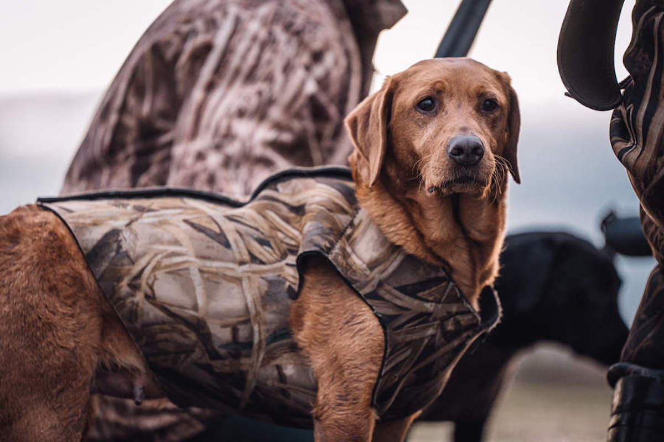

Smaller dogs like dachshunds are especially vulnerable to the cold, making mini dachshund jackets a great investment to ensure they stay protected during rain or damp conditions. If your dog enjoys playing in puddles or running through wet grass, a dog rain suit offers even more protection. These suits, especially the full-body dog rain suit, cover your dog from head to tail, shielding them from water and mud. A dog waterproof suit made from breathable, waterproof material allows your dog to stay dry while still moving comfortably. With the right dog rain coat, cleanup after a walk becomes much easier since the mud and water stay on the jacket rather than on your dog’s fur. This makes a rainproof dog coat perfect for keeping both your dog and your home cleaner after those rainy-day adventures. Beyond daily walks, dog rain coats are also essential if you live in areas with frequent rain or if you love outdoor activities. Having a sturdy waterproof dog jacket means your dog can join you on hikes, beach trips, or long walks in any weather. Dog coats with legs are a great option for more comprehensive protection, especially for dogs that tend to get cold easily. These coats not only keep their body warm and dry but also provide protection against mud and dirt. A dog rain coat is essential for active dogs who spend time outdoors year-round.

For pet owners, the convenience of a waterproof dog jacket cannot be understated. Not only does it protect your dog, but it also makes post-walk cleaning faster and easier. The all-in-one dog suit waterproof is particularly handy for this. By keeping their legs and body covered, you reduce the amount of dirt and water they bring home. This makes your life easier while ensuring your dog stays dry and comfortable. Whether it’s a rainy walk or an outdoor adventure, a dog waterproof suit offers both peace of mind and protection for your pet. In conclusion, dog rain jackets are an essential part of any dog owner’s toolkit, especially for those living in areas with frequent rain. Whether it’s a dog rain suit, mini dachshund jackets, or dachshund coats, the right waterproof gear keeps your pet comfortable and safe. Investing in dog coats with legs or a dog rain suit provides your dog with the best protection against wet weather. Ultimately, a waterproof dog jacket allows your dog to enjoy the outdoors without compromising their health, ensuring you can share more adventures together, no matter the weather.