**Advantages Of Print And Design Service**

In today’s competitive market, businesses need to stand out, and effective advertising is crucial. One way to elevate your brand’s visibility is through printing high-quality promotional materials. From vehicle signwriting to business banners, the right print solutions can make a significant impact. Whether you're promoting an event or a product, working with a professional print shop ensures that your designs are translated into eye-catching displays. The goal is to communicate your brand's message clearly and attractively, leaving a lasting impression on your audience. By focusing on quality and creativity, your advertising efforts can truly pay off. One of the most effective ways to promote your business is through vehicle graphics. Many companies use van sign writing to turn their vehicles into mobile billboards, reaching a wide audience daily. Vehicle signwriting design allows businesses to showcase their logo, slogan, and contact details in a visually appealing way. Are you searching for [hemel printers](https://gtprintanddesign.co.uk/)? View the previously talked about site.

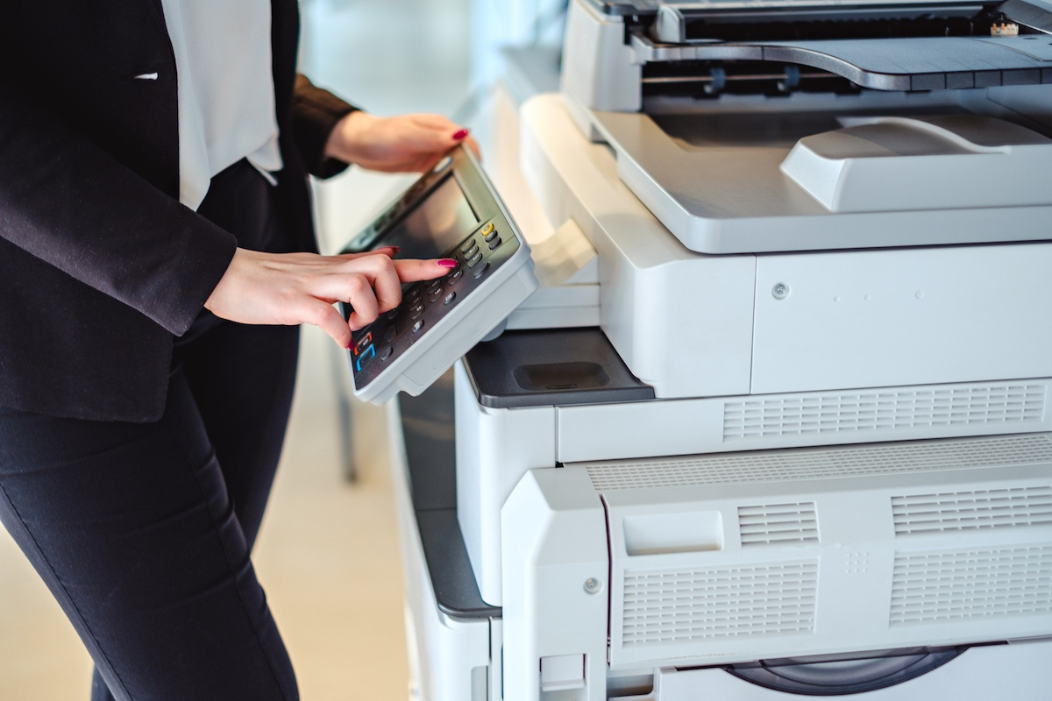

Whether you're on the move or parked, the branding on your vehicle remains visible, making it a cost-effective advertising method. Additionally, investing in custom vehicle graphics not only increases brand recognition but also builds credibility and professionalism for your business. Aside from mobile advertising, businesses can benefit from using pvc advertising banners. These durable and versatile business banners are perfect for outdoor and indoor events, offering great visibility for promotions, sales, and other announcements. A pvc banner roll can be customized to suit your brand’s style, ensuring that the message is bold and clear. The durability of pvc advertising banners makes them a popular choice for long-term use, especially in high-traffic areas. Whether it’s for trade shows, grand openings, or community events, a well-designed banner can help capture the attention of potential customers. For businesses that require more traditional materials, document printing plays a vital role. Document printing services can handle a wide range of needs, from brochures and flyers to important contracts and reports. By working with a reliable print shop, companies can ensure that their documents are professionally produced and tailored to their specifications. The quality of printed materials reflects your brand's professionalism, which is why choosing the right document printing services is essential.

Whether it's for internal use or client-facing materials, quality printing makes a difference in how your business is perceived. Lastly, integrating both mobile and stationary advertising solutions can help maximize your reach. Utilizing vehicle signwriting alongside pvc advertising banners ensures your brand is visible in multiple formats. While van sign writing covers your on-the-go promotional needs, banners can provide a strong presence at events, storefronts, or in strategic locations. By combining these advertising methods, you create a cohesive and far-reaching campaign that can capture various audiences. From mobile visibility to attention-grabbing displays, these tools offer businesses flexible and impactful advertising solutions that can significantly boost brand awareness. In conclusion, effective advertising requires a mix of creativity and the right tools. From vehicle graphics to document printing, businesses have a wide array of options to choose from. Working with a professional print shop ensures that every element, from van sign writing to pvc advertising banners, is of the highest quality. By incorporating these tools into your marketing strategy, you can elevate your brand and leave a lasting impact on your audience. Whether it’s through mobile advertisements or durable banners, the right printing solutions can take your business to the next level.