**Venue Hire - An Introduction**

Transforming a sports venue into the perfect location for your big day is a trend that's gaining traction for all the right reasons. Choosing a venue for sports as your wedding setting can be a unique and exciting way to celebrate. These wedding venues offer expansive spaces that can easily accommodate both your ceremony and reception, providing ample room for all your guests. The flexibility of sports facilities means you can tailor the space to suit your theme, whether you’re aiming for a grand, elegant affair or a casual, laid-back celebration. This blend of functionality and charm makes sports venues an ideal choice for modern couples. One of the significant advantages of opting for sports club venue hire is the variety of options available. Many venues in hire can be transformed into stunning wedding backdrops, offering both indoor and outdoor spaces. This versatility is perfect for couples who want to incorporate their love of sports into their special day or simply appreciate the practicality and size of these locations. If you're searching to learn more about [venues in watford to hire](https://www.metropolitanbushey.co.uk/), visit the above site.

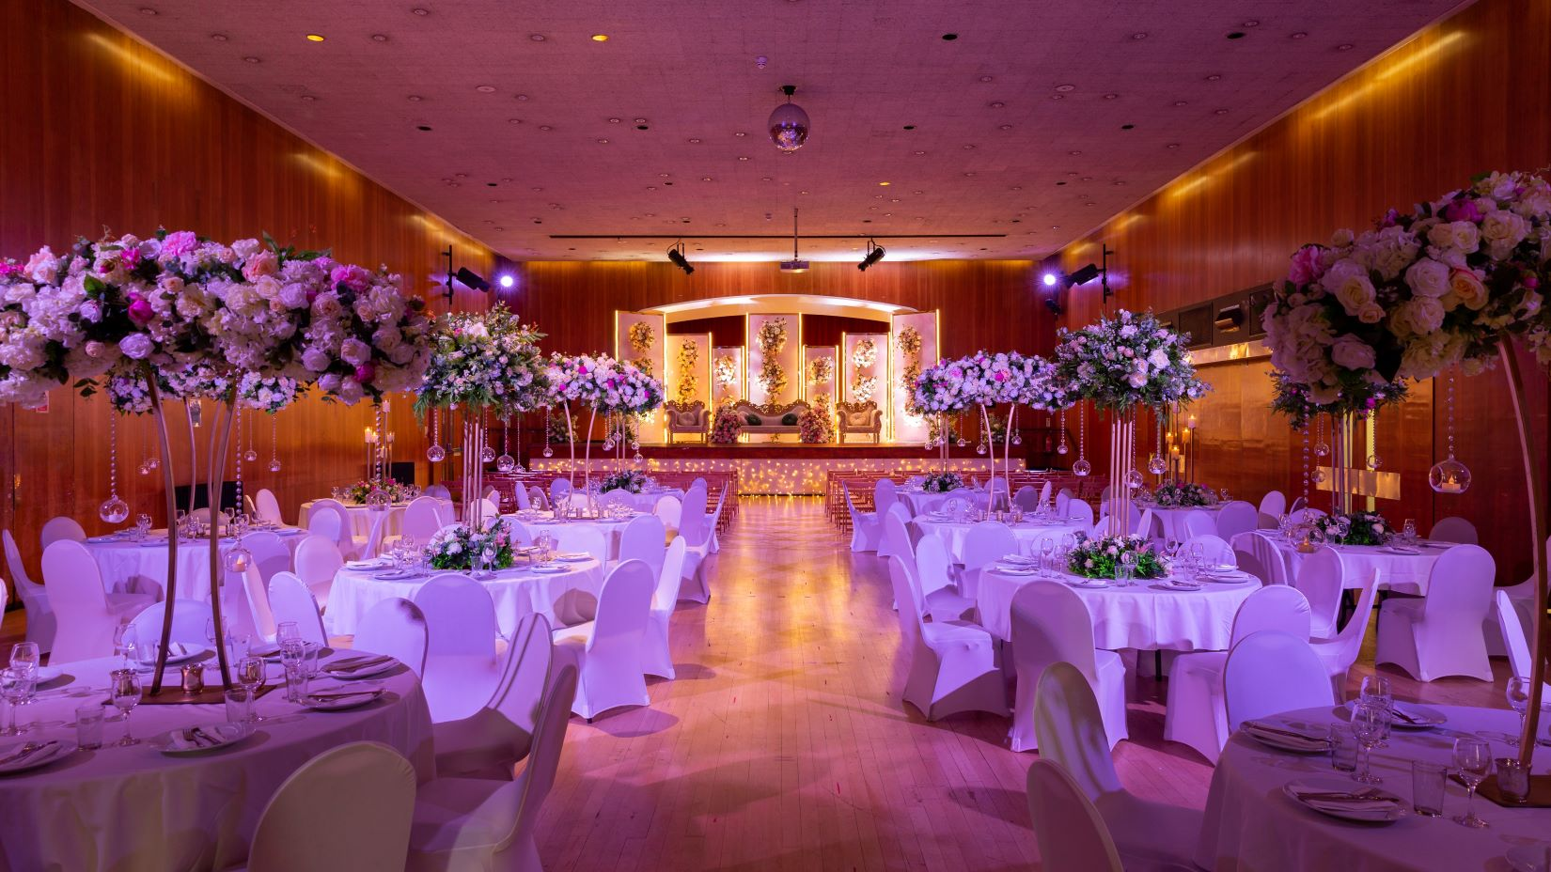

With the right decorations and planning, a venue for sports can rival any traditional event venue in terms of atmosphere and style. Plus, the added bonus of on-site facilities and ample parking makes it convenient for guests. When selecting a venue for sports, it's essential to consider the wedding venue packages available. These packages often include everything you need to create a seamless event, from catering options to décor and entertainment. Some sports facilities even offer the added perk of having a dedicated event planner on hand to help coordinate your day. This can be particularly beneficial if you’re looking to simplify the planning process. By choosing sports club venue hire, you’re not just securing a location; you’re investing in a complete, hassle-free wedding experience that caters to all your needs. Accessibility is another key benefit of choosing a venue for sports. Many wedding venues located within sports complexes are easily accessible from major roads and public transportation, making it easy for your guests to attend. For those looking to add a touch of local flavor, considering pubs near Bushey as part of your wedding itinerary can be a great way to enhance the overall experience.

These pubs offer a charming, intimate setting for pre-wedding gatherings or post-ceremony celebrations, adding to the uniqueness of your event. Finally, the affordability of sports club venue hire is something to consider, especially for couples on a budget. These venues in hire often offer competitive pricing compared to more traditional wedding venues, allowing you to allocate more of your budget toward other aspects of your big day. By choosing a venue for sports, you can enjoy the benefits of a large, flexible space without the hefty price tag. This makes it possible to create a memorable, stylish wedding that reflects your personality and love story without compromising on quality. In conclusion, opting for a venue for sports as your wedding location can be a game-changer in many ways. From the flexibility of sports facilities to the convenience and affordability of sports club venue hire, these spaces offer everything you need to create a truly unique and memorable event. Whether you're drawn to the practicality of wedding venue packages or the charm of pubs near Bushey, a sports venue can provide the perfect backdrop for your special day. By thinking outside the box, you can transform a venue for sports into the wedding venue of your dreams.