# User Guide On Party Lights Hire

Planning a memorable event requires meticulous attention to detail, and one of the most critical aspects is creating the right atmosphere. Whether you're organizing a wedding, corporate event, or outdoor festival, outdoor stage hire can set the stage—literally—for a successful occasion. An outdoor stage provides a focal point for performances, speeches, and other key moments, ensuring your guests have a central place to gather. Coupled with the right party lights hire, your event will shine brightly, captivating your audience and enhancing the overall experience. From intimate gatherings to grand celebrations, the right stage and lighting setup can make all the difference. Lighting is another crucial element in event planning, and choosing the right lighting hire services can elevate your event to the next level. The proper lighting creates ambiance, highlights important areas, and sets the mood. Whether you're planning a wedding, a corporate event, or a private party, wedding lighting hire services offer a variety of options to suit different themes and styles. Are you looking for [party lights hire](https://www.justsmile.co.uk)? Go to the before mentioned site.

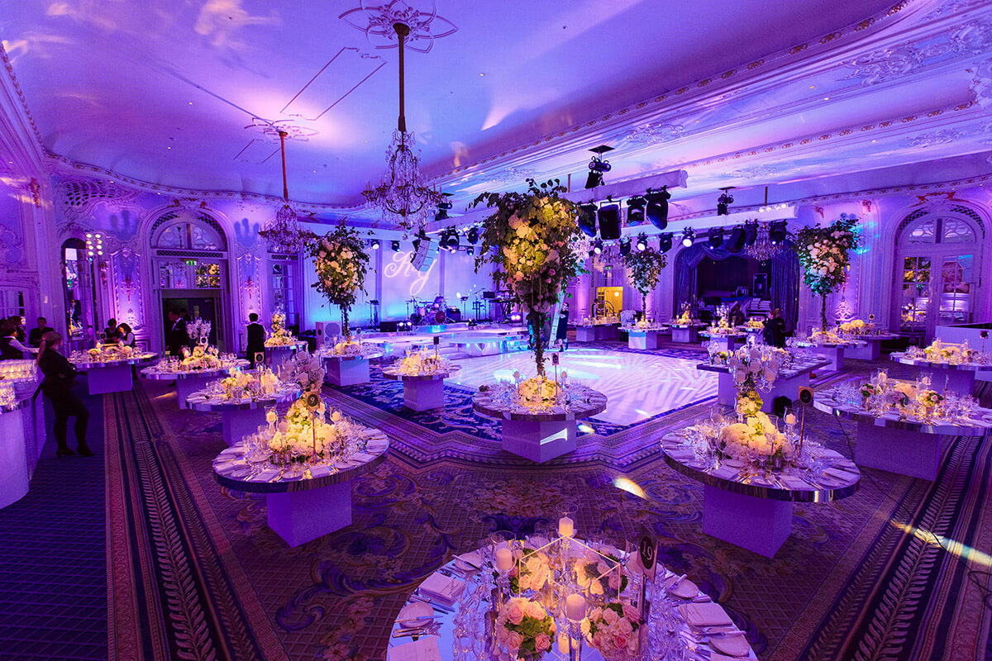

From soft, romantic lighting for a wedding to vibrant, dynamic lighting for a party, professional lighting hire can transform any space. By strategically placing lights, you can draw attention to key elements, create pathways, and ensure your event is both functional and visually stunning. Sound is just as important as visuals when it comes to hosting a memorable event. Clear, high-quality audio ensures that everyone can hear speeches, music, and other important audio elements. Sound equipment hire is essential for events of all sizes, whether you're hosting an intimate gathering or a large outdoor festival. From basic sound hire for small events to comprehensive sound system hire for larger venues, the right equipment can make a significant difference in the overall experience. Clear sound enhances communication, energizes the crowd, and ensures that your event runs smoothly, making it a key component of any successful gathering. In addition to lighting and sound, av equipment hire is crucial for events that require visual presentations, such as corporate meetings or conferences.

Audio visual hire services offer a range of equipment, including projectors, screens, and microphones, ensuring that your visual and audio elements are perfectly synchronized. AV production teams can help with the setup and operation of this equipment, allowing you to focus on other aspects of your event. Whether you're showing a video, delivering a presentation, or hosting a live performance, high-quality AV equipment ensures that your content is delivered effectively and professionally. In conclusion, hosting a memorable event requires careful planning and the right combination of outdoor stage hire, party lights hire, and sound equipment hire. By choosing professional lighting hire services and reliable sound system hire, you can create an atmosphere that captivates your audience and leaves a lasting impression. AV equipment hire and audio visual hire services further enhance the experience, ensuring that every aspect of your event is perfectly executed. With the help of experienced professionals and high-quality equipment, you can host an event that is not only successful but also truly unforgettable.