**Information On Wellness Retreats**

In today's fast-paced world, women often juggle multiple roles and responsibilities, leaving little time for self-care. This constant pressure can lead to burnout, stress, and a sense of disconnection from oneself. Wellness retreats offer an invaluable opportunity for women to step back, recharge, and focus on their mental, emotional, and physical health. These retreats provide a serene environment where women can escape daily demands and reconnect with themselves. The benefits of attending a wellness retreat are numerous, ranging from stress reduction to improved overall health, making them an essential part of modern self-care practices. Attending a wellbeing weekend retreat allows women to immerse themselves in activities that promote relaxation and personal growth. These short, focused breaks are designed to help participants unwind and gain new perspectives on life. Whether through yoga, meditation, or nature walks, a wellbeing weekend retreat offers tools and experiences that can help women regain balance and peace of mind. This concentrated time away from daily routines provides a much-needed pause, enabling women to return to their lives with renewed energy and clarity. If you are looking to learn more about [wellness retreat](https://www.thebodyretreat.co.uk/wellness-retreat), check out the previously mentioned site.

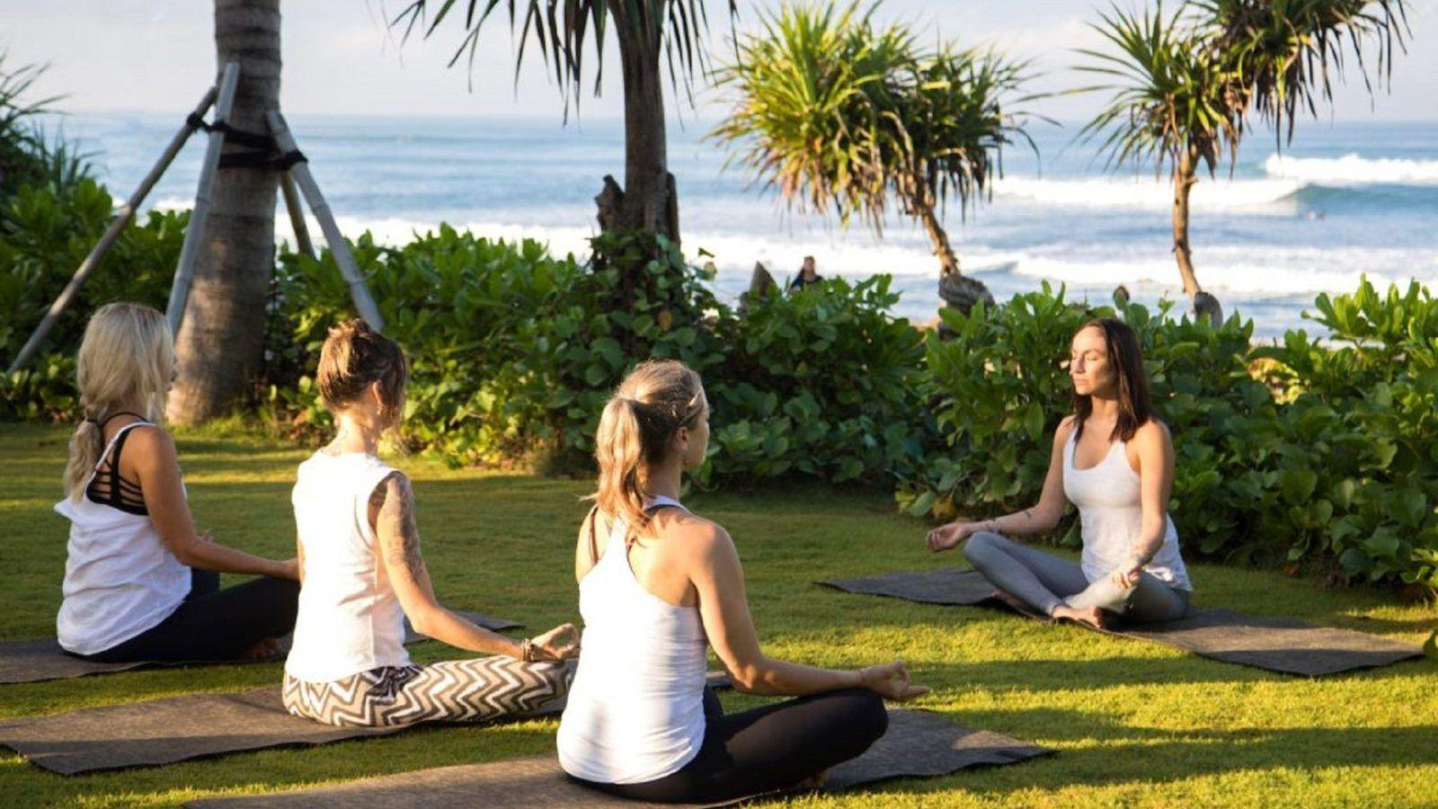

These retreats are not just a luxury but a necessary investment in one's well-being. Wellbeing retreats are gaining popularity as more women recognize the importance of taking time for themselves. These retreats are tailored to address various aspects of well-being, including mental, emotional, and physical health. By participating in wellbeing retreats, women can explore new ways to nurture themselves and build resilience against life's challenges. These experiences often include workshops, counseling, and other therapeutic activities that promote healing and self-discovery. The supportive environment of a wellbeing retreat encourages women to open up, share their experiences, and gain insights from others, fostering a sense of community and belonging. Taking a wellness break is an effective way for women to prioritize their health and well-being. These breaks are designed to provide a complete reset, allowing women to focus on themselves without distractions. A wellness break can include activities such as spa treatments, fitness sessions, and mindfulness practices that cater to the specific needs of women. By dedicating time to self-care during a wellness break, women can alleviate stress, boost their mood, and improve their overall health.

The benefits of such breaks extend beyond the retreat, helping women to maintain a healthier, more balanced lifestyle in the long term. Women's wellness retreats are specially designed to cater to the unique needs of women, offering a supportive space for personal growth and healing. These retreats provide an opportunity for women to connect with like-minded individuals who share similar experiences and challenges. Women's wellness retreats often focus on empowering participants through activities that promote self-awareness, confidence, and emotional resilience. By attending these retreats, women can gain valuable tools and insights that help them navigate life's ups and downs with greater ease. The sense of camaraderie and understanding found in women's wellness retreats can be transformative, leading to lasting friendships and a deeper connection to oneself. In conclusion, wellness retreats offer a much-needed respite for women in today's demanding world. Whether through a wellbeing weekend retreat or a longer wellness break, these experiences provide an opportunity to rejuvenate, reconnect, and revive. By prioritizing self-care and participating in wellbeing retreats, women can enhance their overall well-being and return to their daily lives with renewed vitality. The benefits of attending women's wellness retreats extend far beyond the time spent there, leading to improved mental, emotional, and physical health. Investing in a wellness retreat is not just a way to escape; it's a powerful step towards living a more balanced and fulfilling life.