**Information On Weight Loss Academy**

Losing weight is a common struggle for many people, and everyone’s journey is unique. The road to weight loss can be filled with challenges, from finding motivation to maintaining progress. One major hurdle is navigating through the abundance of information available. Many turn to structured programs like a weight loss academy or the best weight loss courses to get reliable guidance. These resources can provide tailored advice and support, making the process less daunting. Understanding that weight loss is not just about diet and exercise but also about education and mindset can make a significant difference. Enrolling in a weight loss course online or a weight management course online can be a game-changer. These courses offer flexibility, allowing individuals to learn at their own pace and on their own schedule. The best online weight loss coach provides personalized plans and ongoing support, which can be crucial for staying on track. Virtual coaching platforms are becoming increasingly popular, offering the convenience of a weight loss coach virtual. Are you looking about [weight loss academy](https://www.theweightlossacademy.com/)? View the earlier discussed website.

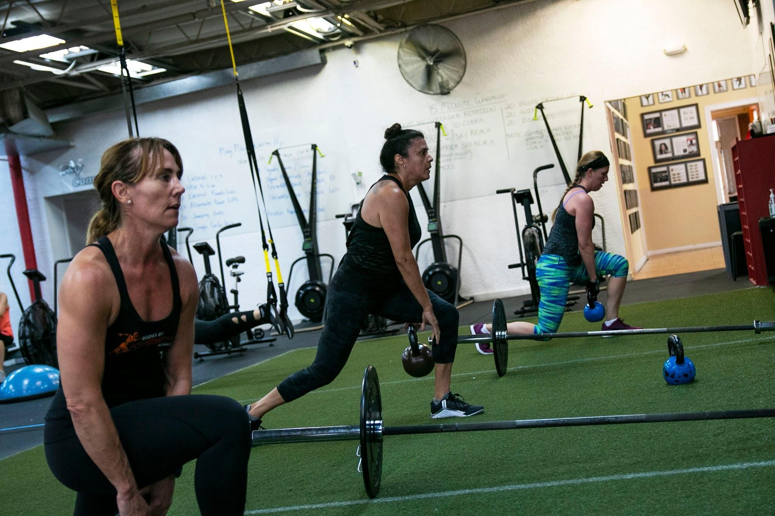

This means you can have expert advice and encouragement at your fingertips, no matter where you are. For those serious about their weight loss goals, finding the best weight loss coach online can be a pivotal step. An online personal weight loss coach offers tailored programs that fit individual needs and lifestyles. This personalized approach can lead to more effective results compared to generic plans. Coaches provide accountability, which is often the missing link in self-guided efforts. They help clients navigate challenges, celebrate successes, and stay motivated. This relationship can transform the weight loss journey into a more manageable and less overwhelming experience. Books can also be a valuable resource on the road to weight loss. Many good books for weight loss offer insights, strategies, and inspiration. Reading about others’ journeys in a weight loss journey book can be motivating and provide new perspectives. Books often include practical tips and evidence-based methods that can complement formal courses and coaching. They can serve as a source of continuous learning and encouragement, helping individuals to stay focused and informed throughout their journey.

The combination of structured learning, personalized coaching, and self-education creates a robust support system. The weight loss academy and similar programs provide the foundation of knowledge and skills needed for effective weight management. Virtual coaching adds a layer of personalized guidance and accountability, making it easier to stick to the plan. Additionally, reading weight loss journey books can offer ongoing motivation and practical tips. Together, these resources create a comprehensive approach to weight loss, addressing both the physical and psychological aspects. In conclusion, the struggles of losing weight are shared by many, but there are numerous resources available to help. Enrolling in a weight loss course online or a weight management course online can provide the necessary education and structure. Finding the best weight loss coach online or a weight loss coach virtual adds personalized support and accountability. Reading good books for weight loss and weight loss journey books can offer additional motivation and practical advice. Combining these elements can make the journey to weight loss more manageable and successful, providing a holistic approach to achieving and maintaining a healthy weight.