**Information On Water Damage Restoration**

Dealing with water damage in your home can be overwhelming, but having the right strategies in place can make the process more manageable. Whether the damage is due to a burst pipe or severe weather, it's crucial to act quickly to minimize the impact. Hiring a water damage restoration company like Remora Restorations can help you address the issue promptly and effectively. Their team of experts can assess the extent of the damage, remove excess water, and begin the drying process to prevent further deterioration. By relying on professionals, you ensure that the restoration process is thorough and your home is returned to its pre-damage state. In addition to addressing immediate water damage, it's essential to consider the potential for mould growth. If water is not removed quickly and thoroughly, mould can begin to develop within 24 to 48 hours. This is where mould treatment becomes crucial. Remora Restorations offers comprehensive mould treatment services, ensuring that any potential mould is eradicated before it becomes a more significant problem. Their specialists use advanced techniques to detect and remove mould, protecting your home and your family's health. Are you looking for [water damage restoration london](https://remorarestorations.com/water-damage/)? Go to the previously outlined website.

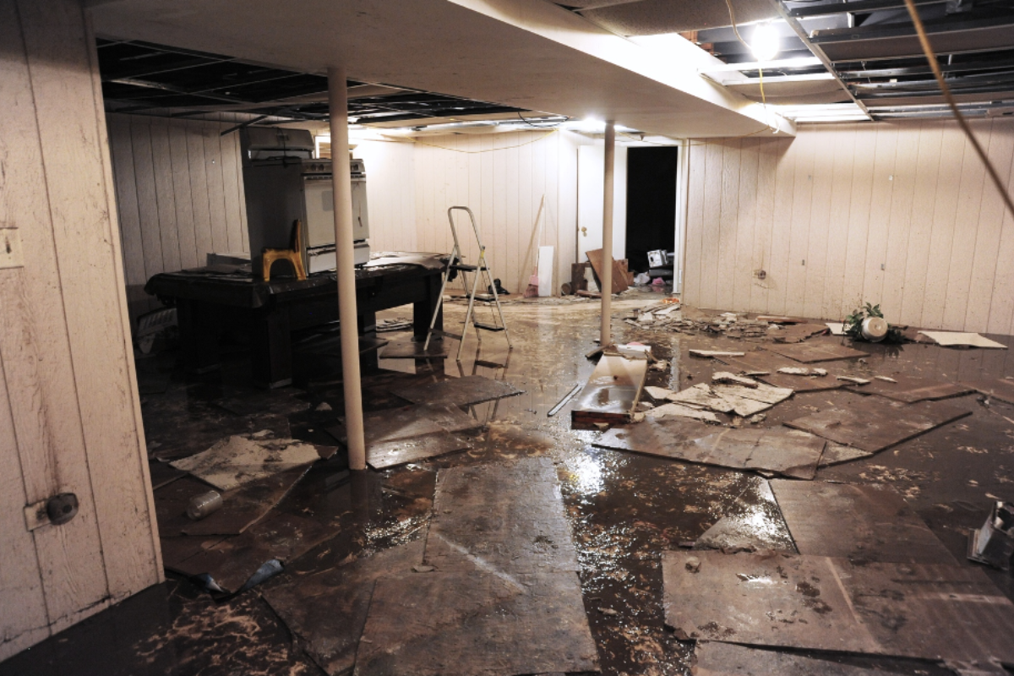

Addressing both water damage restoration and mould prevention simultaneously can save you time, money, and stress in the long run. Beyond water damage, homes are also vulnerable to fire-related incidents, which require specialized restoration services. Home restoration fire damage involves more than just repairing visible damage; it includes addressing smoke and soot residues that can linger and cause further harm. Remora Restorations excels in fire damage restoration, offering tailored solutions to handle everything from structural repairs to air quality improvement. They understand the unique challenges posed by fire damage and provide comprehensive services that cover all aspects of recovery. Their experience in commercial fire restoration also makes them a reliable choice for businesses needing efficient and effective restoration. For homes affected by persistent dampness, engaging damp treatment specialists is a wise investment. Dampness can lead to structural issues, mould growth, and health problems if not treated properly. Remora Restorations offers expert damp treatment services, identifying the source of moisture and implementing solutions to eliminate it.

Their team uses advanced diagnostic tools to pinpoint problem areas and provide long-lasting fixes that prevent future dampness. By choosing professionals with expertise in both water damage restoration and damp treatment, homeowners can protect their property from ongoing moisture-related issues. Lastly, addressing the aftermath of both water and fire damage is crucial to restoring your home to its original condition. Restoration cleaning companies like Remora Restorations provide a comprehensive approach that includes everything from initial damage assessment to final cleanup and repairs. Their services ensure that all traces of damage are removed, and your home is safe and habitable again. Whether dealing with water damage, fire, or mould, having a trusted restoration partner can make all the difference in a swift and successful recovery. In summary, effectively managing water damage and other home disasters requires quick action and the right expertise. Companies like Remora Restorations specialize in water damage restoration, mould treatment, fire damage restoration, and damp treatment to help homeowners recover from these challenges. By engaging a professional restoration cleaning company, you ensure that your home is restored thoroughly and efficiently, minimizing the long-term impact of such events. Whether it's addressing immediate water or fire damage or preventing future issues with mould and dampness, professional services are essential for a successful home recovery.