**Information On Specialist Printing Services**

Transforming your living space with custom large format prints can dramatically change the ambiance of your home. Whether you're aiming to create a striking focal point or simply want to add a personal touch, large format printing offers a versatile solution. Custom prints can be tailored to fit any wall, allowing you to express your style and preferences with high-impact visuals. From vibrant artworks to serene landscapes, the possibilities are endless when you utilize this unique form of decoration. Working with a professional print company ensures you get high-quality results that perfectly match your vision. A key advantage of custom large format prints is their ability to cover substantial wall areas with ease. This is especially useful in open spaces or large rooms where smaller art pieces might feel insignificant. By choosing large format printing, you can create bold statements that enhance the visual appeal of your space. Whether it’s a single large piece or a series of prints, this approach adds a layer of sophistication and can make a room feel more cohesive. Are you searching about [wallace printing](https://wallaceprint.com/)? Look at the earlier discussed website.

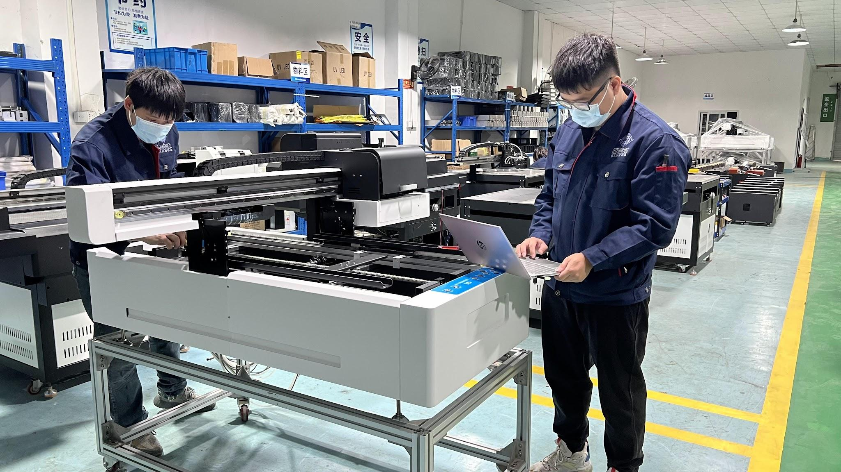

The versatility in design options allows for endless creativity and personalization. Selecting the right print company is crucial for achieving the best results with your large format prints. A reputable company will offer a range of printing options and high-quality materials to ensure your prints look stunning and last long. They should provide guidance on choosing the right paper, ink, and finish to match your specific needs. Additionally, a professional print company can assist with custom sizes and shapes, ensuring that your prints fit perfectly in your space and enhance your decor effectively. Another benefit of large format printing is its potential to enhance various styles of interior design. Whether your home features modern, rustic, or eclectic decor, custom prints can be designed to complement your existing aesthetic. By working with a skilled print company, you can explore different styles, from abstract art to photographic images, and find a design that seamlessly integrates into your home. This customization ensures that your prints not only fit the space but also contribute to the overall design harmony.

Incorporating large format prints into your living space also provides a unique way to showcase personal memories or interests. Custom prints allow you to display family photos, travel memories, or favorite quotes in a format that turns these elements into eye-catching art. This personal touch can make your home feel more welcoming and reflective of your personality. By choosing a print company that understands your vision, you can transform cherished moments into beautiful wall art that is both meaningful and visually appealing. Finally, embracing large format printing as a design solution can be a cost-effective way to update your space. Rather than investing in multiple smaller artworks or expensive renovations, a single large print can make a significant impact. This approach allows you to achieve a high-end look without breaking the bank. By partnering with a professional print company, you can access affordable options that fit your budget while still delivering impressive results. The efficiency and flexibility of large format prints make them a smart choice for any home renovation project.