**Information On Rescue Lifeboats**

Understanding the essentials of lifeboat and rescue boat operation is crucial for anyone involved in maritime safety. A lifeboat and rescue boat are vital components on ships and offshore platforms, designed to ensure the safety of passengers and crew in emergencies. Mastering the operation of these boats involves knowing how to handle them effectively in various conditions, including understanding how to launch, steer, and operate them during emergencies. Proper training in the use of lifeboat and rescue boat equipment is essential for effective emergency response and survival at sea. When looking to acquire a survival boat for sale, it’s important to consider the specific requirements of your vessel or offshore platform. Survival boats for sale come in various sizes and configurations to suit different needs, including those for offshore and rescue operations. Choosing the right survival boat involves evaluating factors such as capacity, durability, and the type of safety equipment included. Are you hunting about [british lifeboats](https://www.survivalsystemsinternational.com/uk/twinfall-lifeboats/)? Look at the previously described website.

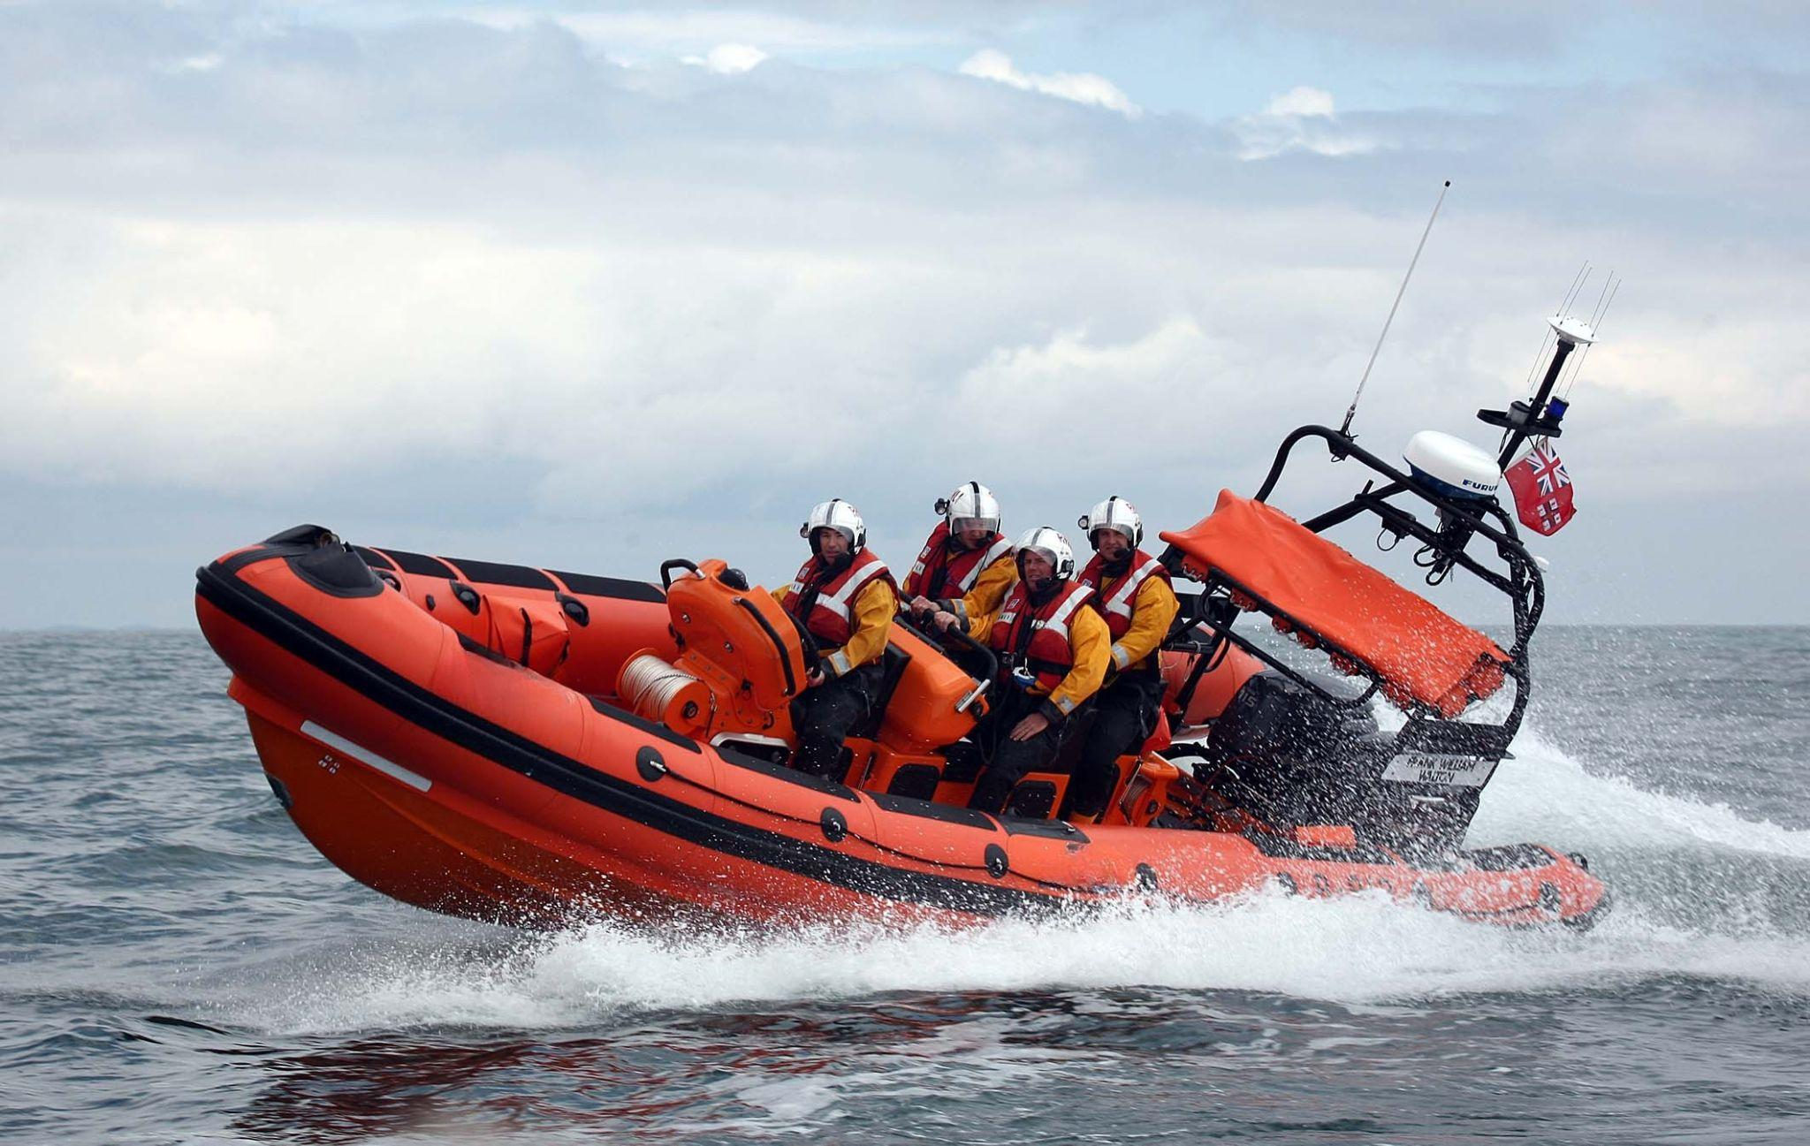

Investing in a high-quality survival boat is crucial for ensuring readiness in case of an emergency and for meeting safety regulations. In offshore environments, having a reliable oil rig lifeboat for sale is critical for safety and compliance. An oil rig lifeboat for sale must meet stringent safety standards due to the hazardous conditions often present on oil rigs. These lifeboats are specifically designed to withstand challenging offshore conditions and provide a safe means of evacuation in emergencies. When purchasing an oil rig lifeboat for sale, it is essential to ensure that it is equipped with all necessary safety features and has been tested for reliability. An emergency life raft is a crucial piece of equipment for maritime safety, offering a temporary refuge for individuals in distress at sea. Emergency life rafts are designed to be deployed quickly and provide essential protection and support until rescue can be achieved. Understanding the different types of emergency life rafts, including their features and deployment methods, is vital for effective emergency preparedness. Regular inspection and maintenance of emergency life rafts ensure they function correctly when needed. For those involved in offshore operations, an offshore life raft is an indispensable safety tool.

An offshore life raft is designed to operate in harsh marine environments, providing reliable flotation and protection in emergencies. Features of an offshore life raft include robust construction, easy deployment mechanisms, and comprehensive survival gear. Familiarity with the operation and maintenance of an offshore life raft is essential for ensuring its effectiveness in a crisis situation. Proper testing of survival equipment, such as inflatable survival rafts and inflatable liferafts, is necessary to ensure their reliability. Techniques like water weight testing and water bag load tests are used to evaluate the performance of inflatable life raft equipment. Inflatable survival rafts need to be thoroughly tested for buoyancy and durability to ensure they can withstand real-life conditions. Regular testing and maintenance of these rafts help ensure they are ready for deployment when needed. In summary, mastering the art of survival boat operation involves understanding the various types of boats and rafts available, such as lifeboat and rescue boat, oil rig lifeboat for sale, and survival boat for sale. Effective operation and maintenance of these safety devices, including emergency life rafts, offshore life rafts, and inflatable survival rafts, are crucial for ensuring safety at sea. Regular testing methods like water weight testing and water bag load tests play a significant role in confirming the readiness of inflatable life raft equipment. Proper knowledge and preparation are key to staying afloat and ensuring safety in emergency situations.