**Information On Gynecomastia Surgery**

Living with gynecomastia can be a challenging experience for many men, often accompanied by feelings of embarrassment and self-consciousness. This condition, characterized by the enlargement of breast tissue in males, affects individuals of all ages and can significantly impact one's self-esteem and quality of life. Despite its prevalence, gynecomastia remains a topic shrouded in silence and misunderstanding. However, breaking this silence and fostering open conversations about the condition is crucial for raising awareness, reducing stigma, and empowering those affected to seek appropriate treatment options. One of the most effective ways to address gynecomastia is through surgical intervention. Gynecomastia surgery, also known as male breast reduction, has become an increasingly popular and successful treatment option for men looking to restore their chest contour and regain confidence. This procedure, performed by a skilled gyno surgeon, involves the removal of excess glandular tissue and fat from the chest area, resulting in a more masculine appearance. Browse the below mentioned site, if you're searching for additional information about [gynecomastia surgery](https://www.drhassannurein.co.uk/).

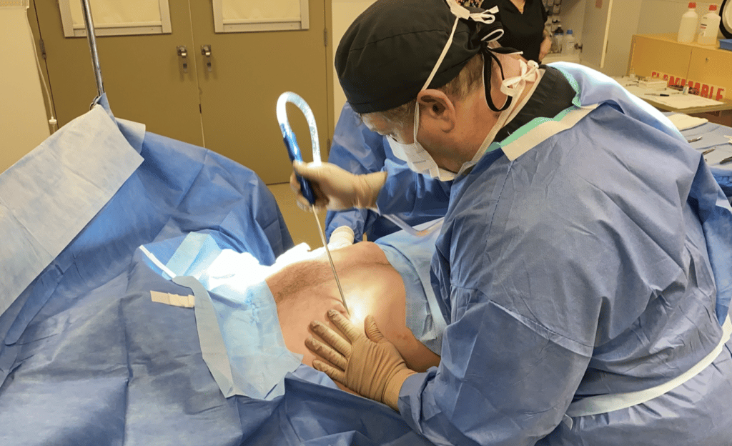

The advancements in surgical techniques have made gyno surgery safer and more effective than ever before, with minimal scarring and faster recovery times. Choosing the right gynecomastia surgeon is a critical step in the journey towards treatment. A qualified and experienced gynecomastia doctor possesses the specialized knowledge and skills necessary to achieve optimal results while prioritizing patient safety. These professionals understand the unique challenges faced by individuals with gynecomastia and can provide personalized care throughout the entire process, from initial consultation to post-operative follow-up. By selecting a reputable surgeon, patients can feel confident in their decision to undergo gynecomastia surgery and look forward to positive outcomes. Open communication with healthcare providers is essential for those considering gyno surgery. During consultations, patients should feel comfortable discussing their concerns, expectations, and medical history with their chosen gyno surgeon. This transparency allows the surgeon to develop a tailored treatment plan that addresses the patient's specific needs and goals.

Additionally, honest conversations about the emotional impact of gynecomastia can help healthcare providers offer comprehensive support, including referrals to mental health professionals if needed. By fostering a more open dialogue about gynecomastia, we can create a supportive environment for those affected by the condition. Sharing personal experiences and success stories can inspire others to seek help and explore treatment options. Education and awareness campaigns can help dispel myths and misconceptions surrounding gynecomastia surgery, empowering individuals to make informed decisions about their health and well-being. As more men speak openly about their experiences with gynecomastia and its treatment, the stigma associated with the condition will gradually diminish. In conclusion, open conversations about gynecomastia are vital for addressing the physical and emotional challenges faced by those living with the condition. By promoting awareness, encouraging dialogue, and highlighting the effectiveness of gynecomastia surgery, we can support individuals in their journey towards improved self-confidence and overall well-being. Whether through seeking the expertise of a skilled gynecomastia surgeon or simply sharing personal experiences, every step towards open communication contributes to breaking down barriers and fostering a more understanding and supportive society for those affected by gynecomastia.