**Information On Ear Stretching Kit**

Ear stretching is a popular practice that allows individuals to express their unique style through body jewellery. Starting with the right ear stretching kit is essential for beginners. The process involves gradually increasing ear stretching sizes to create larger holes in the earlobes. This process, known as how to stretch your ears, requires patience and care to avoid damage. A good ear stretching guide will suggest using ear stretching size charts to determine the correct ear stretching sizes for each stage. Following a proper etching-guide ensures a safe and successful stretching journey. Choosing the right ear tunnels and plugs is crucial for both comfort and style. These pieces of body jewelry and piercing accessories come in various materials, including wood, silicone, and stainless steel. Beginners should start with smaller sizes and gradually move up as their ears adjust. It's important to remember that the type of material used in ear tunnel plugs can affect the healing process. Are you searching about [ear stretching kit](https://www.stretchitbodyjewellery.co.uk/collections/kits)? View the previously talked about website.

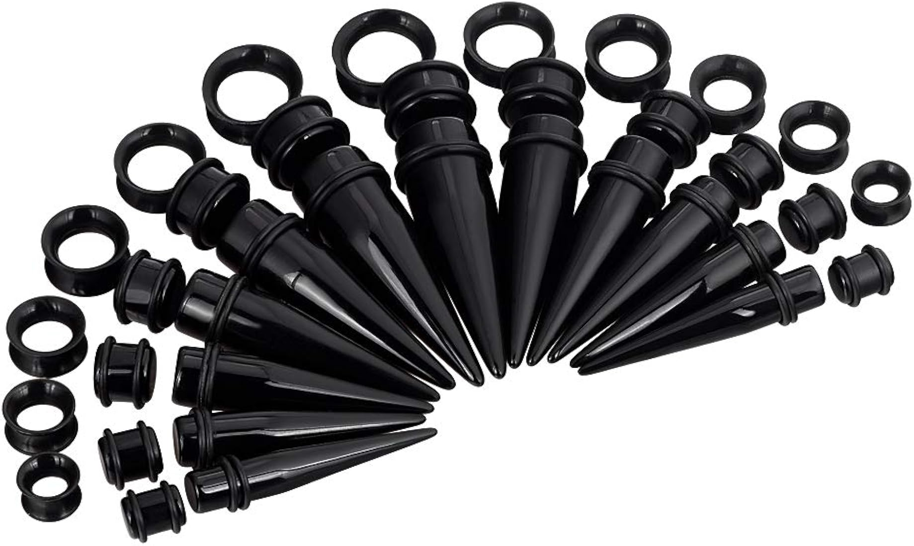

For example, silicone is flexible and comfortable, while stainless steel is durable and easy to clean. Proper care and hygiene are essential to prevent infections and ensure that stretched earlobes heal correctly. The process of how to stretch ears requires a step-by-step approach, starting with smaller gauges and slowly increasing in size. Stretching too quickly can lead to tears and complications, so it's important to follow a reliable ear stretching guide. The ear stretching size chart is a helpful tool that outlines the appropriate sizes and timelines for each stage of stretching. It's also recommended to take breaks between stretches to allow the earlobes to heal. This gradual approach ensures that the stretched earlobes remain healthy and minimizes the risk of injury or infection. For those who have already achieved their desired ear stretching sizes, maintaining the stretched earlobes is key. Regular cleaning of ear tunnels and plugs is important to prevent buildup of dead skin cells and bacteria. Some people may choose to downsize or remove their plugs temporarily to give their earlobes a break. However, it's essential to be cautious when downsizing, as the earlobes can shrink quickly.

Using high-quality ear tunnel plugs and following proper aftercare routines will help keep the body jewelry and piercing looking great and feeling comfortable for years to come. Advanced stretchers often experiment with different styles and materials of body jewellery. As they progress, they may explore more intricate designs and larger sizes of ear tunnels and plugs. It's important to continue using an ear stretching kit that meets the needs of advanced users. Whether you're a beginner or a seasoned pro, understanding the process of how to stretch ears and using a reliable ear stretching guide is essential for a successful experience. Regularly referring to an ear stretching size chart will help you track progress and make informed decisions about your stretching journey. The world of ear stretching offers endless possibilities for self-expression through body jewelry and piercing. From selecting the right ear stretching kit to choosing the perfect ear tunnels and plugs, every step is an opportunity to showcase your style. By following a comprehensive ear stretching guide and paying attention to the ear stretching size chart, you can achieve the perfect look while ensuring the health and safety of your stretched earlobes. Whether you're just starting or have been stretching for years, the key to success lies in patience, care, and a passion for the art of ear stretching.