**Information On Ceiling Fans**

Ceiling fans have evolved from mere functional fixtures into dynamic elements of home décor. Modern homes now feature luxury designer fans that not only provide comfort but also serve as striking visual statements. These designer ceiling fans come in various styles, blending aesthetics with utility, making them an integral part of interior design. Whether it's a designer white ceiling fan complementing a minimalist space or a bold, contemporary ceiling fan in a modern living room, these fans add a touch of sophistication. The market offers a wide range of top rated ceiling fans that cater to diverse tastes and preferences. In recent years, there has been a growing trend of designer fans for living room spaces that emphasize artistic expression. These fans, often referred to as modern designer fans, combine innovative designs with advanced technology to create pieces that are both functional and beautiful. Check out the below mentioned site, if you're searching for more details concerning [ceiling fans](https://henleyfan.com/).

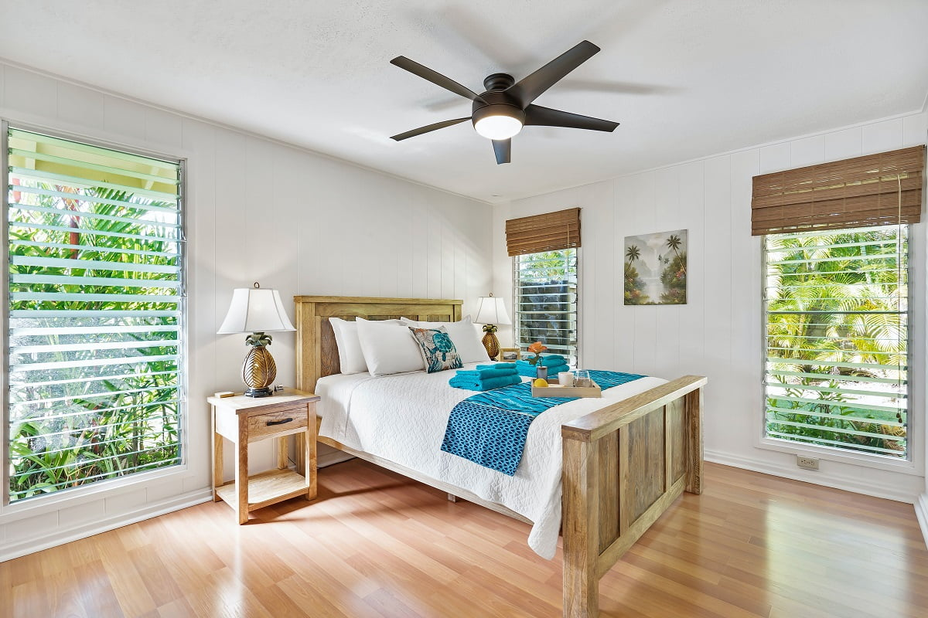

From sleek, minimalist designs to more elaborate and intricate creations, designer fans ceiling installations have become a focal point in many homes. The demand for these best rated ceiling fans is driven by a desire for unique, high-quality products that enhance the ambiance of any room. The use of modern designer ceiling fans in interior design goes beyond aesthetics; it also plays a crucial role in energy efficiency. These designer fans are engineered to optimize air circulation, reducing the need for excessive air conditioning. As a result, homeowners can enjoy a comfortable living environment while also saving on energy costs. The availability of top rated ceiling fans ensures that consumers have access to products that meet the highest standards of performance and durability, making them a smart investment for any home. One of the most exciting developments in the world of designer fans is the integration of smart technology. Today's luxury designer fans can be controlled remotely via smartphones or voice-activated assistants, offering unparalleled convenience and customization.

These fans often feature multiple speed settings, timers, and even reversible motors for year-round use. With these advancements, ceiling fans have transformed into sophisticated, multi-functional devices that enhance both comfort and style in any space. The versatility of designer ceiling fans extends to their application in various settings beyond the living room. From bedrooms and kitchens to outdoor patios, these fans are designed to complement any space. The popularity of designer white ceiling fans in particular has surged, as they offer a clean, modern look that can seamlessly blend with different décor styles. For those seeking to make a statement, contemporary ceiling fans with unique finishes and bold designs are an excellent choice. As the demand for modern designer ceiling fans continues to grow, manufacturers are pushing the boundaries of innovation and creativity. The result is a wide array of best rated ceiling fans that cater to a variety of tastes and needs. Whether you're looking for a subtle, elegant addition to your home or a bold, eye-catching centerpiece, there's a designer fan that will meet your requirements. These luxury designer fans are not just functional; they are a reflection of personal style and a testament to the evolving role of ceiling fans in modern interior design.