**Information On Buy Neon Signs**

In today's competitive restaurant industry, creating a memorable and unique ambiance is crucial. One effective way to achieve this is by investing in custom neon signs. These signs offer vibrant and eye-catching displays that can set your restaurant apart from others. Whether you're looking to buy neon signs or seeking a specialized neon sign shop, opting for bespoke neon signs ensures that your signage reflects your brand's personality and style. Custom neon signs for restaurants can enhance the overall atmosphere and make a strong visual impact on your customers. Custom neon light signs are a popular choice for restaurants aiming to establish a distinct identity. Unlike standard signage, neon name signs and 3D neon signs restaurants create a dynamic, three-dimensional effect that captures attention. These bespoke neon lights can be tailored to match your restaurant's theme and colors, offering a personalized touch that generic signs lack. Are you hunting about [buy neon signs](https://3dneonsigns.co.uk/)? Visit the earlier outlined website.

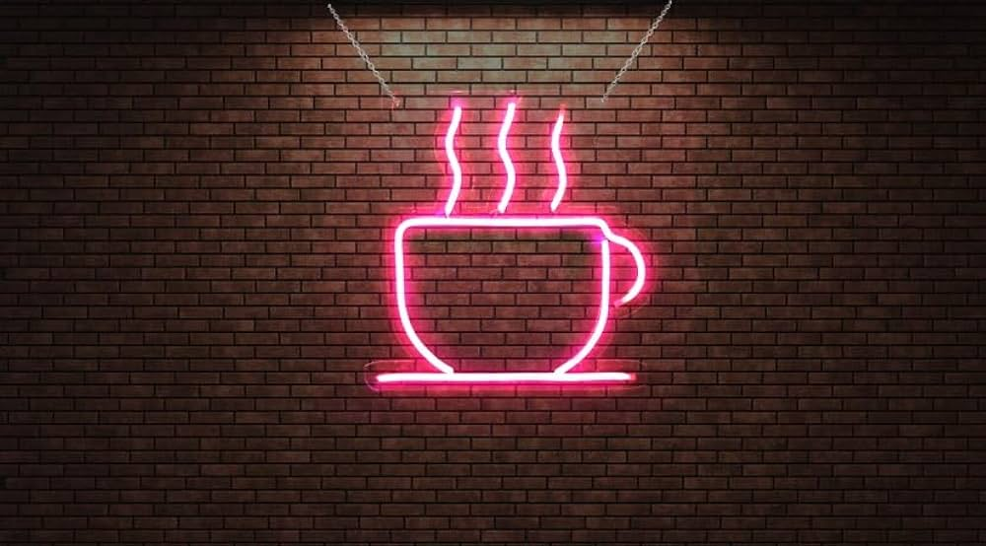

Investing in such custom neon signs not only attracts customers but also reinforces brand recognition and leaves a lasting impression. When considering neon signs custom, it’s essential to choose a provider that specializes in high-quality and innovative designs. A reputable neon sign shop can offer a range of options, from traditional neon to modern LED variations. The key is to select custom neon signs that align with your restaurant's aesthetic while also ensuring durability and visibility. High-quality custom neon light signs can withstand various environmental factors, making them a reliable choice for both indoor and outdoor settings. For special occasions, such as weddings or other significant events, custom wedding neon light signs provide a unique way to celebrate. These custom wedding light signs can be customized to fit any theme or color scheme, adding a personalized touch to the event. Similarly, restaurants can benefit from custom neon signs for restaurants that highlight special promotions or unique features.

The versatility of bespoke neon signs makes them suitable for various applications, enhancing the overall customer experience. 3D neon signs restaurants are becoming increasingly popular due to their striking visual appeal. These signs offer a modern twist on traditional neon by incorporating depth and dimension into the design. Whether used to highlight a restaurant's name, logo, or a special message, custom neon signs with 3D effects can make a significant impact. They not only enhance the restaurant’s interior but also serve as an attractive focal point that draws in potential customers. In summary, custom neon signs are a valuable investment for restaurants seeking to make a lasting impression. From neon name signs to 3D neon signs restaurants, these signs offer a unique and customizable way to enhance your restaurant’s branding and atmosphere. Partnering with a reliable neon sign shop to create bespoke neon lights ensures that your signage stands out and reflects your brand’s identity. With options like custom wedding neon light signs and versatile custom neon signs for restaurants, you can effectively illuminate your brand and attract more customers.