**Details About Ear Gauges**

Ear gauges have a rich history that dates back to ancient civilizations, where body modification was a symbol of status, spirituality, and identity. In these societies, ear stretchers were often used as a rite of passage or a mark of beauty. For instance, ancient Egyptian royalty, including Pharaoh Tutankhamun, adorned themselves with stretch earrings to signify their power. Similarly, tribes in Africa and South America used ear stretching kits to gradually expand their earlobes, often inserting stones or wooden plugs as they progressed. These practices highlight how ear gauges have been intertwined with cultural significance for centuries. As time passed, the tradition of ear stretching evolved but remained prevalent in various cultures. The Mursi tribe in Ethiopia, for example, continues to use stretcher earrings as a symbol of social status. Women of the tribe start with a small incision in their lower lip or earlobe, gradually increasing the size using a gauge kit. This method is similar to modern ear gauge stretching kits, where users incrementally increase the size of their ear piercings. The tools may have changed, but the cultural importance of body modification through ear gauges has endured. If you are seeking for additional info on [ear gauges](https://www.stretchitbodyjewellery.co.uk/), look at the mentioned above site.

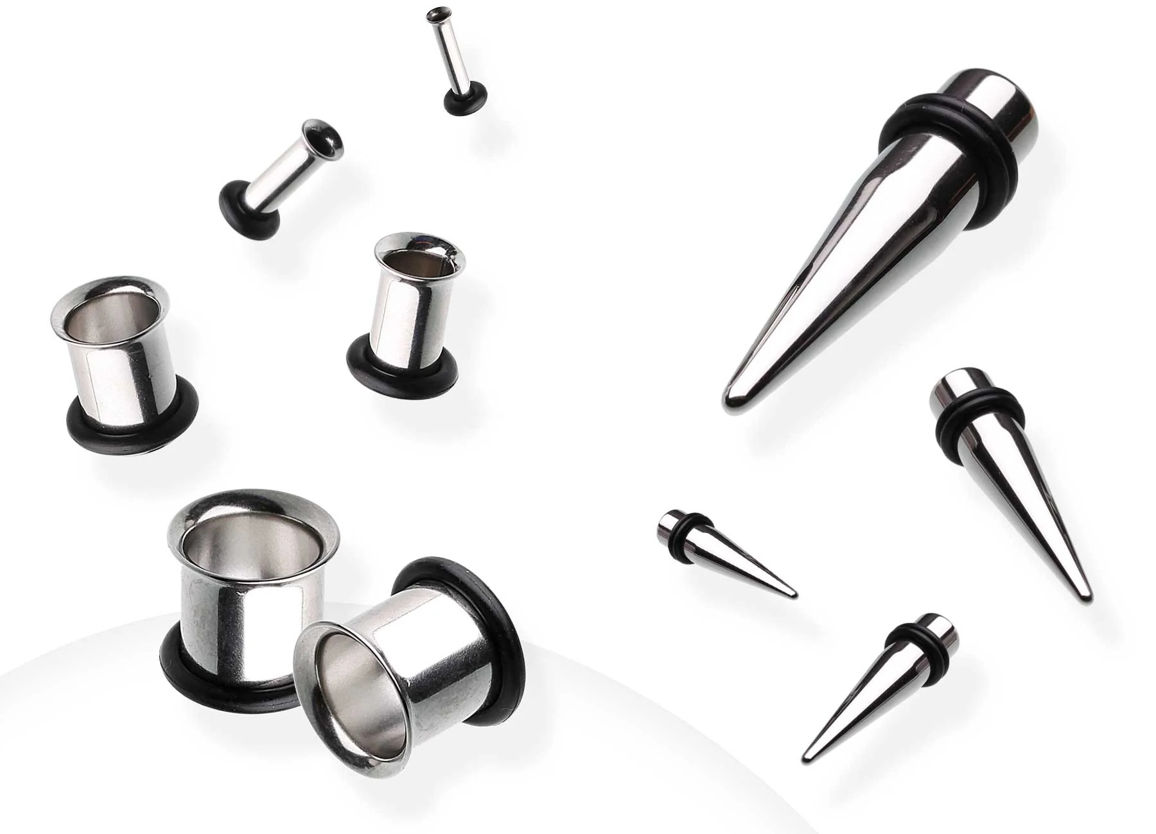

The modern resurgence of ear gauges and stretch earrings can be traced back to the 20th century, with the rise of alternative subcultures that embraced body modification as a form of rebellion and self-expression. Punk and goth communities, in particular, popularized the use of ear stretchers and gauge kits to achieve larger earlobes. The availability of ear stretching kits for beginners made it easier for people to experiment with this ancient practice, leading to its widespread adoption. Today, ear gauge starter kits are commonly used by those looking to stretch their ears in a safe and controlled manner. The process of ear stretching has become more accessible and safer thanks to advancements in ear gauge kits and stretching kits. For those new to the practice, a large ear stretching kit or a stretching kit for gauges provides everything needed to start the journey, including tapers, plugs, and aftercare solutions. These kits are designed to gradually increase the size of the earlobe piercing, reducing the risk of tearing or infection. The availability of various sizes in a gauge kit for ears allows individuals to personalize their stretching experience, much like ancient civilizations did with their own tools and techniques.

Despite its ancient origins, the use of ear gauges has transcended cultural boundaries and is now a global trend. The combination of historical significance and modern fashion has solidified ear stretching as a popular form of self-expression. Whether using a ear stretching kit for beginners or a large ear stretching kit for more experienced individuals, the practice continues to evolve. The availability of different materials and sizes in ear gauge kits ensures that anyone interested in this body modification can do so safely and stylishly, connecting them to a tradition that spans millennia. In conclusion, the journey from ancient ear stretchers to modern stretch earrings illustrates the enduring appeal of body modification. The use of ear gauges has transformed from a cultural rite to a mainstream fashion statement, thanks in part to the accessibility of ear gauge stretching kits. Today, people can explore this ancient practice with the help of a ear gauge starter kit, connecting with a history that stretches across time and civilizations. The evolution of ear gauges reflects humanity's ongoing fascination with the art of body modification, making it a timeless expression of identity and style.