**An Overview Of Lifeboat Services**

When considering the purchase of lifeboats, it’s crucial to understand their importance and functionality. Lifeboats are essential safety vessels designed to save lives in emergency situations at sea. They are equipped with essential survival equipment and are built to withstand harsh marine conditions. If you plan to buy a lifeboat, it’s vital to research various options and understand the specific requirements of your maritime operations. Many companies offer lifeboats for sale, providing a range of sizes and specifications to suit different needs. Ensuring the right choice can make a significant difference in emergency preparedness and response. Selecting the right lifeboat supplier is another critical aspect when you decide to buy lifeboats. A reputable supplier will offer high-quality lifeboat products that meet international safety standards. They can provide expert advice on the best lifeboats for your needs, whether for commercial shipping, offshore oil rigs, or private vessels. It’s essential to work with a supplier who understands the unique challenges of maritime safety and can offer reliable, durable products. Make a search on the following site, if you're searching for additional information on [lifeboats uk](https://www.survivalsystemsinternational.com/uk/).

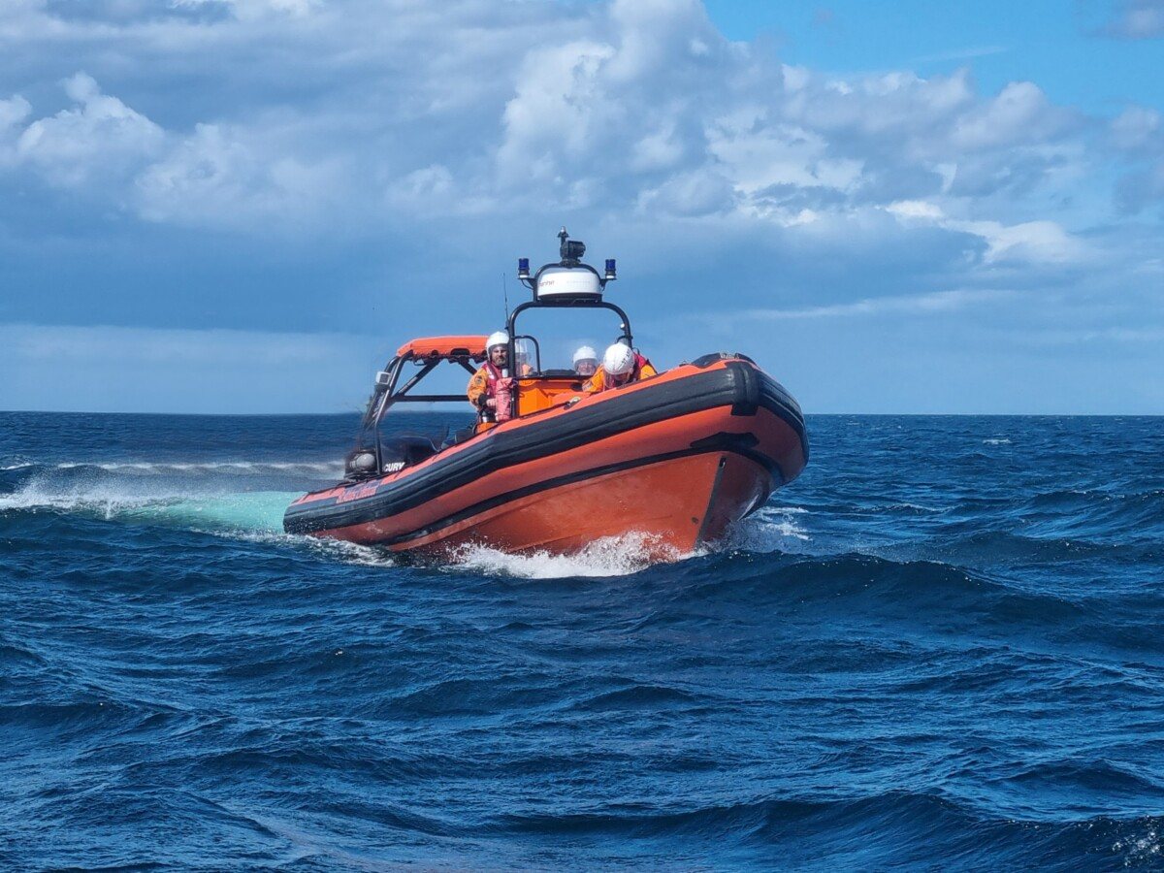

Checking reviews and certifications of lifeboat suppliers can help you make an informed decision and ensure you receive a product that guarantees safety and reliability. Exploring the various types of lifeboats for sale is an important step in the purchasing process. There are different lifeboat designs, such as enclosed lifeboats, free-fall lifeboats, and inflatable lifeboats, each serving specific purposes. Enclosed lifeboats provide enhanced protection against harsh weather conditions, while free-fall lifeboats are designed for rapid deployment. Inflatable lifeboats are typically used for smaller vessels or as additional safety measures. Understanding the advantages and limitations of each type will help you choose the most suitable option for your needs. Investing in the right lifeboat products can significantly enhance the safety protocols of your maritime operations. Maintenance and regular inspections are crucial to ensuring the reliability of your lifeboats. After you buy a lifeboat, it’s essential to establish a maintenance schedule that includes regular checks and servicing. This ensures that all lifeboat products are in optimal condition and ready for use in an emergency. Partnering with a trusted lifeboat supplier who offers maintenance and inspection services can be highly beneficial.

They can provide the necessary support and expertise to keep your lifeboats in compliance with safety regulations. Regular maintenance not only extends the lifespan of the lifeboats but also ensures the safety of all personnel on board. Training is another vital component when you buy lifeboats. Crew members must be thoroughly trained in the operation and deployment of lifeboats to ensure efficient and safe evacuation in an emergency. Many lifeboat suppliers offer training programs that cover the essential aspects of lifeboat handling, including launching procedures, maneuvering, and survival techniques. Ensuring that your crew is well-prepared and confident in their ability to use the lifeboats effectively can save lives during critical moments. Investing in comprehensive training programs is as important as the lifeboats themselves, as it ensures readiness and competence in emergency situations. In summary, lifeboats are indispensable safety equipment for any maritime operation. When you plan to buy a lifeboat, thorough research and selection of a reputable lifeboat supplier are crucial. Understanding the different types of lifeboats for sale and their specific applications will help you make an informed decision. Regular maintenance and proper training are essential to ensure the effectiveness and reliability of your lifeboat products. By focusing on these key aspects, you can enhance the safety and preparedness of your vessel, ensuring that you are well-equipped to handle any emergency at sea.