**An Overview Of Clothes Storage**

When looking for a self-storage unit, it's essential to consider several factors to ensure your belongings are safe and accessible. One of the first aspects to evaluate is security. A reliable self storage facility should have robust security measures, including surveillance cameras, gated access, and on-site personnel. These features are crucial in preventing theft and ensuring that your items are protected. Whether you are storing furniture, documents, or out of season clothing, the security of your storage unit should be a top priority to give you peace of mind. Location is another critical factor when choosing a self-storage unit. The facility should be conveniently located near your home or workplace, making it easy to access your items when needed. This is particularly important for those who may need to frequently retrieve or store items such as clothes storage for seasonal wardrobe changes. Additionally, a nearby self storage facility can save you time and transportation costs. While cheap self storage options may be tempting, it's important to balance cost with the convenience of the location to ensure it meets your needs. Browse the below mentioned site, if you're looking for more information about [clothes storage london](https://smartboxselfstorage.co.uk/services/smartwardrobe/).

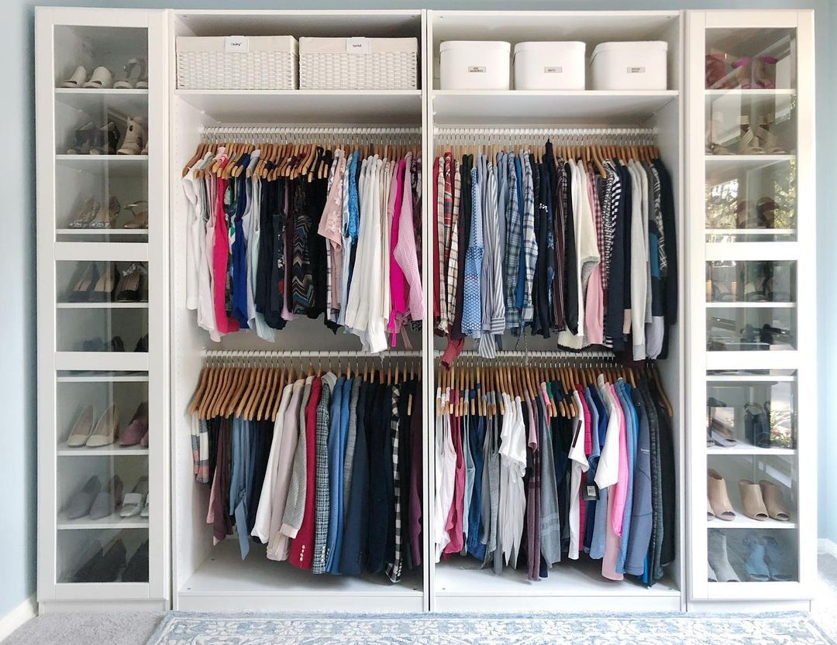

Cost is always a consideration, and finding affordable storage is essential. Compare prices of different storage facilities, keeping an eye out for promotions or discounts on cheap storage space. Many facilities offer competitive rates for long term storage, which can be beneficial if you plan to store items for an extended period. However, be cautious of extremely low prices, as they may come with compromises on security or cleanliness. It’s important to find a balance between cheap self storage and the quality of the facility to ensure your belongings are well-protected. Another important aspect to consider is the size and type of storage unit you need. Assess the volume of items you plan to store, including larger items like furniture and smaller items such as out of season clothing. Some facilities offer specialized units, like climate-controlled spaces, which are ideal for sensitive items. If you have specific needs, such as clothes storage, look for units that offer enough space and amenities like shelves or a wardrobe organiser. Choosing the right size and type of unit can help you utilize the space efficiently and keep your belongings in good condition.

Accessibility is also crucial when selecting a self-storage unit. Consider the facility's hours of operation and how often you will need to access your belongings. Some self storage facilities offer 24/7 access, while others have more limited hours. If you anticipate needing regular access, choose a facility that accommodates your schedule. For those storing items long-term, less frequent access may be acceptable, and you might prioritize cost savings over accessibility. Balancing these factors can help you find cheap long term storage that fits your needs. In conclusion, finding the right self-storage unit involves careful consideration of several factors. Prioritize security to ensure your belongings are safe, and choose a convenient location to save time and transportation costs. Look for affordable storage options, but be mindful of the facility’s quality and security measures. Select the appropriate size and type of unit for your items, especially for specific needs like clothes storage or out of season clothing. Finally, consider the accessibility of the unit based on how often you need to retrieve your belongings. By evaluating these aspects, you can find a self storage solution that meets your requirements and provides peace of mind.