**A Little Bit About Hamper Gifts**

The holiday season is a time for family, joy, and creating lasting memories. Christmas hampers play a significant role in bringing families together during this festive period. These thoughtfully curated christmas hampers 2024 are filled with a variety of treats and goodies, making them a perfect gift for loved ones. Whether it's christmas food hampers brimming with seasonal delights or chocolate hampers overflowing with sweet treats, these hampers add a special touch to holiday celebrations. The act of sharing and enjoying these hampers fosters a sense of togetherness and warmth among family members. In recent years, the popularity of christmas hampers has grown, with more people recognizing their value in enhancing holiday experiences. Christmas hampers 2024 are expected to be even more creative and diverse, catering to a wide range of tastes and preferences. From chocolate gift baskets to birthday hampers for her, there is something for everyone. The variety in christmas food hampers ensures that there is always a delightful surprise waiting for each family member. If you're looking for additional info on [hamper gifts](https://www.hampergifts.co.uk/), take a look at above site.

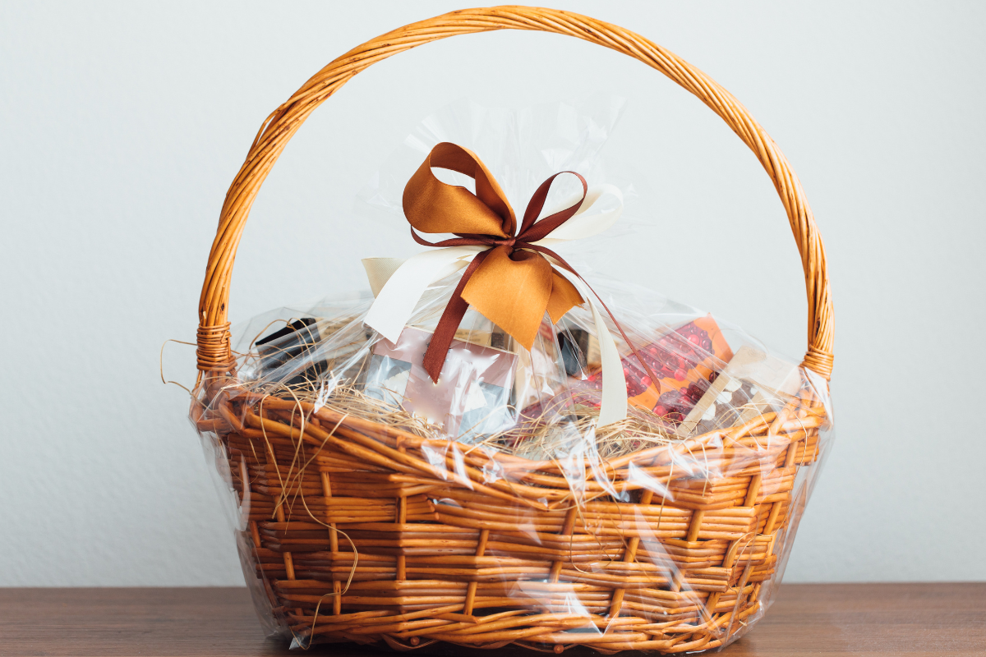

These hampers are not just about the contents but also about the thought and care put into selecting the perfect items. Food plays a central role in holiday celebrations, and food hampers have become a beloved tradition. Food hampers cheese, for instance, are a gourmet delight that adds an element of sophistication to any gathering. The inclusion of high-quality cheeses, crackers, and accompaniments makes these hampers a hit at festive tables. Similarly, food hamper gifts that include a mix of sweet and savory items cater to diverse palates. The joy of unwrapping these hampers and discovering the delicious treats inside adds to the festive excitement and creates lasting memories. Apart from Christmas, chocolate gift baskets and birthday hampers are popular choices for other special occasions. Birthday hampers for her often include luxurious items such as skincare products, scented candles, and gourmet chocolates. These hampers make thoughtful gifts that show appreciation and love. The versatility of food hampers makes them suitable for various celebrations, ensuring that each event is marked with something special. The trend of giving hampers as gifts reflects a shift towards more personalized and meaningful presents that create lasting impressions.

The tradition of exchanging christmas hampers is not just about the gifts themselves but also about the shared experiences they create. Families come together to enjoy the treats, reminisce about past holidays, and create new memories. Christmas hampers 2024 will continue this tradition, with innovative designs and contents that cater to modern tastes. The sense of anticipation and excitement as everyone gathers to open the hampers is a highlight of the holiday season. These moments of joy and togetherness are what make the holidays truly special. In conclusion, christmas hampers, including chocolate hampers and christmas food hampers, play a crucial role in bringing families together during the holidays. The growing popularity of christmas hampers 2024 highlights their importance in creating lasting memories. Food hampers cheese and other gourmet selections add a touch of elegance to celebrations, while chocolate gift baskets and birthday hampers cater to various occasions. The tradition of sharing these hampers fosters a sense of togetherness and makes the festive season truly memorable. The joy and warmth these hampers bring to families are what make them a cherished part of holiday traditions.