**Mountain Landscape Photography - An Overview**

Photography is an art that goes beyond merely pointing a camera and clicking. Mastering the art of composition is crucial for creating stunning photographs that captivate the viewer's eye. One of the most challenging yet rewarding types of photography is mountain photography. Capturing the majesty and grandeur of mountains requires an understanding of light, perspective, and timing. A mountain photographer must be patient, often waiting hours for the perfect shot. The result, however, is often breathtaking, showcasing nature in its most awe-inspiring form. When it comes to mountain landscape photography, the right composition can make all the difference. One effective technique is to use the rule of thirds, placing the mountain or other focal points off-center to create a more dynamic image. Leading lines, such as trails or rivers, can draw the viewer's eye into the photograph, adding depth and dimension. For those photographing in places like the Lake District, incorporating these elements can turn ordinary lake district landscape photos into extraordinary pieces of art. If you are searching to learn more about [mountain landscape photography](https://tomaszjanickiphoto.co.uk/), visit the previously mentioned website.

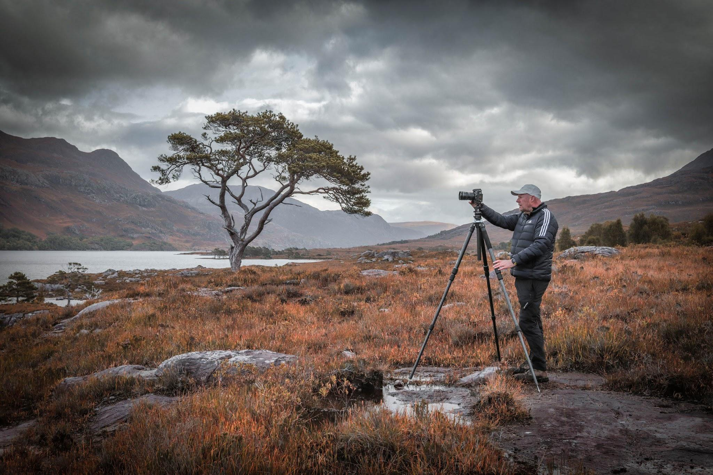

Large landscape photography prints are a popular way to display these stunning images. The size of the print can make the viewer feel as if they are standing right there in the landscape. Choosing the right frame and display method is essential to highlight the beauty of the photograph. High-quality landscape photography prints can transform a space, bringing the serenity and grandeur of nature into a home or office. These prints are not just decorations; they are windows into the world’s most beautiful places. Timing is another critical aspect of mountain landscape photography. The golden hours, shortly after sunrise and before sunset, offer the best lighting conditions. During these times, the light is soft and warm, casting long shadows and highlighting textures in the landscape. A mountain photographer must also be prepared for changing weather conditions, which can dramatically alter the scene. Being in the right place at the right time can result in a truly magical photograph, capturing the essence of the landscape in its best light. For those looking to purchase large landscape photo prints, there are a few things to consider.

The quality of the print is paramount; it should be produced using high-resolution images and printed on premium paper or canvas. The subject matter is also important. Lake District landscape photos, for example, are highly sought after for their stunning beauty and tranquil scenes. Whether you are a photographer or an art collector, investing in high-quality landscape photography prints can bring a piece of nature’s splendor into your life. In conclusion, mastering the art of composition in photography is a skill that can elevate your work from ordinary to extraordinary. Whether you are focused on mountain photography or capturing serene lakes, the principles of good composition remain the same. By paying attention to elements like the rule of thirds, leading lines, and lighting, you can create images that not only capture a moment in time but also tell a story. High-quality large landscape photography prints serve as a lasting reminder of these beautiful scenes, allowing you to share your vision with the world.