**Information On Lifeboat And Rescue Boat**

Knowing how to use lifeboats is essential for survival in emergency situations at sea. Lifeboat survival skills can make the difference between life and death when facing unexpected calamities. Being familiar with lifeboat and rescue boat operations ensures that you can act swiftly and correctly during a crisis. Understanding the basics, such as launching procedures and onboard safety measures, is crucial. Moreover, having access to resources like a life raft for sale and proper training can significantly enhance your preparedness. In emergencies, every second counts, and knowing how to use lifeboats effectively can save lives. Regular lifeboat inspection and lifeboat maintenance are critical aspects of ensuring that these vital safety vessels are ready for use when needed. Proper lifeboat maintenance services help identify potential issues that could compromise the lifeboat survival capabilities. Regular checks and servicing ensure that all equipment functions correctly and meets safety standards. Check out the below mentioned website, if you're searching for additional information regarding [lifeboat and rescue boat](https://www.survivalsystemsinternational.com/uk/twinfall-lifeboats/).

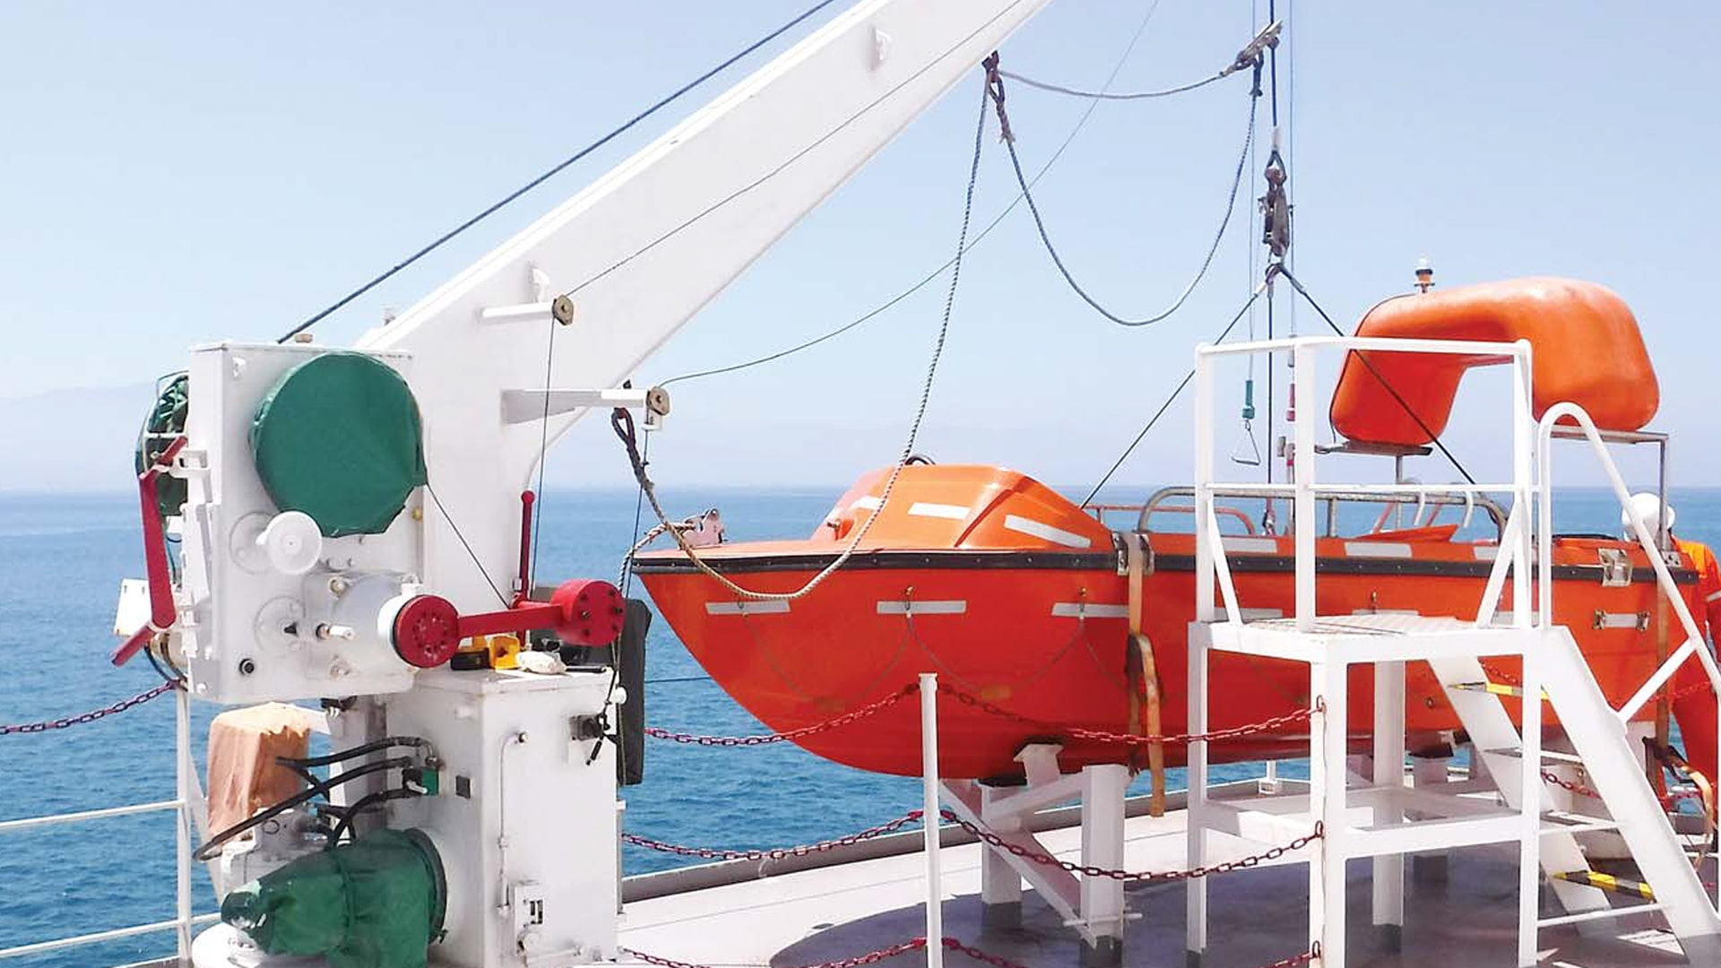

This includes inspecting the hull, engine, and essential safety gear. Investing in high-quality maintenance is not only a regulatory requirement but also a smart practice to guarantee that your emergency lifeboat is always in top condition. In addition to lifeboats, having access to life rafts is also important for maritime safety. A life raft for sale can be a valuable addition to your emergency preparedness equipment. Life rafts provide an alternative means of survival if lifeboats are not available or accessible during an emergency. They are designed to be quickly deployable and offer protection from the elements while awaiting rescue. Knowing how to use both lifeboats and life rafts effectively can enhance your overall lifeboat and rescue boat strategy, ensuring comprehensive coverage in any emergency scenario. Training and drills are fundamental components of lifeboat survival. Regular practice ensures that all crew members are familiar with lifeboat and rescue boat procedures. This includes understanding how to board the lifeboats quickly, operate the equipment, and follow safety protocols. Drills simulate real-life scenarios, helping to instill confidence and competence in the crew.

Additionally, having a survival boat for sale for training purposes can provide a hands-on experience that is invaluable in preparing for actual emergencies. Proper training reduces panic and improves the efficiency of rescue operations. Lastly, it is essential to be aware of the availability of lifeboat maintenance services and resources like life raft for sale to ensure that all your emergency preparedness needs are met. Furthermore, exploring options for a survival boat for sale can provide additional security and preparedness. Knowing that your lifeboats and life rafts are well-maintained and reliable gives peace of mind and enhances overall safety at sea. In conclusion, mastering the essentials of lifeboat survival is crucial for anyone involved in maritime activities. This involves regular lifeboat inspection, proper lifeboat maintenance, and ensuring that all crew members are adequately trained. Having access to resources like life rafts and a survival boat for sale can enhance your emergency preparedness. Understanding how to use lifeboats and life rafts effectively can save lives in critical situations. By prioritizing lifeboat maintenance services and comprehensive training, you can ensure that you are always prepared for any emergency at sea.