**Information On Event Venue**

When planning an event, whether it's a wedding, corporate function, or birthday party, the event venue plays a crucial role in setting the tone and atmosphere. One often overlooked aspect of this is lighting. The right lighting can transform any space, making it feel warm, inviting, and magical. It highlights the features of the venue and creates a mood that aligns with the event’s theme. Therefore, when considering venue hire, it’s essential to pay close attention to the lighting options available. Lighting can make or break an event, impacting everything from photos to guest comfort. Choosing the perfect venues to hire involves more than just finding a beautiful space; it’s about selecting a place that offers flexibility in lighting arrangements. For instance, venues with adjustable lighting systems allow you to create different atmospheres throughout the event. This flexibility can be particularly beneficial for events that transition from day to night. A venue with poor lighting options may leave you struggling to achieve the desired ambiance, regardless of how stunning the venue itself might be. Are you searching for [event venue hertfordshire](https://www.metropolitanbushey.co.uk/)? View the previously talked about site.

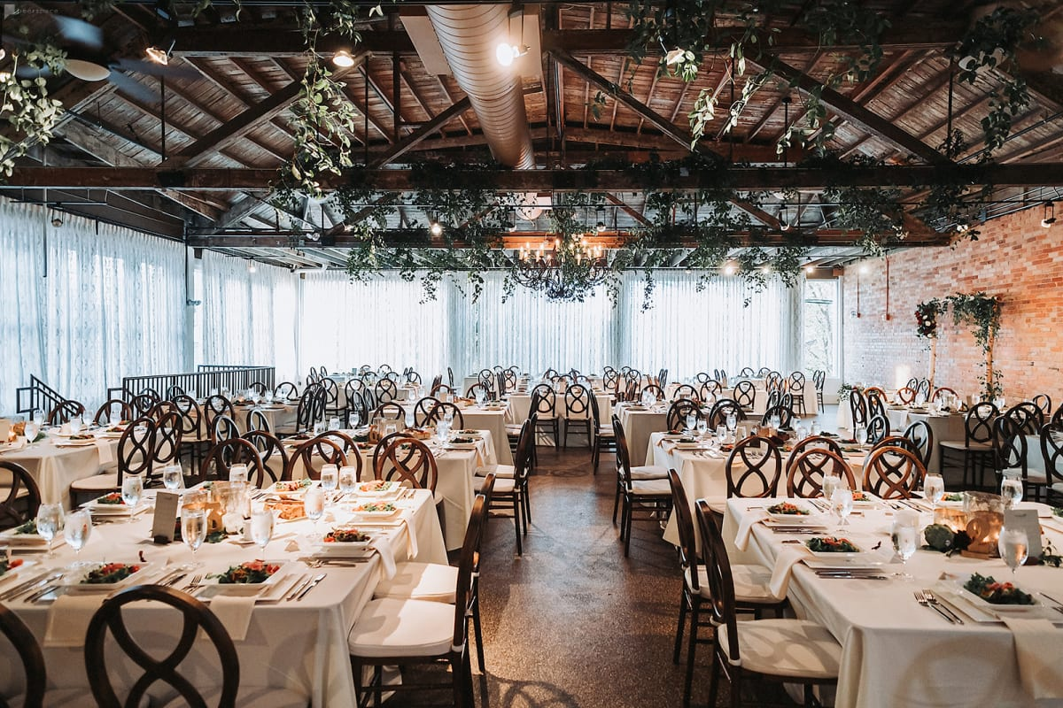

Therefore, it's wise to prioritize lighting capabilities when exploring different halls to hire. Furthermore, venue hire that includes professional lighting equipment and staff can significantly enhance your event experience. Many halls for hire offer basic lighting setups, but having access to professional lighting can elevate the entire event. Professional lighting technicians understand how to use light to highlight focal points, such as the stage or dance floor, and create a captivating visual experience for your guests. They can also ensure that the lighting complements other elements like decor and photography, making your event seamless and aesthetically pleasing. When considering pubs as an event venue, lighting plays a unique role in creating a cozy, intimate atmosphere. Pubs often come with their own set of lighting fixtures that can be adapted for different types of events. The warm, ambient lighting typically found in pubs can be perfect for smaller gatherings or casual celebrations. However, it’s still important to assess the flexibility of these lighting options to ensure they can be adjusted to fit the specific needs of your event.

The goal is to make sure the venue’s lighting enhances the overall experience for you and your guests. In conclusion, the importance of lighting in an event venue cannot be overstated. Whether you’re looking at halls for hire or pubs, the right lighting can transform your event from ordinary to extraordinary. It’s a key element that affects the mood, visibility, and overall aesthetic of the event. When exploring venues to hire, make lighting a top priority in your decision-making process. This will ensure that your event is not only visually stunning but also memorable for all the right reasons. So next time you’re planning an event, remember to think beyond the basics and consider how lighting can enhance your venue hire experience. Ultimately, the success of an event hinges on numerous factors, with lighting being a critical one. As you search for the perfect event venue, keep in mind that lighting can significantly influence your guests' experience. From setting the mood to highlighting key areas, effective lighting is essential for creating a captivating and enjoyable event. So, when you’re browsing halls to hire or pubs for your next event, don’t underestimate the power of good lighting. It’s an investment in the overall success and enjoyment of your special occasion.