**Information On Best Car Insurance**

Comprehensive vehicle insurance is essential for protecting yourself and your vehicle. It provides coverage beyond basic liability, including protection against theft, vandalism, and natural disasters. By having comprehensive insurance, you ensure that you are financially protected in a wide range of scenarios. Insurance brokers often recommend comprehensive policies due to their extensive coverage options. This type of insurance can save you from significant out-of-pocket expenses if an unexpected event occurs. As a vehicle owner, investing in comprehensive insurance offers peace of mind and financial security. Finding the right policy requires careful consideration and comparison. When you compare car insurance, you can identify the best car insurance for your specific needs. Good car insurance companies offer various plans that can be tailored to fit different requirements and budgets. It's crucial to evaluate coverage options, deductibles, and premium costs. Seeking advice from insurance brokers can help you navigate the complexities of insurance policies. Check out the below mentioned website, if you're searching for more details regarding [best car insurance](https://www.gmib.ie/compare-car-insurance).

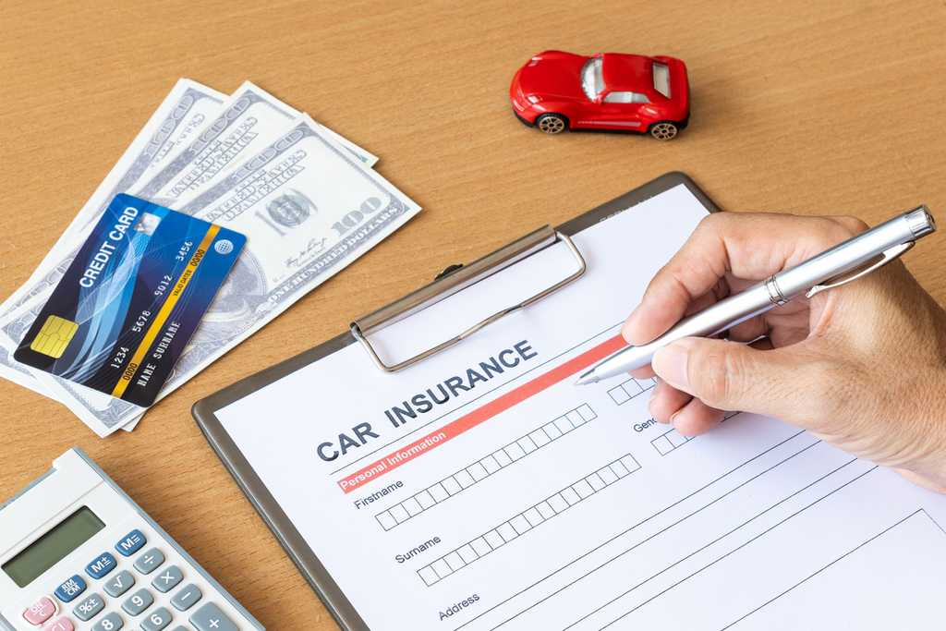

They can assist in finding the top car insurance by providing expert recommendations based on your needs. Obtaining an insurance quote is a fundamental step in securing the right policy. Many providers offer online tools to get a car insurance quote quickly. By comparing quotes from multiple companies, you can find the cheapest insurance without sacrificing coverage quality. However, it's important to remember that the lowest price isn't always the best option. The top rated car insurance providers may have higher premiums but offer better coverage and customer service. Ensuring you have adequate protection is worth the investment in a comprehensive policy. In addition to vehicle insurance, securing cheap home insurance is also beneficial. Home insurance protects your property and personal belongings against damage or theft. Obtaining a cheap home insurance quote allows you to compare different policies and find one that fits your budget. Some insurance brokers specialize in bundling car and home insurance policies, which can lead to significant savings. By consolidating your insurance needs with one provider, you can simplify the management of your policies and benefit from discounts.

Choosing the top car insurance involves more than just finding the lowest price. The best policies offer a balance of affordability, comprehensive coverage, and excellent customer service. Researching and reading reviews can help identify good car insurance companies. These companies are known for their reliability and efficiency in handling claims. The best car insurance providers also offer additional benefits like roadside assistance and rental car reimbursement, adding extra value to their policies. It's important to choose an insurance provider that meets your needs and provides the best overall value. In conclusion, comprehensive vehicle insurance is a vital investment for any vehicle owner. It offers extensive protection against various risks and ensures financial security. By using resources to compare car insurance and obtain an insurance quote, you can find the best car insurance policy for your needs. Working with insurance brokers can simplify the process and help you get the best deal. Additionally, bundling vehicle and home insurance policies can lead to cost savings and better coverage. Ultimately, investing in comprehensive coverage from top rated car insurance companies provides peace of mind and financial protection, making it an indispensable part of responsible vehicle ownership.