**Features About LOG LAP Cladding**

Decorative wall panels offer a versatile solution for transforming spaces with endless design possibilities. From interior timber wall cladding to sleek MDF panelling kits, these options cater to various aesthetic preferences. Decorative wall panels enhance the visual appeal of any room, providing texture and depth. They come in a variety of styles, including bead and butt MDF and log lap timber cladding, allowing homeowners to achieve their desired look. Whether it's a modern or rustic interior, panels decorative walls can seamlessly integrate into the design, offering both functionality and style. Their versatility makes them a popular choice for interior renovations. A DIY panelling kit is a convenient option for those looking to update their homes without professional help. These kits often include pre-cut panels and installation instructions, making it easy to achieve a professional finish. MDF wall panelling kits are particularly popular due to their affordability and ease of installation. Ship lapped timber cladding and log lap cladding are also great choices for a more natural, textured look. If you're searching for additional details on [log lap cladding](https://www.panellingdirect.co.uk/product-category/timber-cladding/log-lap/), explore the previously mentioned site.

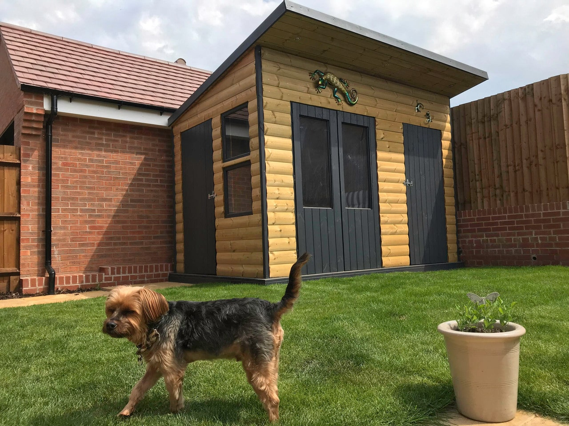

With a DIY panelling kit, homeowners can experiment with different designs and layouts, creating custom panels decorative walls that reflect their personal style and preferences. Timber cladding interior solutions are ideal for adding warmth and character to a space. Shiplap timber cladding and log lap timber cladding are two popular options that provide a rustic, cozy feel. These materials are durable and can withstand wear and tear, making them suitable for high-traffic areas. Interior timber wall cladding can be used in various settings, from living rooms to bedrooms, and even commercial spaces. The natural texture and color of wood create a welcoming atmosphere, and timber cladding panels can be painted or stained to match the existing decor. This versatility ensures a timeless appeal. For a classic and elegant look, butt and bead panelling is an excellent choice. This style features evenly spaced vertical lines that add height and sophistication to a room. Bead and butt panels can be used in both traditional and contemporary interiors, making them a versatile option for any design scheme. Butt and bead panelling is often used in dining rooms, hallways, and other formal areas to create a refined atmosphere. The simplicity of the design allows it to complement various decorative elements, ensuring a cohesive and stylish look.

Bead and butt MDF is a practical and stylish choice for many homeowners. MDF wall panelling kits offer a modern alternative to traditional wood panelling. These kits are made from medium-density fiberboard, which is durable and easy to work with. MDF panelling kits can be painted in any color, allowing for endless design possibilities. They are also resistant to warping and cracking, making them a long-lasting option for any home. The smooth surface of MDF wall panelling kits provides a sleek and contemporary look that can be easily customized to fit any design style. From minimalist to elaborate designs, panel decorative wall solutions can transform any space into a stylish and inviting environment. In conclusion, decorative wall panels are a versatile and stylish option for enhancing the aesthetics of any space. Whether you choose timber cladding interior solutions like shiplap timber cladding or log lap timber cladding, or opt for the convenience of a DIY panelling kit, there are countless ways to create beautiful panels decorative walls. The flexibility of MDF wall panelling kits and the elegance of butt and bead panelling offer something for every taste and style. With the wide range of options available, homeowners can easily find the perfect panel decorative wall solution to suit their needs and preferences.