**Details On English Voice Over**

Selecting the perfect voice actor for your podcast can transform your audio content from ordinary to extraordinary. A well-chosen voice artist brings a unique tone, emotion, and personality to your podcast, engaging listeners and keeping them coming back for more. The process of finding the right voice isn’t just about picking someone with a pleasant sound; it involves understanding the nuances of your content and what kind of voice will best represent your brand. Working with a professional voice over agency can simplify this process, offering a range of talented voice actors who can match your specific needs. Understanding the importance of a voice artist is crucial in making your podcast stand out. A skilled voice actor can convey emotions and nuances that resonate with your audience, creating a deeper connection with your listeners. They can also help establish the tone of your podcast, whether it’s professional, casual, or somewhere in between. By investing time in selecting the right voice, you ensure that your podcast communicates its message effectively, keeping your audience engaged and invested in your content. Are you searching for [english voice over](https://matinee.co.uk/voice-over-agency/english/)? Visit the before talked about site.

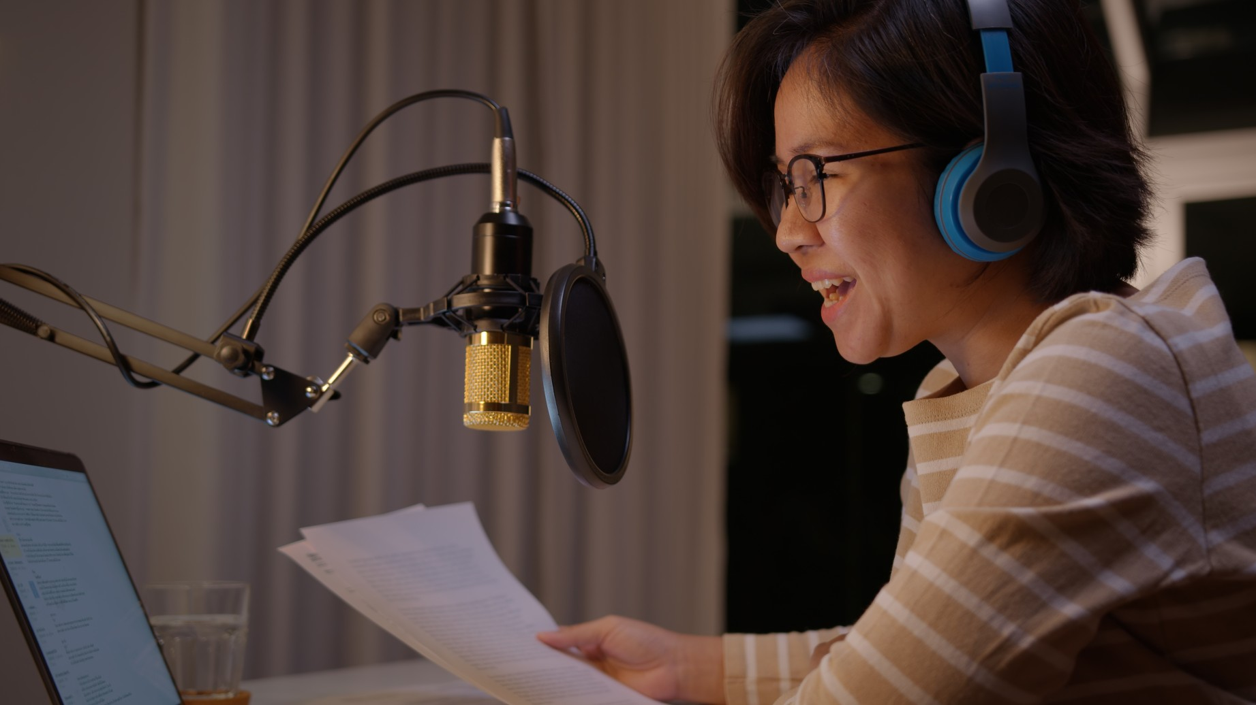

One of the primary benefits of working with a voice over agency is the access to a diverse pool of voice actors. These agencies have a roster of professionals who specialize in different styles and genres, making it easier to find the perfect match for your podcast. Agencies also handle the logistics, such as contracts and payments, allowing you to focus on the creative aspects of your podcast. Additionally, agencies can provide guidance and advice, helping you choose a voice artist who not only fits your current needs but can also grow with your podcast as it evolves. When selecting a voice artist, it’s essential to consider the qualities that will best suit your podcast. Think about the tone, pace, and personality you want to convey. Do you need a voice that’s warm and inviting, authoritative and informative, or energetic and lively? Listening to demo reels can give you a sense of a voice actor’s range and versatility. It’s also helpful to conduct auditions, where you can hear how potential candidates interpret your script and bring it to life. This hands-on approach ensures that you find a voice that aligns perfectly with your vision.

Working with a voice over agency can also offer long-term benefits. Building a relationship with an agency means you have a go-to source for future projects, whether you’re launching a new podcast or need additional voice work. Agencies often provide additional services such as scriptwriting, editing, and post-production, offering a comprehensive solution for all your podcasting needs. This holistic approach not only saves time but also ensures consistency and quality across your projects. In conclusion, selecting the right voice actor is a crucial step in elevating your podcast. A professional voice artist can add depth and personality to your content, making it more engaging and memorable for your audience. Working with a voice over agency provides access to a wide range of talent and simplifies the selection process, allowing you to focus on creating great content. By investing in the right voice, you can enhance the overall quality of your podcast and build a stronger connection with your listeners. Whether you’re just starting out or looking to refresh your existing podcast, the right voice can make all the difference.