**An Overview Of Document Printing Services**

When choosing the right print and design partner, it's essential to consider various factors that impact the quality and effectiveness of your printed materials. First, evaluate the print shop's reputation and reliability. Check reviews and testimonials from past clients to ensure they consistently deliver high-quality document printing services. A reputable print shop will have a history of satisfied customers and positive feedback, which can give you confidence in their ability to meet your printing needs. Additionally, consider the range of printers they use, as advanced equipment often results in better print quality and faster turnaround times. Location is another crucial factor. Search for "document printing near me" to find a convenient print shop. Proximity can save you time and money on shipping and allow you to easily visit the shop to discuss your project in person. Are you looking for [document printing services](https://gtprintanddesign.co.uk/print-services/document-printing)? Check out the previously outlined website.

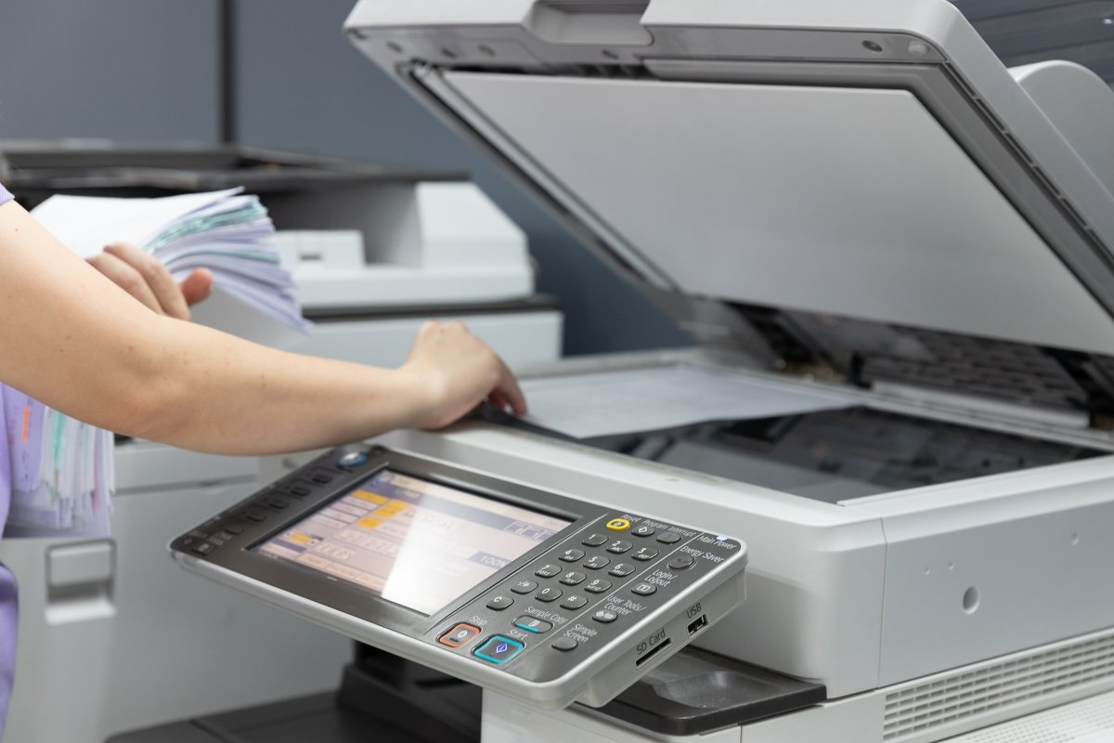

Local document printing services often provide more personalized attention and quicker response times, ensuring your requirements are understood and met efficiently. Moreover, having a nearby partner allows for easier collaboration, making it simpler to make last-minute changes or address any issues that may arise during the printing process. When it comes to specialized services like van sign writing and vehicle signwriting, experience and expertise are paramount. These types of projects require precision and a keen eye for detail to ensure the graphics are applied correctly and look professional. Look for a print shop with a proven track record in vehicle graphics, as this indicates they have the necessary skills and knowledge to handle complex jobs. Quality vehicle graphics can significantly enhance your brand's visibility and make a lasting impression on potential customers. The range of services offered by the print shop is also an important consideration. Beyond standard document printing, you may need services like shop signs or custom signs for your business. A versatile partner can handle various projects, providing a one-stop solution for all your printing and design needs.

This can streamline your workflow and ensure consistency across all your printed materials. Discuss your specific requirements with potential partners to confirm they have the capabilities to deliver what you need. Finally, consider the cost and value of the services provided. While it's essential to stay within your budget, the cheapest option isn't always the best. Compare quotes from different print shops and evaluate what is included in the price. Look for a balance between cost and quality, ensuring you get the best value for your investment. High-quality document printing and vehicle graphics can boost your business's image and attract more customers, making it worthwhile to invest in a reputable print shop. In summary, choosing the right print and design partner involves evaluating their reputation, location, experience, range of services, and cost. A reliable print shop with advanced printers and expertise in areas like vehicle signwriting and shop signs can ensure high-quality results for all your printing needs. By considering these key factors, you can find a partner that will help your business stand out and succeed. Whether you need standard document printing or specialized services like van sign writing, selecting the right partner is crucial for achieving the best possible outcomes.