A Synopsis Of Buy CBD Online

CBD, or cannabidiol, has gained significant attention for its potential health benefits. Derived from the cannabis plant, CBD is known for its therapeutic properties without the psychoactive effects associated with THC. Many people are exploring various CBD products to address health issues ranging from anxiety to chronic pain. One popular form is full spectrum CBD gummies, which are not only easy to consume but also provide the benefits of the full spectrum of cannabinoids. Consumers often buy full spectrum CBD gummies to experience a holistic approach to wellness, making them a preferred choice in many online CBD stores. The popularity of CBD gummies has surged due to their convenience and effectiveness. These edibles offer a discreet and tasty way to consume CBD, making them ideal for those new to CBD or those who prefer not to inhale their supplements. If you're looking for more information on buy cbd online, click on the above website.

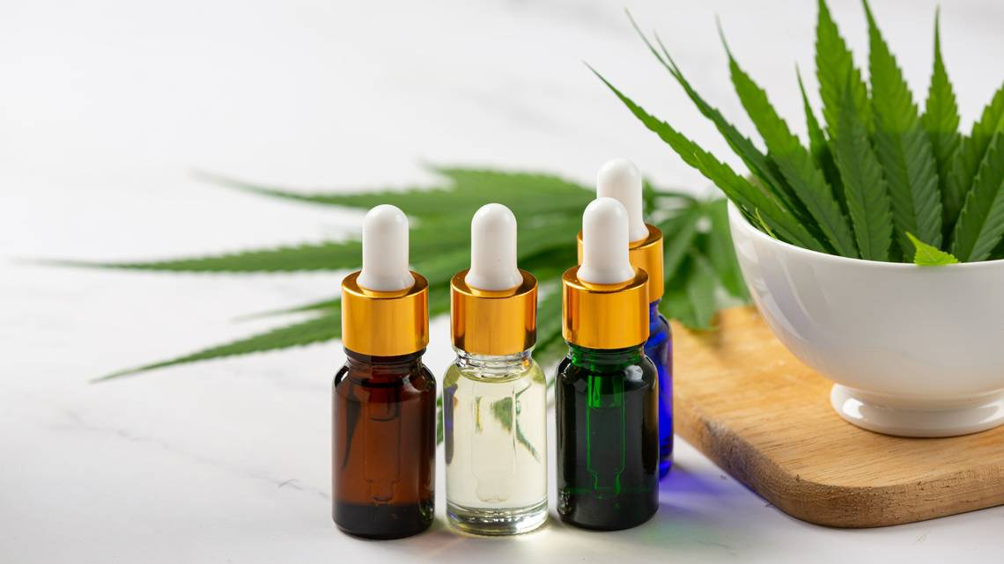

When you buy CBD gummies, you're not just getting a sweet treat but also a dose of potential health benefits. Whether you're looking for menopause symptoms relief or a way to manage anxiety, gummies could be an excellent addition to your wellness routine. Many people buy CBD edibles for their versatility and ease of use. CBD's role in managing menopause symptoms is another area of growing interest. Many women wonder, "Can CBD help manage my menopause symptoms?" The answer seems to be promising. CBD interacts with the body's endocannabinoid system, which plays a role in regulating mood, sleep, and pain—all areas often affected during menopause. As a result, many turn to natural remedies for menopause symptoms like CBD. Herbal supplements for menopause are becoming increasingly popular, with CBD products leading the way. Women looking for menopause symptoms relief might find that adding CBD to their regimen provides significant benefits. When considering where to purchase CBD products, it's essential to find a good CBD online store.

The best places to buy CBD online offer a wide range of products, detailed information, and third-party testing to ensure quality and safety. Whether you're looking to shop CBD now or doing some research before making a purchase, an online CBD store can provide the resources you need. From full spectrum CBD gummies to other edibles, these stores offer various options to suit different needs and preferences. In conclusion, CBD continues to grow in popularity due to its potential health benefits and versatility. From full spectrum CBD gummies to other edibles, there are numerous ways to incorporate CBD into your daily routine. Whether you're looking to manage stress, seek menopause symptoms relief, or explore herbal supplements for menopause, CBD products offer a natural solution. When you buy CBD, choosing a reputable online CBD store ensures you get high-quality, safe products. With the ease of purchasing online, now is a great time to shop CBD now and experience the potential benefits for yourself.

