**A Summary Of Water Damage Restoration**

Restoring historic homes is a rewarding but challenging endeavor. Uncovering the Past: A Guide to Restoring Historic Homes involves addressing various issues, including mould and water damage. Mould treatment is essential in preserving the integrity of these homes. This process often requires professional mould removal services to ensure thorough eradication. A mould specialist can identify hidden mould and recommend the best treatment methods. Additionally, water damage restoration is crucial, as historic homes are susceptible to water infiltration. Effective water damage clean up by restoration water damage experts can prevent further deterioration and preserve the home’s original structure and charm. Fire is another significant threat to historic homes. Fire damage restoration is a meticulous process that involves repairing and cleaning the affected areas. Fire damage and restoration efforts must be thorough to ensure the home is safe and habitable. A reputable fire restoration company can provide the necessary expertise to handle these delicate tasks. They specialize in fire restoration damage, focusing on salvaging as much of the original materials as possible. Are you hunting for [water damage restoration](https://remorarestorations.com/water-damage/)? Look at the earlier described site.

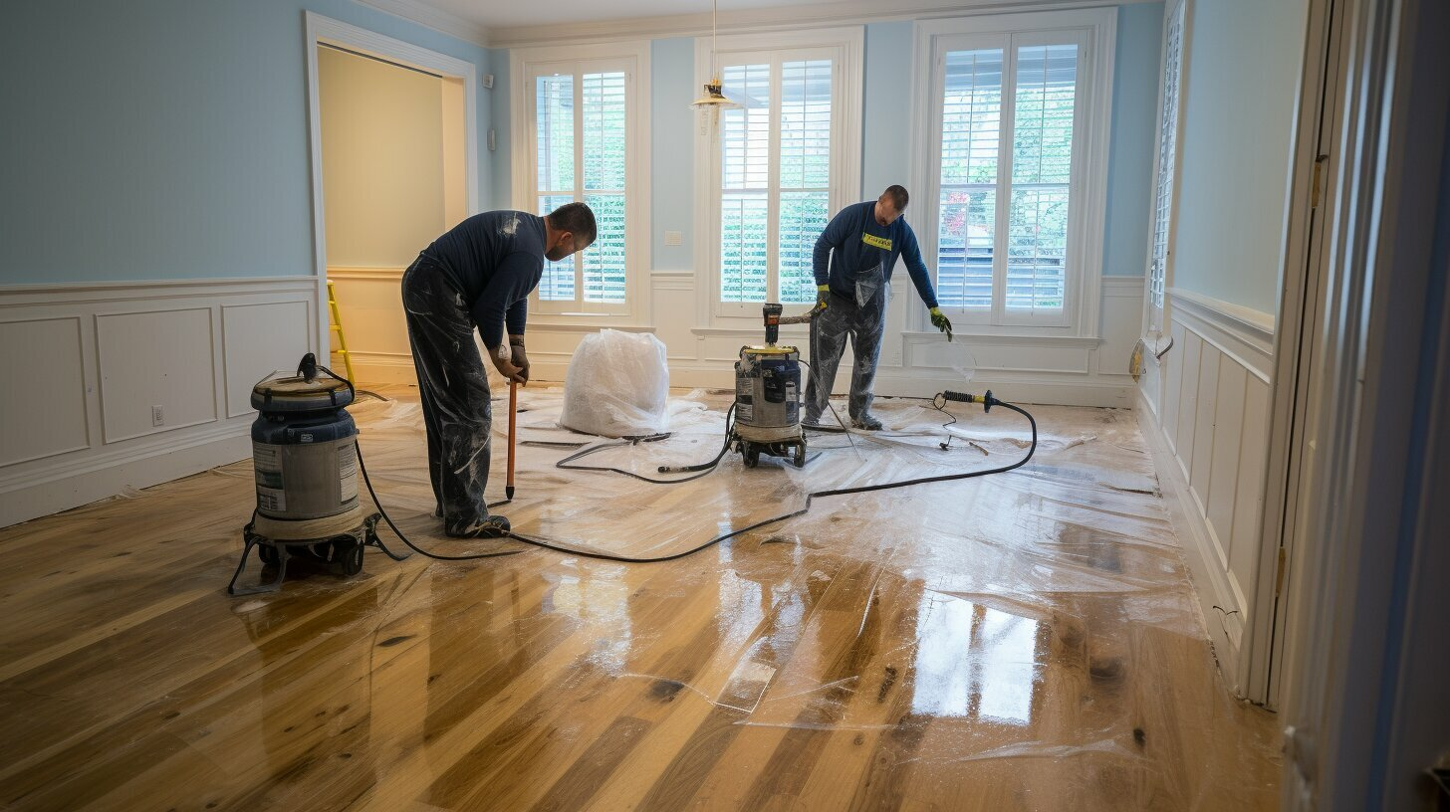

This attention to detail helps maintain the historical authenticity of the home while ensuring it meets modern safety standards. Uncovering the Past: A Guide to Restoring Historic Homes also involves addressing less visible issues. For instance, underlying structural damage might be present due to prolonged exposure to moisture or fire. Restoration experts must conduct a comprehensive assessment to identify and rectify these hidden problems. This often includes reinforcing the foundation, repairing damaged walls, and replacing compromised beams. The goal is to restore the home’s structural integrity while preserving its historical essence. Each step in the restoration process must be carefully planned and executed to ensure the home’s longevity and historical value. In addition to structural repairs, aesthetic restoration is a key aspect of restoring historic homes. This involves meticulously replicating original design elements, such as intricate woodwork, vintage wallpapers, and period-appropriate paint colors. These details are crucial in maintaining the historical character of the home. Collaborating with craftsmen who specialize in historical restoration can help achieve an authentic look.

They bring a wealth of knowledge about traditional techniques and materials, ensuring that the restoration work respects the home’s original design and craftsmanship. Finally, maintaining restored historic homes requires ongoing care and attention. Regular inspections can help detect potential issues before they become serious problems. Homeowners should stay vigilant about signs of mould, water damage, or fire hazards. Engaging professional mould removal services and restoration water damage experts for routine maintenance can prevent major issues from developing. Additionally, having a reliable fire restoration company on hand for emergencies is crucial. Consistent upkeep not only preserves the home’s historical value but also ensures it remains a safe and enjoyable living space for future generations. In conclusion, Uncovering the Past: A Guide to Restoring Historic Homes is a complex but rewarding process. It requires addressing mould and water damage through professional mould treatment and water damage restoration services. Fire damage also demands careful attention, with fire damage restoration efforts focusing on safety and historical accuracy. Structural and aesthetic restorations are equally important in preserving the home’s character. Ongoing maintenance is essential to protect these valuable properties. By following these guidelines, homeowners can ensure their historic homes are beautifully restored and preserved for years to come.