**A Peek At Ear Stretchers**

Getting an ear piercing is a popular way to express personal style, but ensuring the process is safe and stylish requires careful consideration. Choosing the right piercer is the first crucial step. Look for a professional with a solid reputation and proper certifications. It's important that the piercer uses sterilized equipment and follows strict hygiene protocols to prevent infections. When it comes to ear stretching, a skilled piercer will guide you through the process, recommending the best ear stretching kit or ear stretching starter kit to begin your journey safely and effectively. Selecting the appropriate jewelry is equally important in achieving a stylish look while maintaining health and safety. High-quality materials like surgical steel, titanium, and biocompatible plastics are essential to minimize the risk of allergic reactions and infections. For those interested in ear stretchers or stretcher earrings, these materials ensure a smoother and safer stretching process. Starting with a best ear stretching kit that includes all necessary tools can make the transition easier. Are you looking about [ear stretchers](https://www.stretchitbodyjewellery.co.uk/)? View the earlier talked about site.

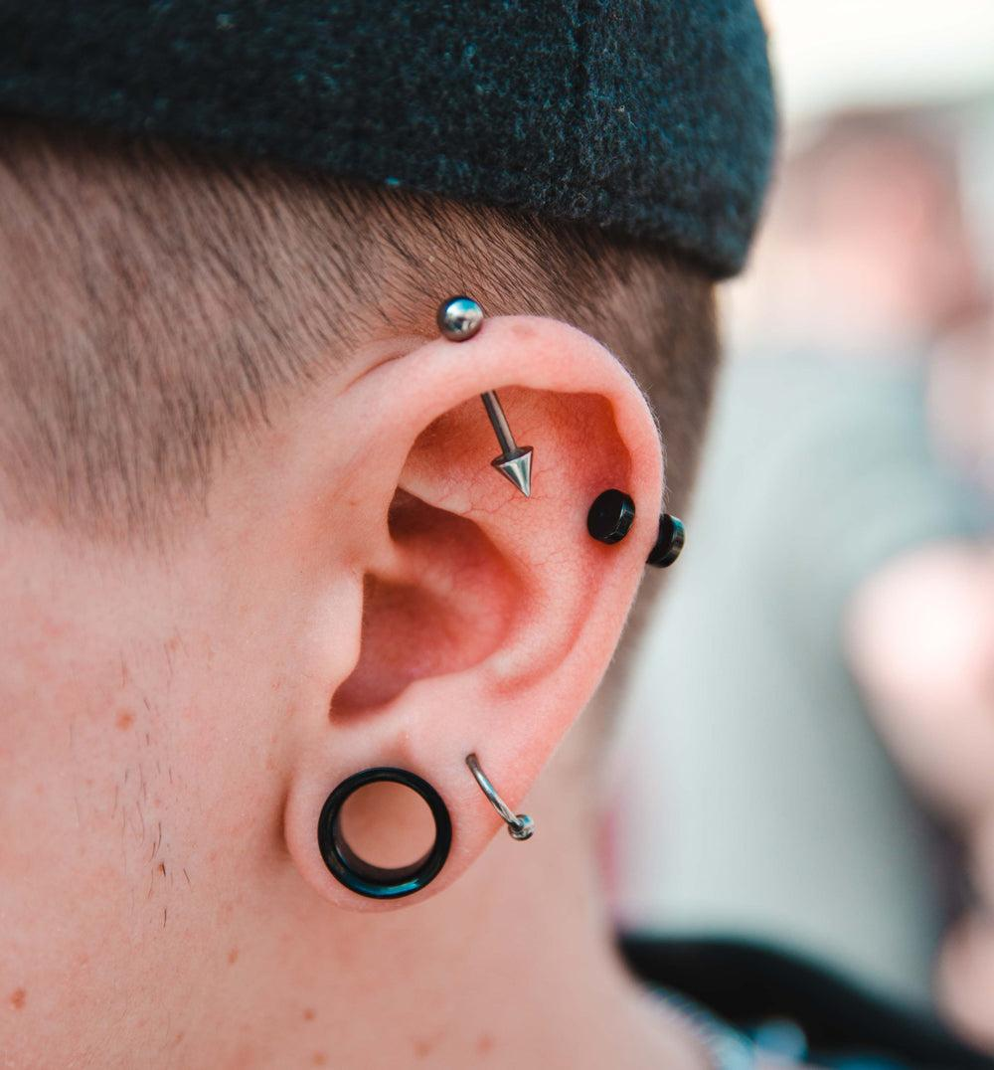

This kit should ideally include ear gauge or ear gauges to gradually increase the size of the piercing without causing damage. The process of ear stretching involves gradually increasing the size of your earlobe piercings, which requires patience and proper tools. A comprehensive ear stretching kit or earlobe stretching kit often includes tapers, ear tunnels, and plugs. These tools help you stretch the earlobe incrementally. Using a gauge stretching kit ensures that the process is done correctly, minimizing pain and the risk of tearing. Beginners should opt for an ear stretching starter kit to learn the basics before moving on to more advanced techniques and larger sizes. Maintaining your piercings and stretched ears involves a regular cleaning routine to prevent infections and ensure healthy healing. Using saline solutions and avoiding irritants like alcohol or hydrogen peroxide is crucial. Regularly inspecting your jewelry and the pierced area helps catch any potential issues early. For those using ear tunnel plugs or ear tunnels and plugs, it's important to clean both the jewelry and the piercing site regularly.

Proper aftercare supports the healing process and ensures your piercings remain stylish and healthy. Choosing the right size and style of jewelry is essential for both comfort and aesthetics. Stretch earrings and ear tunnels come in various designs, allowing for personal expression. When starting with an ear stretching kit, it's important to begin with smaller sizes and gradually increase. A dead stretching kit can be used for more advanced stretching without the use of tapers, relying instead on heavier jewelry to stretch the earlobe naturally over time. This method requires careful monitoring and consistent aftercare to avoid complications. In conclusion, safe and stylish ear piercing involves selecting a reputable piercer, choosing high-quality jewelry, and using the right tools and kits for stretching. Whether you are starting with a best ear stretching kit or exploring advanced techniques with a dead stretching kit, proper care and patience are key. By following these guidelines, you can enjoy a fashionable and healthy piercing experience. Remember, the journey to achieving your desired look with ear stretchers, ear gauge kit, or ear tunnels and plugs is as important as the final result.