**A Little Bit About Wall Graphic Printing**

Maximizing brand visibility is essential for any business looking to grow its market presence and attract more customers. One highly effective method is through hoarding advertising. Strategically placed hoardings can create a significant impact by reaching a broad audience in high-traffic areas. Companies like Wallace Print specialize in producing high-quality hoardings that capture attention and convey powerful messages. These large-scale advertisements are not only eye-catching but also provide a durable and weather-resistant medium for showcasing your brand. By utilizing custom printed wall graphics, businesses can ensure their message stands out in any environment. The location of your hoarding advertising plays a crucial role in its effectiveness. Placing hoardings in areas with high footfall, such as busy streets, shopping centers, or near public transportation hubs, can significantly increase the visibility of your brand. Wallace Printing offers expert advice on selecting the best locations for your advertisements to maximize impact. By strategically positioning hoardings where potential customers are likely to see them, you can create a lasting impression and enhance brand recognition. If you are searching for more information on [custom printed wall graphics](https://wallaceprint.com/printed-wall-graphics/), look into the earlier mentioned site.

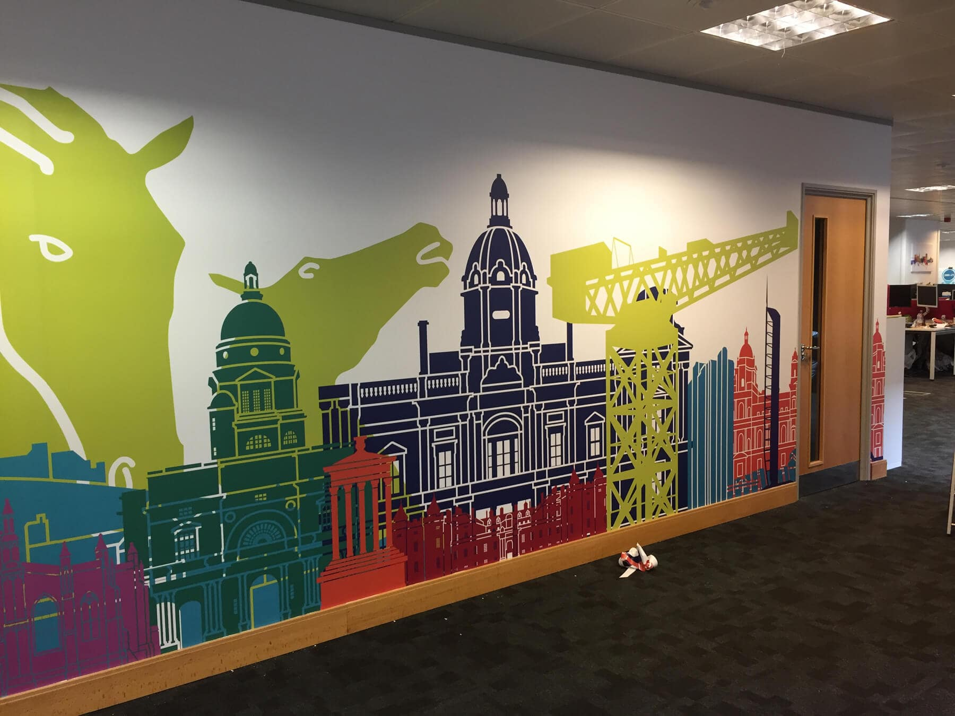

This targeted approach ensures that your marketing efforts reach the right audience. The quality of the hoardings is equally important as their placement. Trade printing services, such as those provided by Wallace Print, ensure that your hoardings are produced to the highest standards. Using advanced printing techniques and high-quality materials, trade printers can create vibrant, durable advertisements that withstand the elements and maintain their appearance over time. This durability is essential for outdoor advertisements, which are exposed to various weather conditions. High-quality hoardings not only look professional but also reinforce the credibility and reliability of your brand. Custom printed wall graphics add a unique touch to hoarding advertising. These graphics allow businesses to create personalized and engaging advertisements that reflect their brand identity. Wallace Printing offers a wide range of customization options, from bold and colorful designs to sleek and minimalist styles. By incorporating elements such as logos, slogans, and brand colors, custom wall graphics make your advertisements instantly recognizable. This personalization helps in creating a strong visual connection with your audience, enhancing brand recall and loyalty. One of the key benefits of hoarding advertising is its ability to deliver continuous exposure.

Unlike digital ads that can be skipped or ignored, hoardings are constantly on display, providing ongoing visibility for your brand. This constant presence reinforces your marketing message and keeps your brand top of mind for potential customers. Additionally, hoardings can serve multiple purposes, such as hiding construction sites or decorating unsightly areas, while simultaneously promoting your business. The benefits of hoarding advertising extend beyond mere visibility, offering practical solutions for urban environments. In conclusion, strategically placed hoardings are a powerful tool for maximizing brand visibility and enhancing marketing efforts. By partnering with trade printers like Wallace Print, businesses can create high-quality, durable advertisements that capture attention and convey their brand message effectively. The strategic placement of hoarding advertising in high-traffic areas ensures that your marketing reaches a wide audience. Customizing these hoardings with custom printed wall graphics adds a personal touch that strengthens brand identity. The continuous exposure provided by hoardings keeps your brand in the public eye, making them an invaluable addition to any marketing strategy.