**A Glance At Extension Plans**

When embarking on a home renovation, finding the right architect is crucial. The perfect match will bring your vision to life, ensuring that your house extension plans are both functional and aesthetically pleasing. An architectural designer can provide a range of services, from initial extension planning drawings to securing the necessary permits. These professionals use their expertise to create detailed drawings for planning permission, which are essential for obtaining approval from local authorities. A well-chosen architect will guide you through each step of the process, making your dream home a reality while adhering to regulations and budget constraints. The initial stage of your project involves developing comprehensive extension plans. This phase is critical as it sets the foundation for the entire build. Architect extension plans should encompass every aspect of your design, from structural elements to interior layouts. The planning drawings created during this phase will be used to communicate your vision to builders and contractors, ensuring that everyone involved is on the same page. By working closely with an architect, you can refine these plans to meet your specific needs and preferences, resulting in a tailored solution that enhances your living space. If you are seeking for additional details on [extension plans](https://www.survessex.co.uk/essex-architects/extension-plans/), check out the earlier mentioned website.

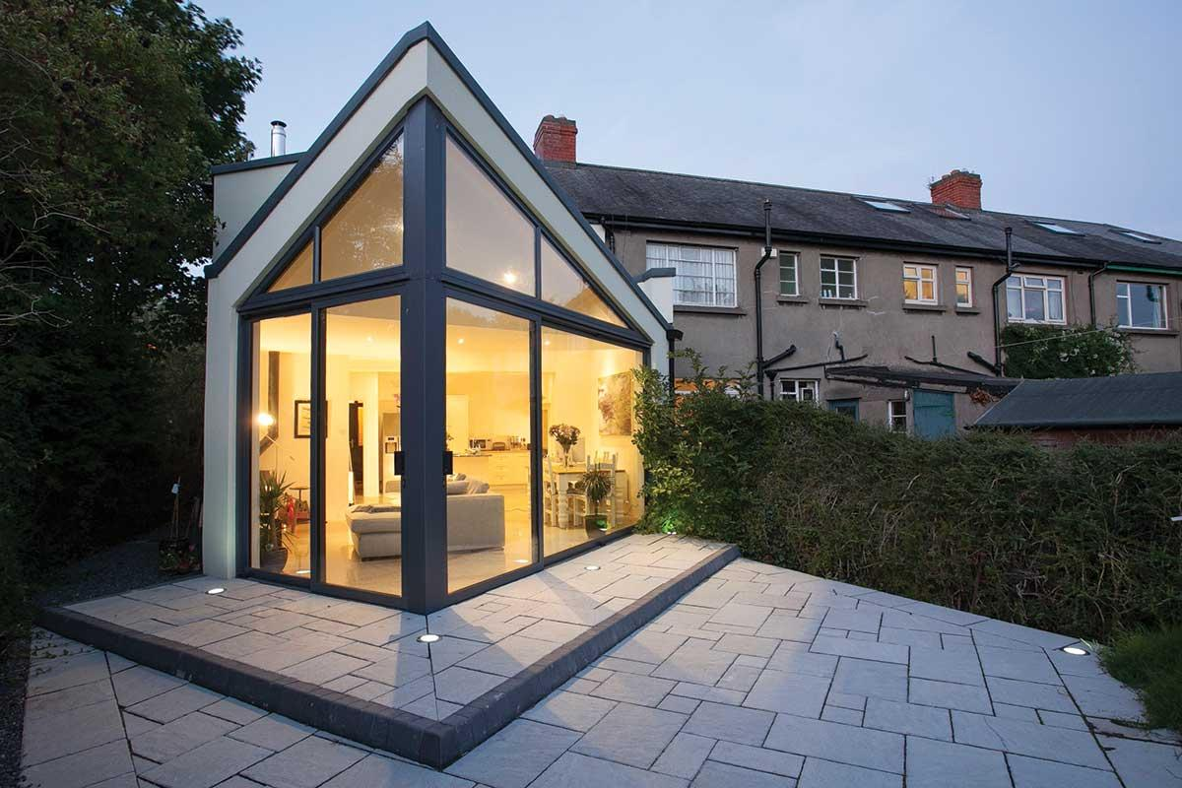

Securing planning permission for extension drawings is a vital part of any renovation project. This process can be complex, requiring detailed drawings for planning permission that comply with local building codes and regulations. An experienced architectural designer will be familiar with these requirements and can produce accurate planning drawing submissions to ensure a smooth approval process. They will also handle any necessary revisions, liaising with planning authorities on your behalf. This expertise not only saves you time and stress but also increases the likelihood of obtaining the necessary permits for your extension. Choosing the right architect involves considering several factors, including their experience with house extension plans and their ability to deliver creative yet practical solutions. Look for an architectural designer with a proven track record of successful projects similar to yours. Reviewing their portfolio and speaking with previous clients can provide valuable insights into their capabilities and working style. Additionally, ensure that they are adept at producing precise extension planning drawings and navigating the planning permission process. A good architect will also offer innovative design ideas that maximize the potential of your space, adding value to your home.

The collaboration between you and your architect is essential for the success of your project. Open communication and mutual trust will enable you to work together effectively, turning your house extension plans into reality. Regular meetings and updates ensure that the project stays on track and any issues are promptly addressed. Your architect should be responsive to your feedback, incorporating your ideas while providing professional guidance. This partnership ensures that the final result aligns with your vision, budget, and timeframe, creating a seamless and enjoyable renovation experience. In conclusion, finding the perfect architect for your home extension project is a critical step in achieving your dream home. Through comprehensive extension plans and detailed planning drawings, a skilled architectural designer will navigate the complexities of the planning permission process and bring your vision to life. By choosing an experienced and creative professional, you can ensure that your house extension plans are executed flawlessly, resulting in a functional and beautiful living space. The right architect will not only enhance your home but also make the renovation process smooth and enjoyable, ultimately adding value to your property.