**A Few Facts About Wellness Breaks**

Achieving fitness goals can seem daunting, especially with the demands of daily life. However, with the right approach, making significant strides in your fitness journey in 2024 is entirely possible. Incorporating structured activities such as wellbeing retreats can be a game changer. These retreats offer a focused environment to work on physical and mental health, away from everyday distractions. Whether it's yoga, meditation, or fitness boot camps, wellbeing retreats provide the tools and support needed to jumpstart your fitness journey and set the stage for lasting healthy habits. Taking wellness breaks is another effective strategy for reaching your fitness goals. A wellness break allows you to step away from the stresses of work and home life to focus solely on your health. These breaks can range from weekend spa visits to week-long fitness vacations. During these wellness breaks, you can engage in activities such as hiking, swimming, or group fitness classes, all while enjoying nutritious meals that support your fitness goals. Check out the below mentioned website, if you're searching for additional information regarding [wellbeing retreats](https://www.thebodyretreat.co.uk/).

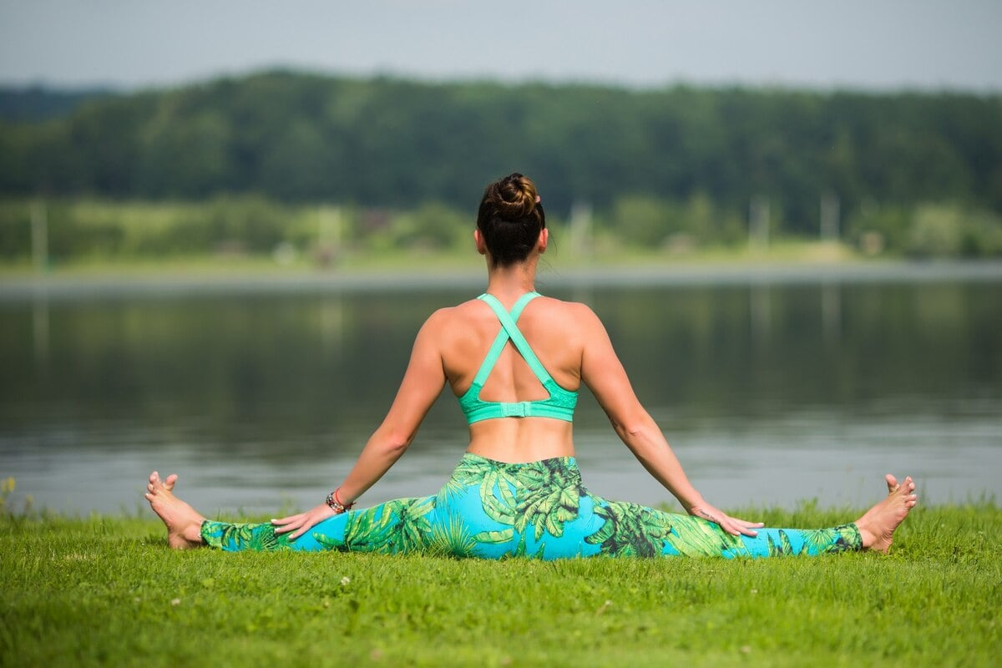

For women going through menopause, a menopause retreat or menopause holiday can offer specialized support to meet fitness goals. A womens menopause holiday typically includes tailored fitness programs, nutritional guidance, and stress management techniques designed to address the unique challenges of menopause. These retreats create a supportive community where women can share experiences and strategies for maintaining health. Participating in a menopause retreat not only helps in managing symptoms but also fosters a commitment to fitness that can be sustained long after the retreat ends. Planning healthy holidays throughout the year can also play a crucial role in achieving fitness goals. Unlike traditional vacations, healthy holidays focus on physical activity and wellness. Whether it's a beach vacation with morning yoga sessions or a mountain trip filled with hiking and biking, these holidays ensure you stay active while enjoying your time off. Health and wellness holidays provide a balanced approach to relaxation and fitness, making it easier to return to your daily routine with renewed energy and a continued focus on your fitness objectives.

Attending health retreat holidays can further enhance your fitness journey. These retreats offer comprehensive programs that include fitness training, nutritional education, and wellness activities. A health retreat holiday provides an immersive experience where you can dedicate time solely to your fitness and health, surrounded by professionals who guide you every step of the way. The structured environment helps in building new, healthy habits that can be integrated into your daily life. The benefits of a health retreat holiday extend beyond the duration of the retreat, providing long-term strategies for maintaining fitness and wellbeing. In conclusion, making your fitness goals come true in 2024 requires a combination of dedicated effort and strategic planning. By incorporating wellbeing retreats, wellness breaks, and healthy holidays into your routine, you can create a sustainable approach to fitness. For those experiencing menopause, a menopause retreat offers specialized support to meet unique health needs. Attending health retreat holidays provides an intensive, supportive environment to develop lasting healthy habits. By making these activities a priority, you can achieve your fitness goals and enjoy a healthier, more balanced life.