**A Few Details About Videographer Agency**

Creating professional-looking videos requires mastering several key techniques. While working with a videographer agency or a digital video agency can provide expertise, DIY videographers can also achieve cinematic results with the right approach. Start by investing in high-quality equipment. Good cameras, lenses, and lighting are crucial. Understanding how to use this equipment effectively will elevate your content. For instance, learning about different types of shots and camera movements can add a dynamic feel to your videos, similar to what a commercial video production company would deliver. Consistency in branding is another critical aspect. A branded content video agency focuses on maintaining a cohesive brand image across all videos. DIY videographers should adopt this mindset by ensuring each video aligns with their brand’s voice and aesthetic. This involves meticulous planning, from scripting to post-production. Successful brand video production requires a clear understanding of your brand’s message and target audience. By mirroring the practices of a corporate video production team, you can create content that resonates with viewers and strengthens your brand identity. Lighting plays a significant role in making videos look professional. Check out the following site, if you are seeking for more information concerning [videographer agency london](https://www.thefilmfarmers.co.uk/).

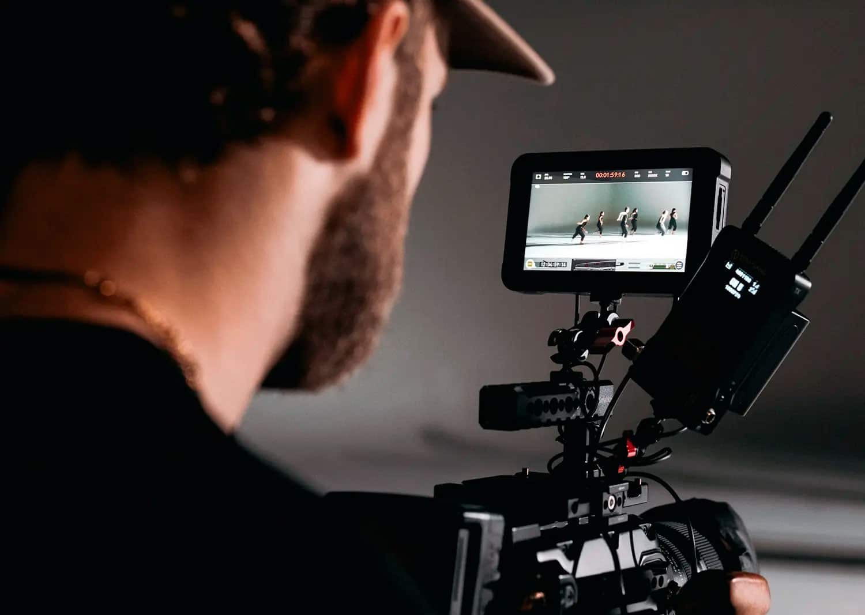

Good lighting can dramatically improve the quality of your footage. Understanding how to use natural and artificial light effectively is essential. Experiment with different lighting setups to see what works best for your subject and environment. Many videographers use a three-point lighting setup, which includes key light, fill light, and backlight. This technique adds depth and dimension to the subject, making your videos look polished and professional, just like those produced by a digital video agency. Sound quality should never be overlooked. Poor audio can ruin an otherwise great video. Investing in a good microphone and learning basic audio editing techniques can make a significant difference. Ensure that your audio is clear and free from background noise. If you hire a videographer, discuss their approach to sound to ensure they meet your standards. Even DIY videographers can achieve excellent audio quality by following best practices, ensuring their videos are on par with those from a commercial video production company. Editing is where your video truly comes to life. Effective editing can transform raw footage into a compelling story. Learn to use editing software and pay attention to details like transitions, color correction, and sound design. These elements can significantly enhance your video’s final look.

If editing feels overwhelming, consider collaborating with a videographer agency or a branded content video agency. Their expertise can help ensure your video meets industry standards and captures your audience’s attention. Finally, always seek feedback and continuously improve your skills. Analyzing viewer engagement and feedback can provide insights into what works and what doesn’t. This information is invaluable for ongoing improvement. Even commercial video production companies and corporate video production teams rely on analytics to refine their strategies. DIY videographers should do the same, adjusting their techniques based on audience reactions. By consistently evaluating and improving, you can produce high-quality videos that rival those created by professional agencies. In conclusion, achieving professional-looking videos involves investing in quality equipment, maintaining consistent branding, mastering lighting and sound, and refining your editing skills. Whether working independently or with a videographer agency, understanding and implementing these techniques is key. With dedication and continuous learning, you can create cinematic videos that effectively communicate your message and engage your audience, matching the quality of content produced by top digital video agencies and corporate video production companies.