**In-Depth Analysis On The Wedding Venues**

Choosing the right wedding venue is crucial for creating a memorable and seamless wedding day. The venue sets the ambiance and tone for the entire event, impacting every other element of the celebration. When selecting an event venue, couples should first consider the size. The venue must comfortably accommodate all guests, ensuring there is enough space for dining, dancing, and other activities. Moreover, the style and aesthetic of the venue should align with the couple's vision. Whether opting for a rustic barn, an elegant ballroom, or a unique sports club venue hire, the setting significantly influences the overall atmosphere and guest experience. Location is another critical factor when choosing a wedding venue. Ideally, the venue should be easily accessible for all guests, with ample parking and proximity to hotels or public transportation. This convenience is crucial for ensuring guests arrive on time and comfortably. Exploring pubs near the venue can also provide additional spaces for pre-wedding gatherings or after-parties. The right location not only adds to the guests' convenience but also enhances the overall flow and enjoyment of the event, making the day more enjoyable and stress-free for everyone involved. Are you searching for [wedding venues watford](https://www.metropolitanbushey.co.uk/wedding-venue-watford/)? Visit the previously described website.

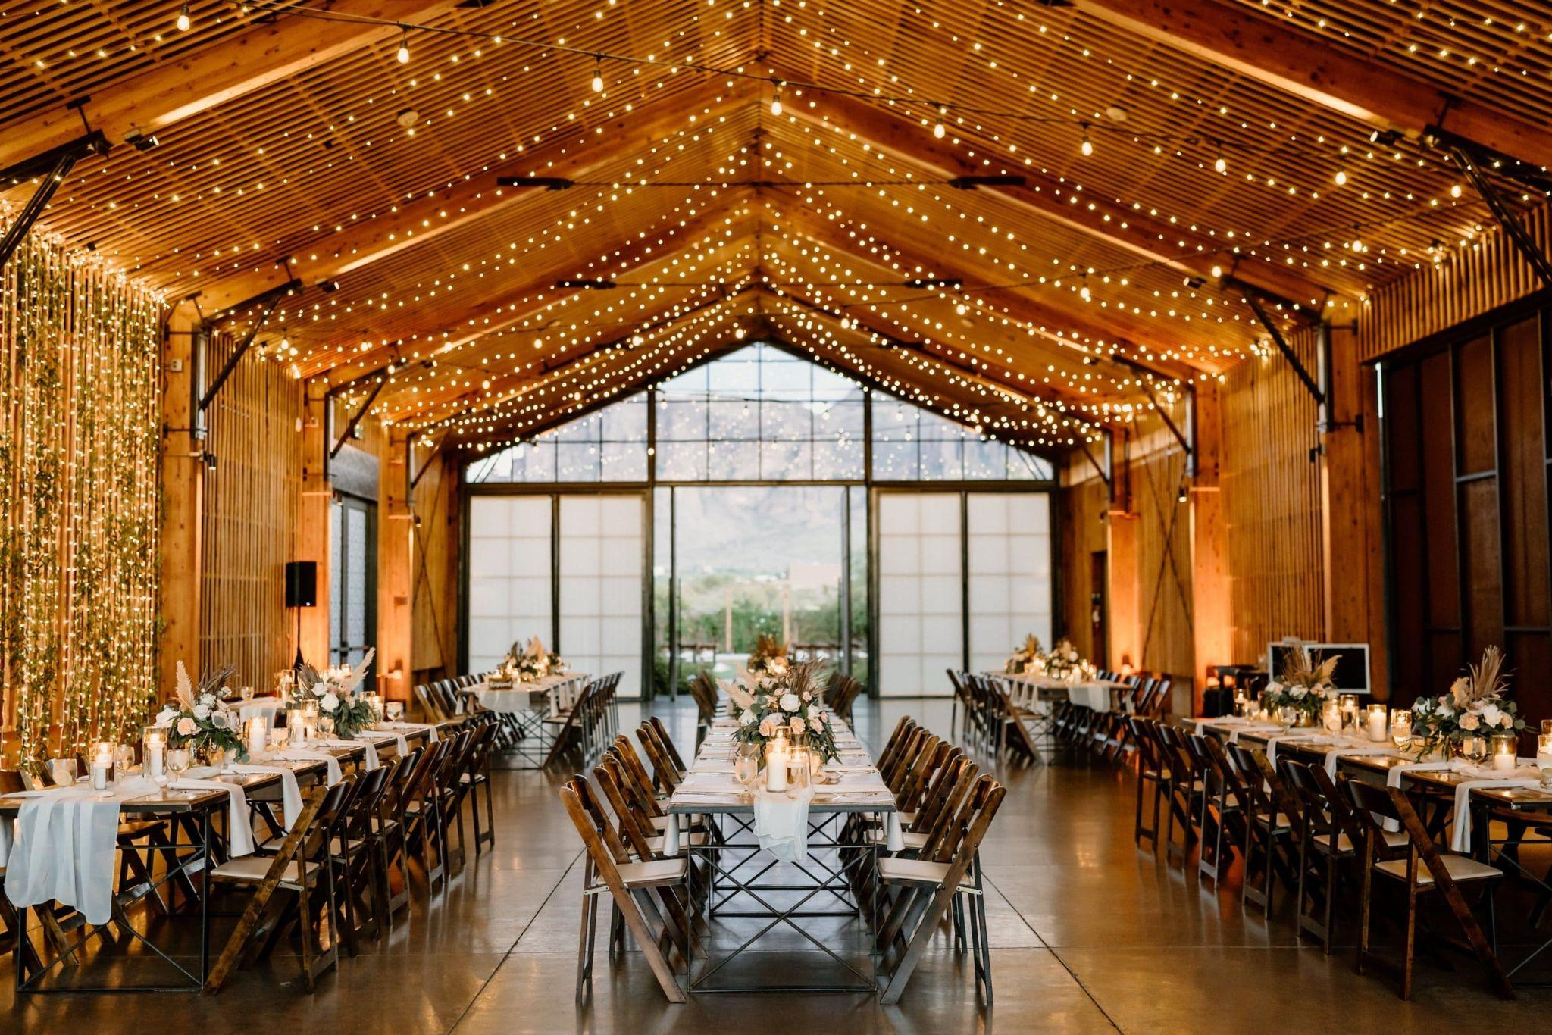

The amenities and services provided by the event venue are also important considerations. Many wedding venues offer comprehensive packages that include catering, decoration, and even event planning services. For those seeking a more intimate setting, function room hire might be a perfect choice, offering a cozy space with all necessary facilities included. Larger weddings might benefit from venues with multiple areas for different parts of the event, such as separate spaces for the ceremony, cocktail hour, and reception. Checking what is included in the venue hire helps avoid unexpected costs and ensures that all necessary services are readily available on-site. For a unique and memorable experience, couples might consider non-traditional wedding venues such as sports club venue hire. These venues often come with extensive conference facilities that can handle large gatherings and offer a distinctive touch to the wedding. Additionally, such venues might provide extra activities or unique features to entertain guests, adding a special element to the celebration. Visiting potential venues in person and visualizing the event layout can help couples plan decor and arrangements that align with their vision, ensuring a cohesive and stunning presentation on the wedding day.

Lastly, the support and flexibility offered by the venue staff are essential. The best wedding venues provide experienced coordinators who assist with planning and execution, ensuring that everything runs smoothly. From setting up the meeting room for pre-wedding preparations to handling last-minute changes, their support is invaluable. Reading reviews and testimonials from other couples can offer insights into the level of service and reliability of the venue staff. Choosing a venue with a supportive team ensures that any challenges are managed efficiently, allowing the couple and their guests to enjoy the day without unnecessary stress. In conclusion, selecting the right wedding venue involves careful consideration of several key factors. The venue's size, location, amenities, and unique characteristics all contribute to the success and memorability of the wedding. Whether opting for a traditional event space or a distinctive sports club venue hire, it's crucial that the venue aligns with the couple’s vision and meets all logistical requirements. By thoroughly researching and visiting potential wedding venues, couples can make informed decisions that will help create a memorable and enjoyable wedding day for themselves and their guests.